ASSIGNMENT 4

McKinley Harlett

2021- 01-06

# Markdown Basics

## Favorite Foods

1.) Pizza 2.) Pasta 3.) Pickles

## Images

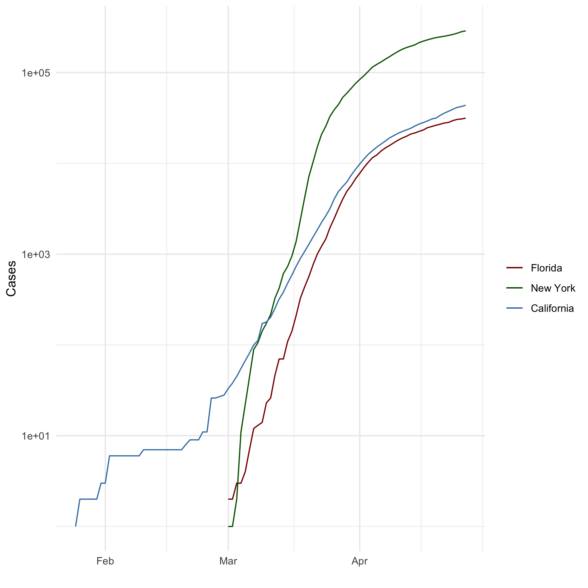

Image from Completed Assignment 4

## Add a Quote

A book names Scoring Wilder by R.S. Grey wrote:

She believed she could, so she did!

## Add an Equation

$$y=mx+b$$

## Add a Footnote

This is a footnote [^1] [^1]: I am really enjoying this course

## Add Citations

* R for Everyone (see **???**, J.P._2014)
* Discovering Statistics Using R (see **???**, A. and Miles, J. and Field, Z_2012)

# Inline Code

## NY Times COVID-19 Data

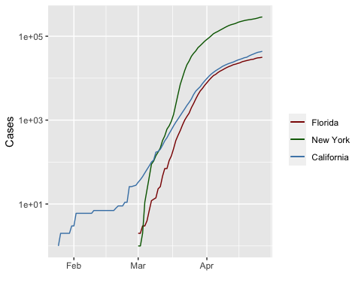

## R4DS Height vs Earnings

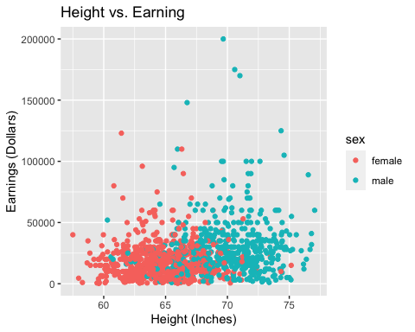

# Tables

## Knitr Table with Kable

setwd("/Users/mckinleyharlett/Documents/Bellevue Grad Courses/Winter semester/Statistics in Data Science/GitHub Assignments/dsc520/dsc520/data")  
characters_df <- read.csv("Charactersdf.csv")  
knitr::kable(characters_df, caption = "One Ring to Rule Them All")

One Ring to Rule Them All

|  |  |  |  |  |
| --- | --- | --- | --- | --- |
| Name | Race | In.Fellowship. | Is.Ring.Bearer | Age |
| Aragon | Men | Yes | No | 88 |
| Bilbo | Hobbit | No | Yes | 129 |
| Frodo | Hobbit | Yes | Yes | 51 |
| Sam | Hobbit | Yes | Yes | 36 |
| Sauron | Maia | No | Yes | 7052 |

## Pandoc Table

|  |  |  |  |  |
| --- | --- | --- | --- | --- |
| Name | Race | In Fellowship? | Is Ring Bearer? | Age |
| Aragon | Men | Yes | No | 88 |
| Bilbo | Hobbit | No | Yes | 129 |
| Frodo | Hobbit | Yes | Yes | 51 |
| Sam | Hobbit | Yes | Yes | 36 |
| Sauron | Maia | No | Yes | 7052 |

# References