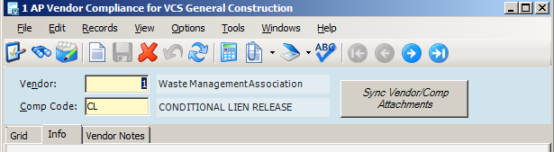

When a user clicks the *Sync Vendor/Comp Attachments* button, the process will

1. Compare the attachments for the active record (in the above example, Vendor 1, Compliance Code: CL) against attachments present in other Vendor/Compliance Code records within other AP Companies sharing the same Vendor Group
   1. If the active record has one or more attached files that are not present in the other records, the process will add those attachments to the other records, and return an appropriate message to the user.
      1. See the messages below.

All records have at least one attachment, and they all match.   
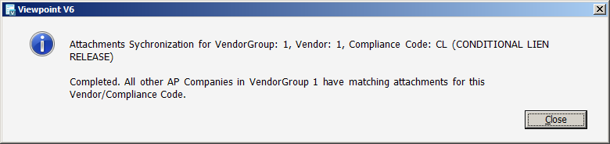

The active record has no attachments.  
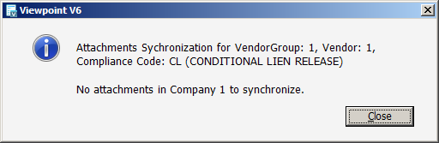

The active record has one attachment added (other records do not have the document attached).  
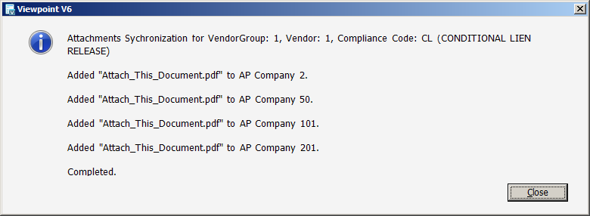

The active record has more than one attachment added (other records do not have any of the documents attached).  
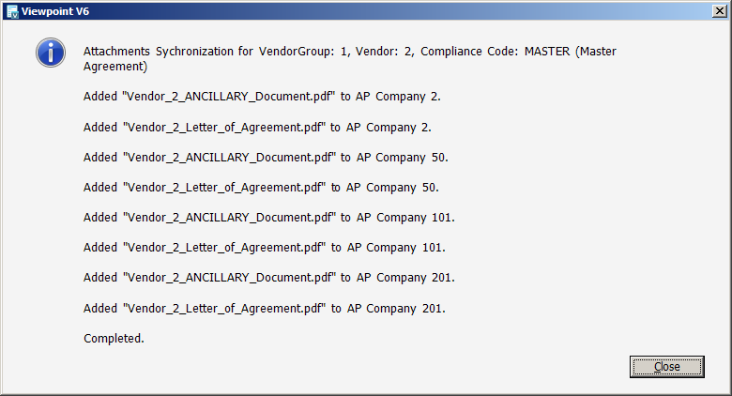

The active record has a document attached, and an entry for one other company has that document attached but the other records do not. Only records who needed the attachment added will get it and be reported back.  
