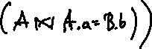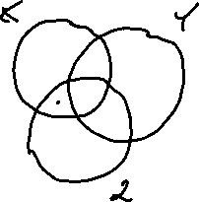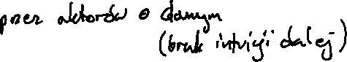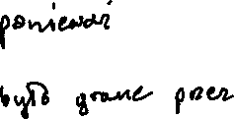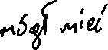

gamma directors.first_name, directors.last_name; COUNT(actors.id) →

ids (((directors⨝directors.id=movies_directors.director_id movies_directors)

⨝roles)

⨝roles.actor_id=actors.id actors)

