**University of Nevada Las Vegas. Department of Electrical and Computer Engineering Laboratories.**

|  |  |  |  |  |  |
| --- | --- | --- | --- | --- | --- |
| Class: | **CPE300L - Digital System Architecture and Design Lab** | | | Semester: | **Fall 2025** |
|  | | | | | |
| Points |  | Document author: | **Darryll Mckoy** | | |
|  | Author's email: | **Mckoyd1@unlv.nevada.edu** | | |
|  | | | |
| Document topic: | **Postlab 3** | | |
| Instructor's comments: | | | | | |

1. **Hours spent on this lab**

About 10 hours (could not get the DE2 usb blaster to work)

1. **Reaction timer black box diagram**

1. **Reaction timer block diagram**

1. **System Verilog code and submodules**

Reaction sv code (reaction.sv)

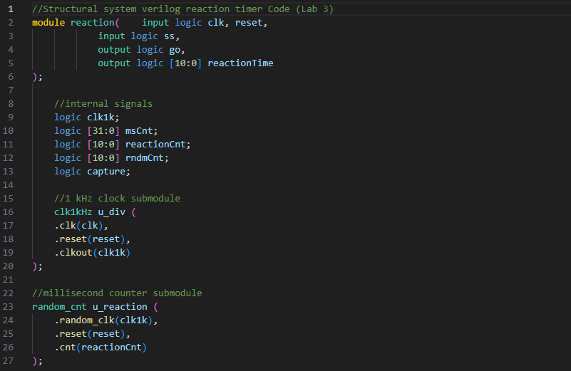

1kHz clock sv code (clk1kHz.sv)

Random counter sv code (random_cnt.sv)

Reaction FSM code (reaction_FSM.sv)

Reaction timer testbench (testbench_reaction.sv)

1. **Reaction timer simulated waveform**

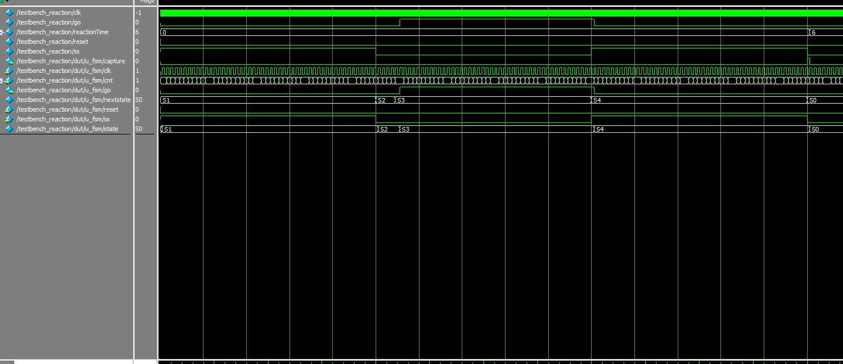

1. **Screenshot of binary reaction time on DE2-115 board**

**Video demonstration:** [**https://youtu.be/7MMEMc39STY?si=XSUWIVGCfESqhqm5**](https://youtu.be/7MMEMc39STY?si=XSUWIVGCfESqhqm5)

1. **Feedback**

Would recommend a video demonstration or screenshots of expected outcomes on DE2 board within the assignment instruction PDF.