University of Nevada Las Vegas. Department of Electrical and Computer Engineering Laboratories.
Class: | CPE300L - Digital System Architecture and Design Lab |  |  | Semester: | Fall 2025
Points |  | Document author: | Darryll Mckoy
 |  | Author's email: | mckoyd1@unlv.nevada.edu
 |  | Document topic: | Postlab 9
Instructor's comments:

- Time required to complete this lab
This lab took around 12 hours.

2. Multicycle processor box diagram

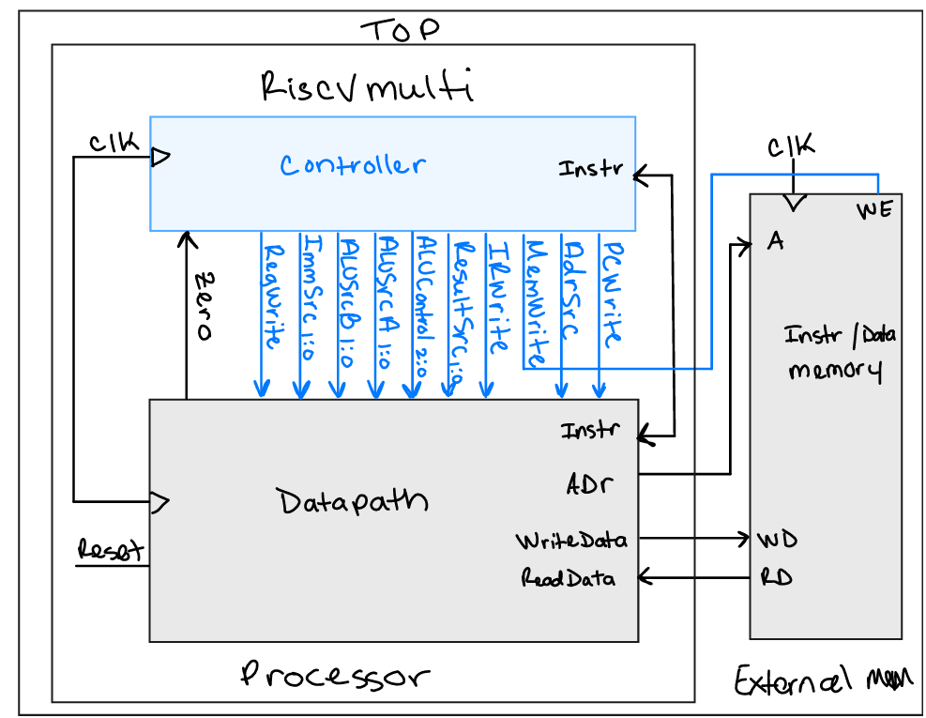
3. Hierarchical SystemVerilog code of top-level processor module (and submodules)

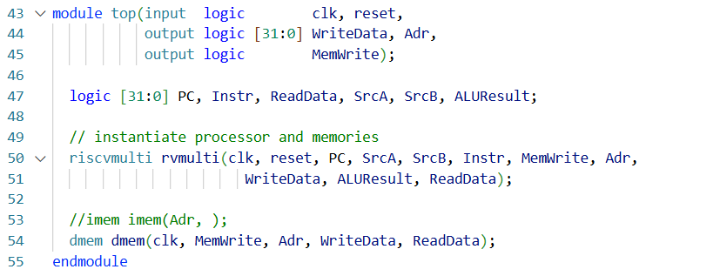

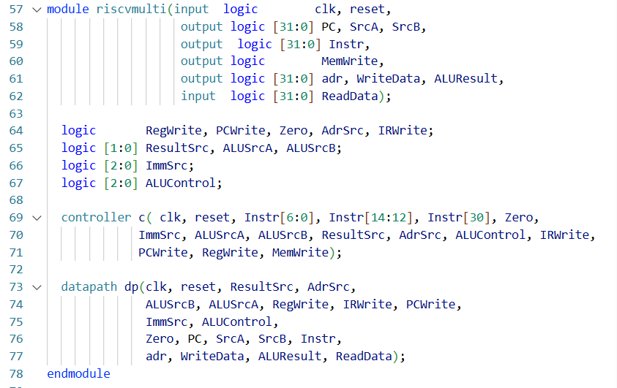

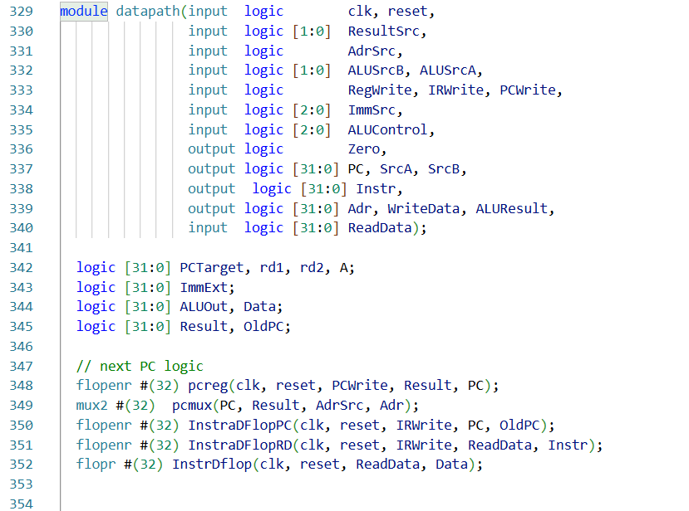
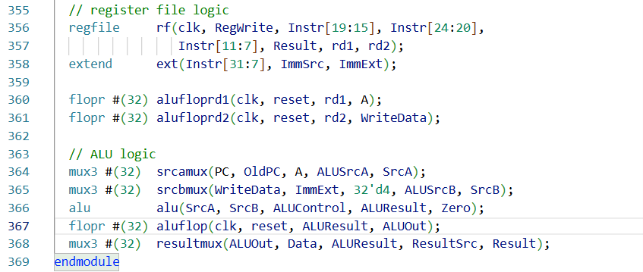

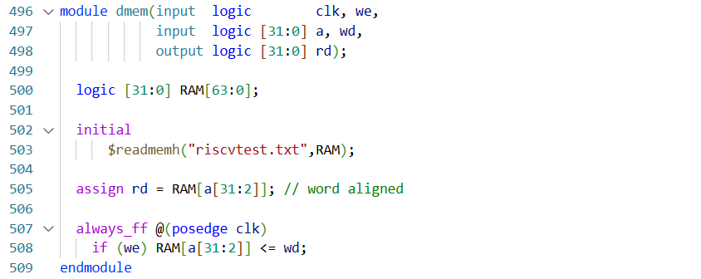

GitHub link to full code:
https://github.com/mckoyd1/CPE300L/blob/main/CPE300L_PostLab9/riscvmulti.sv

4. Table 1 showing key signals for at least the first three instructions

Step | PC | Instr | State | Result | Result Notes
1 | 00 | 00000000 | S0: Fetch | 00000004
2 | 04 | 00500113 | S1: Decode | 00000005
2 | 04 | “ “ | S8: ExecuteI | 00000005
2 | 04 | “ “ | S7: ALUWB | X
2 | 04 | “ “ | S0: Fetch | 00000008
3 | 08 | 00c00193 | S1: Decode | 00c00000
3 | 08 | “ “ | S8: ExecuteI | 00c00000
3 | 08 | “ “ | S7: ALUWB | X
3 | 08 | “ “ | S0: Fetch | 00000004
4 | 0c | FF718393 | S1: Decode | Ff718008
4 | 0c | “ “ | S8: ExecuteI | 00318000
4 | 0c | “ “ | S7: ALUWB | X
4 | 0c | “ “ | S0: Fetch | 00000010

5. Simulation Waveforms

