Clase5_ejemplo

# Quarto

Quarto enables you to weave together content and executable code into a finished document. To learn more about Quarto see <https://quarto.org>.

### Running Code

When you click the **Render** button a document will be generated that includes both content and the output of embedded code. You can embed code like this:

1 + 1

[1] 2

You can add options to executable code like this

#|  
  
library(ggplot2)  
  
cars<-cars  
  
cars |>   
 ggplot() +  
 geom_point(aes(x = speed, y = dist)) +  
 labs(x = "Velocidad (millas/h)", y = "Distancia de frenado (pies)")

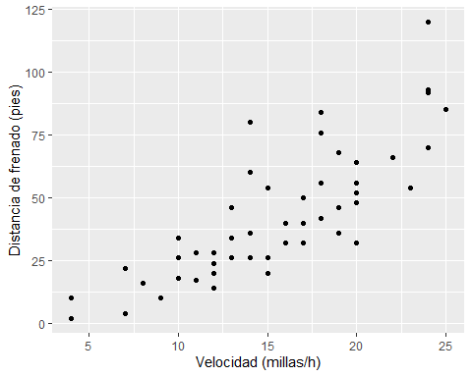

The echo: false option disables the printing of code (only output is displayed).