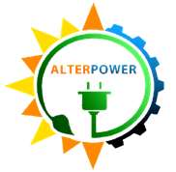  ALTERPOWER  DIGOS SOLAR INC. | EQUIPMENT INCIDENT REPORT | ADSI-2026-001
 |  | Revision Code: 0 | Page 1 of 2
Section: INVERTER SUPPORT |  | Revision Date:
Subject: CATASTROPHIC BUSBAR FAILURE AND FIRE ON INVERTER 19 |  | Effectivity Date:

Equipment: | Inverters 19 and 20
Brand / Serial No.: | INGECON SUN 920TL X360 (SN: 400152A17R20 and 400152A17R80)
Location: | Block 10
Date of Failure: | August 07, 2026
Reported by: | Engr. Gerie May R. Rivas – Operations Engineer
Action Taken by: | Engr. Clariden D. Montaño – Inverter Engineer

EXECUTIVE SUMMARY
On August 07, 2026 (Friday), a severe, localized fire occurred inside Cabinet 1 (the DCAC Supply Module) of Inverter 19, resulting in the total destruction of the main AC breaker and surrounding components. The fire was triggered by extreme heat (thermal runaway) and a subsequent phase-to-ground arc fault on the Line 2 busbar. The fault caused a massive electrical surge into the shared grounding, which correctly triggered protective alarm code 0200H on Inverter 19 and caused the neighboring Inverter 20 to trip protectively without sustaining any damage. The primary root cause has been identified as the accelerated loosening of the bolted connection on the Line 2 busbar driven by extreme environmental thermal cycling and operational micro-vibrations. This degradation was further compounded by severe seismic shear stress from a Magnitude 7.0 earthquake on August 5, 2026. Ultimately, the ensuing degradation progressed undetected due to critical gaps in the site's legacy Preventive Maintenance System (PMS), specifically the absence of physical torque checks and Infrared (IR) thermal scanning.

A. INCIDENT TIMELINE & RESPONSE
- At approximately 1208H, Engr. Gerie May Rivas, the assigned Operations Engineer verbally reported to Inverter Engineer Engr. Clariden Montaño that multiple inverters were displaying alarms on the Inverter Monitoring Dashboard. The sequence began with a 0200H (Ground Fault) alarm on Inverters 19 and 20, immediately followed by cascading alarms across other units.
- At 1210H, INCOMER 2 tripped protectively, safely isolating Block Stations 10 and 11 from the grid. Approximately two minutes later, the plant’s main Auxiliary Power Supply also tripped. This cascaded into a plant-wide power interruption, causing the entire inverter field to de-synchronize.
- At 1212H, the emergency response team arrived at the incident location. Upon arrival, the team immediately observed that Cabinet 1 of Inverter 19 was actively emitting smoke and fire.

Maintenance personnel were instantly directed to de-energize RMU 10 to achieve complete electrical isolation of Block 10. Engr. Clariden, Engr. Gerie and Engr. Froilan led the fire suppression efforts, safely securing the unaffected Power Blocks (Cabinets 2-4) before fully extinguishing the fire at its epicenter in Cabinet 1.
- By 1227H, the fire was successfully suppressed. Engr. Clariden and Engr. Gerie returned to the Main Control Room (MCR) to assist with the plant-wide power restoration. After ensuring all field lines were clear and safe, the team reset the main breaker of the Auxiliary Power Supply. Auxiliary power was successfully restored, allowing the unaffected field inverters to re-synchronize and resume generation.
- Simultaneously, Engr. Froilan directed the Maintenance Team to achieve absolute mechanical isolation of Inverter 19. This was executed by physically disconnecting the XLPE cables linking Inverter 19 to the Low Voltage (LV) side of the transformer. This critical step ensured that the neighboring Inverter 20 could safely and independently resume operation once the block was re-energized. The physical isolation procedures were completed by 1538H, concluding the day's emergency response with only Inverter 19 remaining offline.

B. EQUIPMENT DAMAGE & CURRENT STATUS
During the post-incident inspection, the engineering team successfully identified the exact epicenter of the fire. The Line 2 (Phase B) busbar, located on the input side of the 1600A main AC Breaker, was completely melted. The remaining two phase lines also sustained severe secondary damage.

- The major components in Cabinet 1 of Inverter 19 were severely damaged or destroyed:

Inverter No. | Affected Parts | Remarks
Inverter 19 | ABB 1600A AC Breaker and Busbars | Totally burnt and melted
 | DC Switch Isolator | Burnt/non-functional
 | Common Mode Choke / CMC Filters | Burnt
 | Thermal Breakers | Burnt
 | AC Cables and Control Signal Wiring | Burnt/Melted
 | Surge Protection Devices | Burnt
 | Cooling Fans | Burnt/Totally Damaged

(Note: All electronic devices and electrical components within Cabinet 1 are irreparable. The structural integrity of the cabinet itself has been compromised by the extreme heat, making it unsafe to simply install new replacement parts. The entire cabinet module requires replacement).

- Current Status:
- Inverter 19: Remains completely mechanically and electrically isolated from the plant's system.
- Inverter 20: Fully operational. It was safely brought back online on the same day following the absolute mechanical isolation of Inverter 19.
- Photographic Evidence: The following images document the physical aftermath of the fire incident inside Cabinet 1 of Inverter 19.

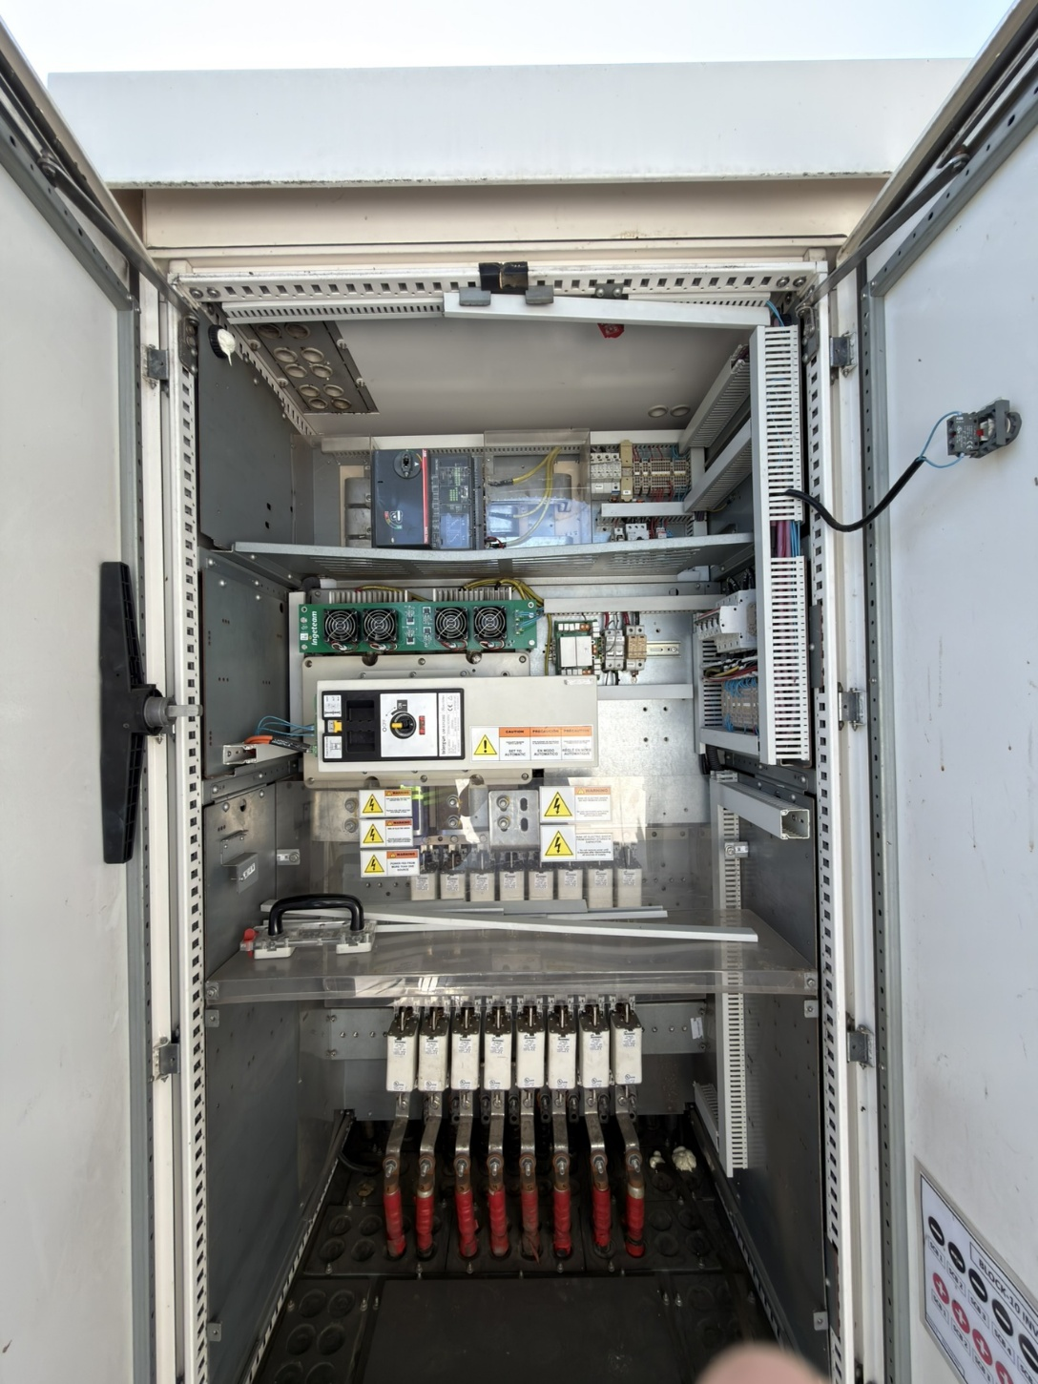  DC SWITCH ISOLATOR | 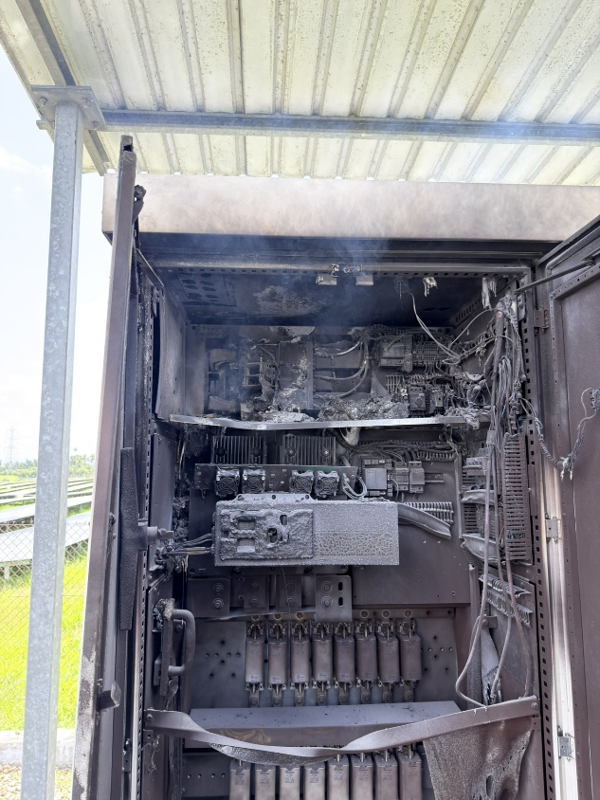  ABB 1600A AC BREAKER
INVERTER 19 CABINET 1:
Displays the extensive damage to the major components inside Cabinet 1, showing both before and after the fire incident.
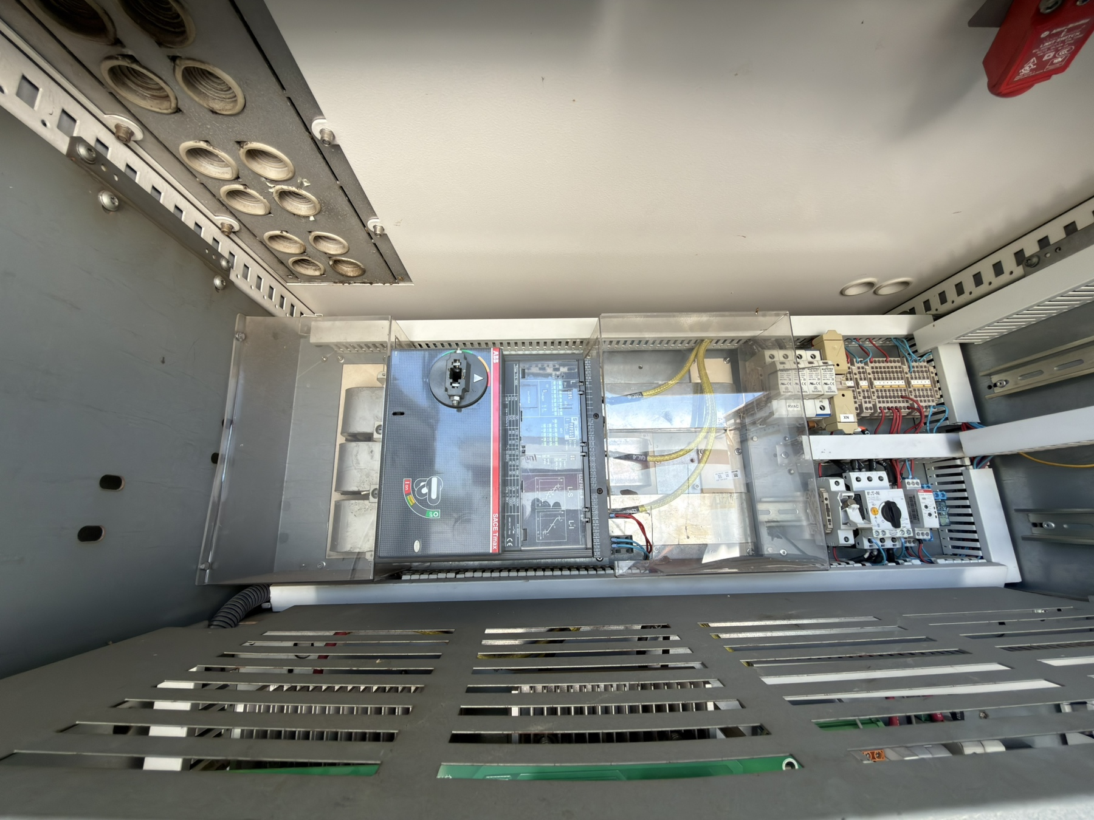  LINE 3  LINE 2  LINE 1 | 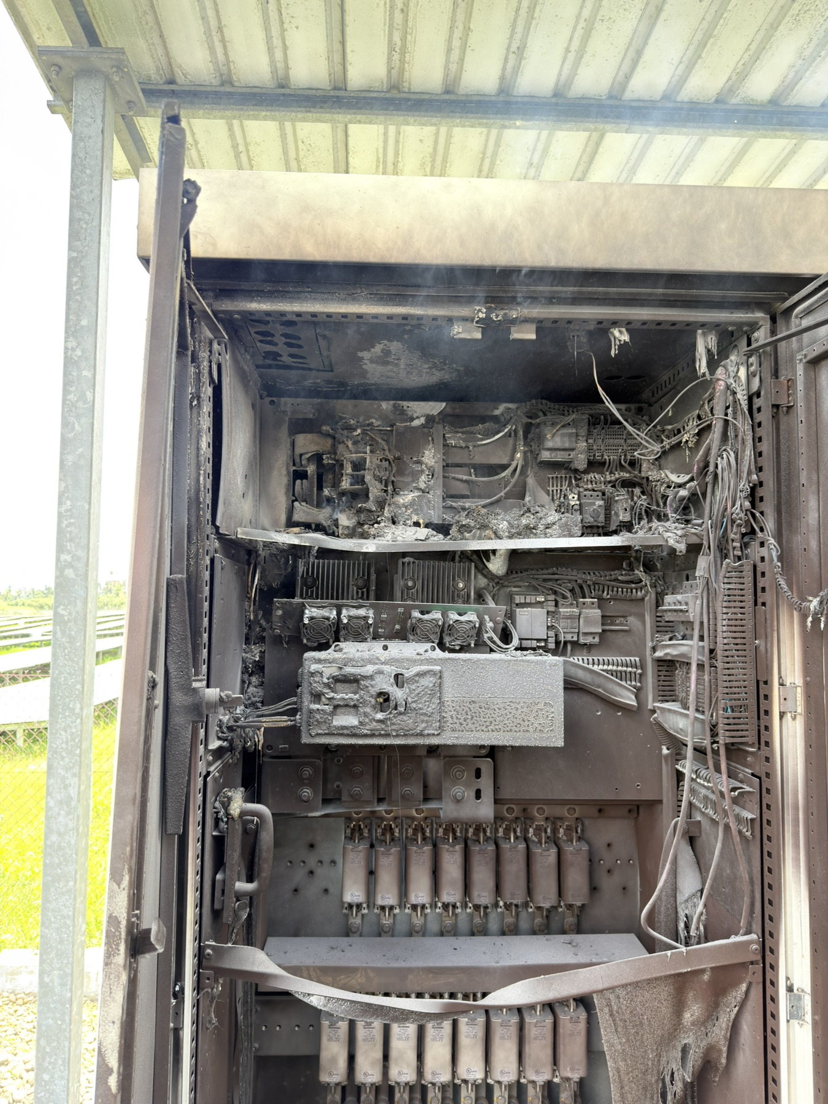
AC BUSBARS AND ABB 1600A BREAKER
Before and after views showing the total melting and disconnection of the Line 2 busbar—the identified epicenter of the fire.

C. ROOT CAUSE ANALYSIS (RCA)
A comprehensive Root Cause Analysis was performed to determine why the Line 2 busbar failed so catastrophically.

- Findings
Initial engineering analysis indicates that severe environmental thermal cycling (the continuous expansion and contraction of the metal joint due to extreme daily temperature swings) combined with standard operational micro-vibrations induced rapid, unpredictable mechanical fatigue on the bolted L2 busbar connection.

This mechanical loosening was severely compounded by a confirmed Magnitude 7.0 earthquake that struck the region on August 5, 2026, merely 48 hours before the fire incident. The low-frequency seismic waves caused extreme lateral and vertical shear stress on the heavy, rigid copper busbars, further accelerating the loss of torque on the already degrading joint.

This sudden loss of clamping pressure created an abnormally high-resistance joint, resulting in extreme localized heating (I²R losses/resistive loss). Because the site's legacy maintenance standards only mandated visual inspection of torque markings and lacked thermal scanning, this severe internal degradation was allowed to progress undetected until the melting busbar bridged the air gap to the grounded metal cabinet enclosure. This massive surge of fault current into the earth ground instantly triggered the 0200H GFCI alarm on Inverter 19. Furthermore, because both inverters are connected to the same transformer block and share a common ground network, this sudden ground surge caused the neighboring Inverter 20 to accurately detect the ground fault and trip protectively.

- Conclusion
While environmental thermal cycling and recent seismic events acted as the mechanical catalysts that loosened the joint, a critical finding of this investigation is the inadequacy of the legacy Preventive Maintenance System (PMS) inherited from previous site engineering teams. The inherited PMS relied exclusively on visual torque mark inspections, which are physically incapable of detecting internal clamping pressure loss. Furthermore, the complete lack of Infrared (IR) thermal scanning meant there was no mechanism to detect the extreme localized heating before it escalated to an arc fault. The failure is therefore attributed to severe environmental stress (thermal and seismic) compounded by fundamentally flawed legacy visual-only inspection procedures.

- Supporting Analytical Model: The "5 Whys"
To formally validate the root cause, a 5-Whys analysis was conducted:

- Why did Inverter 19 catch fire?
Because the Line 2 busbar experienced extreme localized heating (thermal runaway) and struck a phase-to-ground arc fault.
- Why did the busbar experience extreme localized heating?
Because the bolted connection on the main AC breaker developed an abnormally high electrical resistance.
- Why did the connection develop high resistance?
Because the mechanical clamping pressure holding the joint together was lost.
- Why was the clamping pressure lost?
Because the metal suffered rapid mechanical fatigue driven by extreme environmental thermal cycling and operational micro-vibrations, which was significantly compounded by shear stress from the Magnitude 7.0 earthquake on August 5, 2026.
- Why wasn't this loss of pressure detected before the fire? (ROOT CAUSE)
Because the legacy Preventive Maintenance System (PMS) was fundamentally inadequate, relying solely on visual torque mark inspections and entirely omitting critical diagnostic tools like physical torque wrenching and IR thermal scanning.

D. CORRECTIVE & PREVENTIVE ACTIONS (CAPA)
To restore operations and prevent future occurrences across the fleet, the following actions have been mandated:
- Corrective Actions:

Inverter Relocation:
As replacing only Cabinet 1 is unfeasible, Inverter 19 will be entirely replaced by relocating Inverter 14 (currently situated at Block 7). Inverter 14 currently has the lowest generation output due to incomplete String Combiner Boxes (SCBs) and operating with only 2 power blocks (nodes).

Component Salvage & Optimization

Prior to the fire, Inverter 19 operated with a complete set of power blocks. The healthy power blocks from the unaffected cabinets of Inverter 19 will be safely salvaged.

These nodes will be strategically installed into other active inverters across the plant that are currently operating with incomplete power blocks, thereby recovering and optimizing overall plant generation capacity.

Preventive Actions:

Enhanced Preventive Maintenance Schedule (PMS):

Update the official site PMS checklist to include mandatory Infrared (IR) thermal scanning of all major inverter busbars and connection points while the units are operating under load (>70%).

Accelerated Torque Verification:

Deploy the maintenance team to proactively verify and retighten the torque on all QAC breaker connections for all other inverters on site using a calibrated torque wrench, counteracting any weather/seismic-related mechanical loosening.

Prepared by: Reviewed by: Approved by:
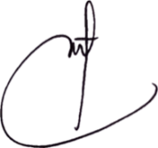
ENGR. CLARIDEN D. MONTAÑO ENGR. RHETT M. L. AYLLON ENGR. JOHN L. COLOSO
Inverter Engineer O&M / Plant Manager Operations Head

