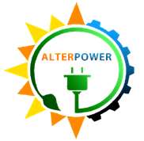  ALTERPOWER  DIGOS SOLAR INC. | EQUIPMENT INCIDENT REPORT | ADSI-2026-001
 |  | Revision Code: 0 | Page 1 of 2
Section: INVERTER SUPPORT |  | Revision Date:
Subject: BUSBAR FAILURE AND FIRE ON INVERTER 19 |  | Effectivity Date:

Equipment: | Inverters 19
Brand / Serial No.: | INGECON SUN 920TL X360 (SN: 400152A17R20)
Location: | Block 10
Date of Failure: | August 07, 2026
Reported by: | Engr. Gerie May R. Rivas – Operations Engineer
Action Taken by: | Engr. Clariden D. Montaño – Inverter Engineer

EXECUTIVE SUMMARY

A. INCIDENT TIMELINE & RESPONSE
- 1208H: Engr. Gerie May Rivas, the assigned Operations Engineer, verbally reported to Inverter Engineer Engr. Clariden Montaño that multiple inverters were displaying alarms on the Inverter Monitoring Dashboard. The sequence began with a 0200H (Ground Fault) alarm on Inverters 19 and 20, immediately followed by cascading alarms across other units.
- 1209H: Engr. Clariden informed Engr. Froilan of the Maintenance Team about the alarms. Subsequently, Head Security Guard Randell Frasco reported to Engr. Froilan that Inverter 19 was actively emitting smoke and had caught fire. Guard Frasco also noted hearing an unusual loud humming/buzzing sound from Block Station 10 just prior to the fire.
- 1210H: INCOMER 2 tripped protectively, safely isolating Block Stations 10 and 11 from the grid. Approximately two minutes later, the plant’s main Auxiliary Power Supply also tripped. This cascaded into a plant-wide power interruption, causing the entire inverter field to de-synchronize.
- 1212H: Emergency response team arrived on-site and confirmed Cabinet 1 of Inverter 19 actively emitting smoke and fire. RMU 10 was instantly manually switched off to achieve complete electrical isolation of Block 10. Engr. Clariden, Engr. Gerie, and Engr. Froilan executed fire suppression. Fire successfully suppressed.
- 1227H: Engr. Clariden and Engr. Gerie returned to the Main Control Room (MCR). Team verified all field lines clear and safe, then reset the main breaker of the Auxiliary Power Supply. Auxiliary power restored; unaffected field inverters re-synchronized and resumed generation.
- 1230H: Simultaneously, Engr. Maurice Anton directed Engr. Froilan to lead the Maintenance Team in completely isolating Inverter 19 from the plant's system by removing the cables linking Inverter 19 to Transformer 10. The physical isolation procedures were completed by 1538H, concluding the day's emergency response with only Inverter 19 remaining offline.

B. EQUIPMENT DAMAGE & CURRENT STATUS
During the post-incident inspection, the operations team has identified that the high voltage busbar was completely burned and melted, which points to the cause of the fire and smoke.

- The major components affected by the fire:

Inverter No. | Affected Parts | Remarks
Inverter 19 | ABB 1600A AC Breaker and Busbars | Totally burnt and melted
 | DC Switch Isolator | Burnt/non-functional
 | Common Mode Choke / CMC Filters | Burnt
 | Thermal Breakers | Burnt
 | AC Cables and Control Signal Wiring | Burnt/Melted
 | Surge Protection Devices | Burnt
 | Cooling Fans | Burnt/Totally Damaged

- Current Status:
- Inverter 19: Remains completely mechanically and electrically isolated from the plant's system.
- Inverter 20: Fully operational. It was safely brought back online on the same day following the absolute mechanical isolation of Inverter 19.
- Photographic Evidence: The following images document the physical aftermath of the fire incident inside Cabinet 1 of Inverter 19.

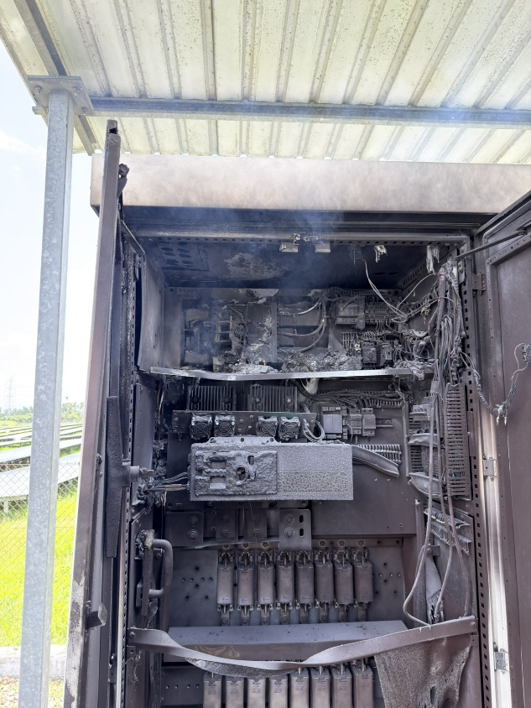
ABB 1600A AC BREAKER
INVERTER 19 CABINET 1:
Displays the extensive damage to the major components inside Cabinet 1 especially the AC Circuit Breaker.
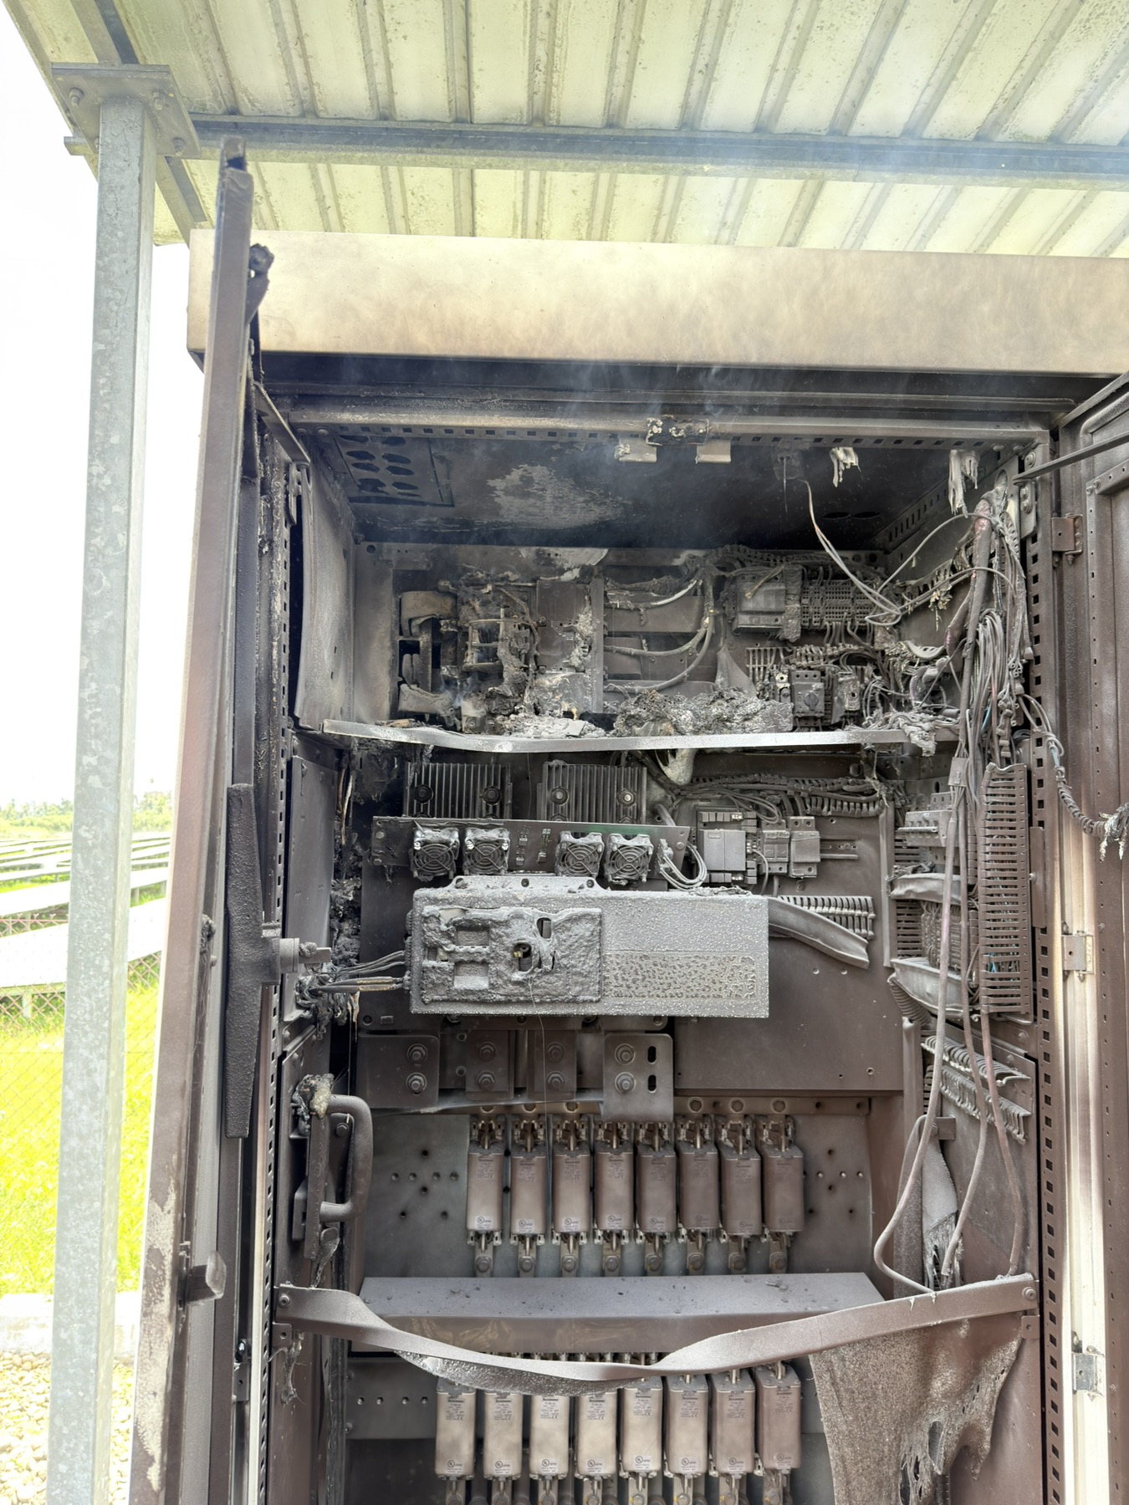
LINE 3 (PHASE C)
LINE 1 (PHASE A)
LINE 2 (PHASE B)
AC BUSBARS AND ABB 1600A BREAKER
Showing the total melting and disconnection of the busbars.

C. ROOT CAUSE ANALYSIS (RCA)
A comprehensive Root Cause Analysis was performed to determine why the busbars failed.

- Findings
Initial plant’s operations and maintenance analysis indicates that the fire originated at the connection points between the busbars and the main AC breaker due to extreme heating (thermal runaway). This thermal runaway was the direct result of abnormally high electrical resistance developing at these bolted connections.
The high electrical resistance was caused by the bolted connections becoming loose over time. This mechanical loosening is attributed to a combination of continuous environmental thermal cycling and standard operational micro-vibrations. Furthermore, this degradation was worsened by an Intensity 2 earthquake felt in Digos City (originating from a Magnitude 7.0 earthquake with its epicenter in Sarangani) on August 5, 2026, which contributed to the loosening of the connections prior to the incident.

- Conclusion
The root cause of the fire in Inverter 19 was the loosening of the bolted connections at the AC breaker, which led to high electrical resistance and subsequent severe localized heating. This loosening was driven by natural environmental thermal cycling and operational micro-vibrations, compounded by the recent seismic activity (Intensity 2 earthquake) on August 5, 2026.
- Supporting Analytical Model: The "5 Whys"
To formally validate the root cause, a 5-Whys analysis was conducted:

- Why did Inverter 19 catch fire?
- Because the busbars experienced extreme heating.
- Why did the busbar experience extreme heating?
- Because the connection points of the busbars and the AC breaker had an abnormally high electrical resistance.
- Why did the connection develop high resistance?
- The high resistance developed potentially due to loose connections (bolted connections).
- Why were the bolted connections potentially loose? (ROOT CAUSE)
- Due to environmental thermal cycling, operational micro-vibrations, and an Intensity 2 earthquake in Digos City (originating from a Magnitude 7.0 epicenter in Sarangani) on August 5, 2026.

D. CORRECTIVE & PREVENTIVE ACTIONS (CAPA)
To restore normal operations and prevent future occurrences across the plant’s inverters, the following actions have been mandated:
- Corrective Actions
- Immediate Joint Rehabilitation:
If any thermal degradation is detected, immediately de-energize the unit, clean the affected bolted connections, and re-terminate using new hardware torqued to manufacturer specifications.

- Preventive Actions

Post-Earthquake Torque Verification:

Immediately deploy the maintenance team to conduct a comprehensive, out-of-cycle torque verification on all main AC breaker bolted connections across the remaining field inverters to ensure no other units suffered vibration-induced loosening.

Enhanced Diagnostic Scanning:

To ensure early detection of high electrical resistance at bolted joints before it escalates to extreme heating, the site will increase the frequency of standard Infrared (IR) thermal scanning and physical torque inspections on all major high-voltage connection points from quarterly to monthly.

Prepared by: Reviewed by: Approved by:
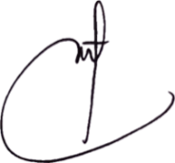
ENGR. CLARIDEN D. MONTAÑO ENGR. RHETT M. L. AYLLON ENGR. JOHN L. COLOSO
Inverter Engineer O&M / Plant Manager Operations Head

