CTI Website SPMP

Prepared By:

Matthew Clark

6/27/2021

Project Scope

Customer – CTI Underground. Business: Irrigation, and lighting

Customer would like a website built for the company.

The website will consist of several static web pages and an additional interactive feature, allowing users to book specified appointments with the CTI (my client)

The website will contain 3 pages:

1. Home page

2. Gallery

3. Schedule Appointment

The homepage will contain the following sections:

1. About us

2. Services

3. Contact information

The Gallery will contain pictures of client’s homes, previous projects and other photos related to the work the company provides

The Schedule appointment will contain a feature that allows customers to schedule several types of appointments as early as 3 days and as late as 2 months out from the current date.

The types of the appointments are

1. Lighting installation evaluation– 1 hour

2. Irrigation installation evaluation – 1 hour

3. Lighting maintenance – 30 min

4. Irrigation maintenance – 30 min

This feature will be connected to the scheduling service that the customer (CTI) uses. Customers will be able to see what times are open/closed.Upon scheduling an appointment customers must agree that their appointment has the potential to be moved (they will be contacted via phone call if that is the case).

Table Of Contents

**1 Introduction** **4**

1.1 Project Overview 4

1.2 Project Deliverables 4

1.3 Evolution of SPMP 4

1.4 Reference Material 4

1.5 Definitions and Acronyms 5

**2 Project Organization** **5**

2.1 Process Model 5

2.2 Organizational Structure 5

2.3 Organizational Interfaces 6

2.4 Project Responsibilities 6

**3 Managerial Process** **6**

3.1 Management Objectives and Priorities 6

3.2 Assumptions, Dependencies and Constraints 6

3.3 Risk Management: 7

3.4 Monitoring and Controlling Mechanisms 7

**4 Technical Process** **7**

4.1 Methods, Tools and Techniques 7

4.2 Software Documentation 7

4.3 Project Support Functions 8

**5 Description of Work Packages** **8**

# 1 Introduction

## 1.1 Project Overview

I have been tasked with providing an interactive website for my former company, CTI underground.

## 1.2 Project Deliverables

Tool selection

Domain Name Selection

Hosting Space

Website Design

Appointment plugin implementation

Testing

Product Review and Demonstration to client

Completion of Final of Product

## 1.3 Evolution of SPMP

Anticipate changes: I expect changes to the look and layout of the website will be changed

Unanticipated changes:The use of the appointment feature’

## 1.4 Reference Material

<https://www.youtube.com/watch?v=Z1ND4HeGj3o>

<https://www.youtube.com/watch?v=oELnKi_avMc>

<https://www.springsirrigation.com/>

<https://affordable-lawn-irrigation-services-inc.business.site/>

Your Powerpoints

## 1.5 Definitions and Acronyms

* SPMP - Software Project Management Plan
* UI - User Interface
* HTML - Hypertext Markup Language
* CSS - Cascading Style Sheets
* JS - JavaScript
* SQL - Structured Query Language
* WBS - Work Breakdown Structure

# 2 Project Organization

## 2.1 Process Model

The project was initiated on June 7, 2021 and terminated with a submission deadline of July 26th. Major milestones are the Design and tool selection Review (June 30th), The Client Project Review (July 16th) and the System Test Procedure (July 23)

The process model used for this project will be an Agile model that will allow us to have an iterative approach which will allow us to focus on the code rather than the design.

## 2.2 Organizational Structure

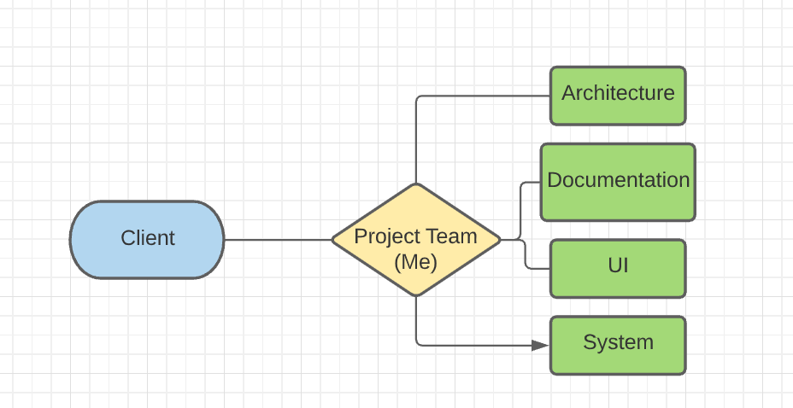

## 2.3 Organizational Interfaces

* GitHub
* GoDaddy
* Host Gator
* WordPress
* Easy Appointments

## 2.4 Project Responsibilities

This project is being completed by a single individual. Therefore all responsibility lies within that single individual.

# 3 Managerial Process

## 3.1 Management Objectives and Priorities

The philosophy adopted by management within this project relies on the relationship between client and developer. In this case, the relationship is strong. This is because both client and developer know each other and have worked together on a personal level. Since there's only one developer on the project, communication between developer and client is very transparent.

The process is divided into two objectives within this project, which is priorities and requirements. These requirements include a website built meant to market the work of the client's business and feature allowing for users to book appointments . However, the priority of management is to ensure fluidity within the website and a simple process when the user wishes to book an appointment . In regards to the schedule, I am aiming to complete the website with functionality by 7/26. The management group is aiming to stay under $250 for this project as a budget.

## 3.2 Assumptions, Dependencies and Constraints

External Events:

Busy schedule on the clients end

I would consider external workloads coming from sources such as school (the group project) and my day job

The only two constraints the project faces is the time frame in which it must be completed, and the budget allocated for this project.

## 3.3 Risk Management:

Risk: lack of experience with wordpress and web design process

Contingency: There is a plenty of information on the internet providing a basis for creating and implementing a functional website in wordpress

Risk:Compatibility issues with the client’s scheduling software and account

Contingency: A more compatible software could be used however, this is not as desired for the client

## 3.4 Monitoring and Controlling Mechanisms

Weekly phone meeting with my client in regards to any reports or issues

# 

# 4 Technical Process

## 4.1 Methods, Tools and Techniques

I will be using WordPress as a content management system. To my knowledge The backend part consists of PHP and MySQL. The frontend consists of CSS, Javascript, HTML

## 4.2 Software Documentation

ReadMe Documentation will be included in core file repositories, along with thorough documentation of the software development process. Standard coding practices will be implemented as well.

## 4.3 Project Support Functions

* Plans (at least) the following project support functions.
  + Plan to ensure quality assurance
    - Document tests to make sure edge cases are fulfilled

# 5 Description of Work Packages

## 5.1 WBS Chart

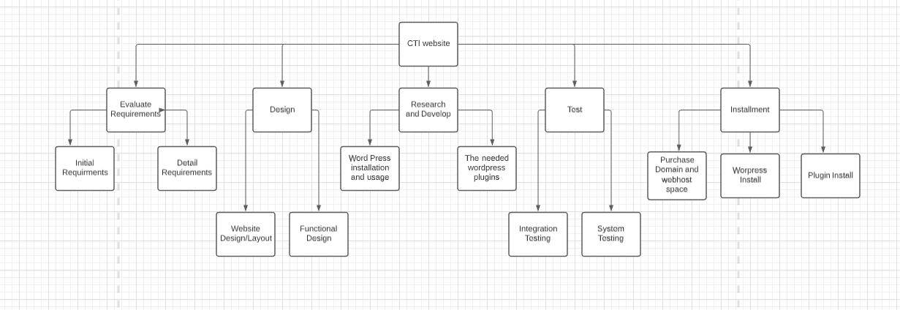

## 5.2 Gantt Chart

