Your problem will have different numbers. Here is my problem.

A conical container of radius 10’ and height 40’ is filled to a height of 36’ of a liquid weighing 62.4 pounds per cubic feet.

1. How much work will it take to pump the liquid to the rim?
2. How much will it take to pump the liquid to a level of 3 feet above the cone’s rim?

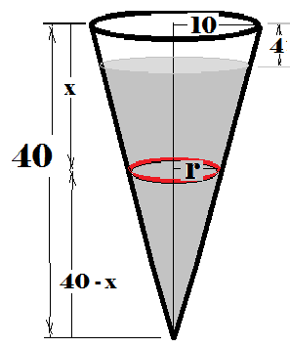

What we need to do is to lift the wt of a nickel, dx thick a distance of x.

Area \* thickness \* #/cubic ft = 

To get rid or r, we use similar triangles , or r = . Thus 2405648 ft-lbs = W = 

The nickels start at x = 4 and continue until x = 40.

To lift it 3 feet above the rim, w = 