Mathematics 1441 L, Fall 2013 Test 2 Dr. Bruce McLean Name___________________

1. The graph of the function, f, is shown below where the dotted line, y = 3 is an asymptote. The domain of f is [-6, +oo).

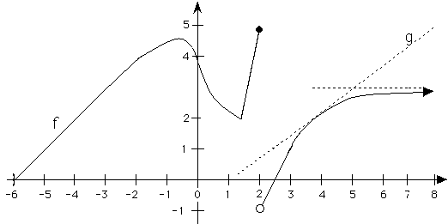

1.

|  |  |
| --- | --- |
| a) Where is the x-coordinate of the absolute maximum? | b) Write down the x coordinate of all critical points. |
| c) Where are the local minimum(s)? | d) Approximate [f(x)g(x)]’ when x = 4. |
| e) Where is f decreasing? |  |

2. Find f '(x) where .

3. If , only on [5, 10],

a) find g’(x),

b) find the average rate of change of g on [5, 10], and.

c) find the x that makes your answer to a) the same as your answer to b).

4. Find h '(x) if .

5. If  , evaluate .

6. Let 

1. Find s’(x).
2. Find s’().

7. Suppose that a body moves on a coordinate line such that it has position

s(t) = .

a) Find the critical points.

b) Use the 1st or 2nd derivative test to classify your critical points as relative maximum, relative minimum or neither.

c) Where is s increasing?

.

d) Find all values of t when the body stops ( velocity = 0 ).

8. Consider . Write the equation of the line tangent to the graph of h when x = 2.

9. Suppose . Use implicit differentiation to find  at the point (1, 2).

10. Find where the absolute max. and absolute min. of g(x) =  are on [2,5].

DO 11 i) or 11 ii)

11 i) . V = I R describes the number of volts when I in amps and R in ohms are known.

a) If none of the values are constant, write a relationship that describes how the volts change,, in terms of the way current and resistance change at different values of I and R.

1. If I is increasing at amps per sec while R is decreasing at 1 ohm per second when I = 2 and R = 3, find .

11 ii). Suppose a police helicopter is flying East at 120 mph at a constant altitude of 3 miles. Her radar gun hits a thief in an automobile traveling West and measures -76 mph. Find the actual speed of the thief when the radar gun is 5 miles from the thief.

