Mathematics 1441 F, Fall 2013 Test 2 Dr. Bruce McLean Name___________________

1. The graph of the function, f, is shown below where the dotted line, y = 3 is an asymptote. The domain of f is [-6, +oo).

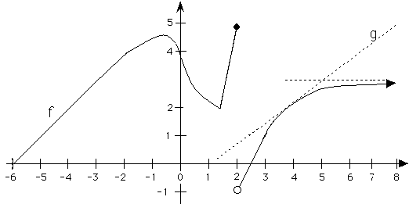

1.

|  |  |
| --- | --- |
| a) Write down the x coordinate of  all local maximums? | b) Write down the x coordinate of all critical points. |
| c) Where are the local minimum(s)? | d) Approximate []’ when x = 4. |
| e) Where is f increasing? |  |

2. Find f '(x) where .

3. If g(x) =  only on [0, 2], find

a) g '(x),

b) the average rate of change on [0, 2], and

\c) the x where your answer to a) equals your answer to b).

4. Find h '(x) if .

5. If  , evaluate .

6. Let 

1. Find s’(x).
2. Find s’().

7. Suppose that a body moves on a coordinate line such that it has position

s(t) = .

a) Find the critical points.

b) Use the 1st or 2nd derivative test to classify your critical points as relative maximum, relative minimum or neither.

c) Where is s increasing?

.

d) Find all values of t when the body stops ( velocity = 0 ).

8. Consider . Write the equation of the line tangent to the graph of h when

x = 3.

9. Suppose . Use implicit differentiation to find  at the point (1, 2).

10. Find where the absolute max. and absolute min. of g(x) =  are on [2,5].

DO 11 i) or 11 ii)

11. i) Suppose a pulley on a dock is always 50 feet above a ring on a boat and a rope goes over the pulley and is attached to the ring. If the owner is pulling the rope at 1.5 feet per second over the pulley when x = 120 feet, find the speed of the boat in the water approaching the dock.

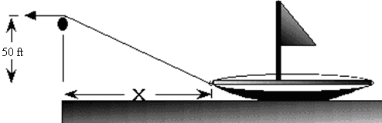

11 ii). The mathematical equation for Boyle's law in a given system is: , where

*p* denotes the [pressure](http://en.wikipedia.org/wiki/Pressure) of the system.

*V* denotes the [volume](http://en.wikipedia.org/wiki/Volume) of the gas.

1. Differentiate Boyle’s law implicitly where p and V are functions of t.
2. If p = 1.5 pounds per sq. inch and increasing at 0.3 pounds per sec, how fast is V changing?
3. Is V increasing or decreasing?