MATH 1441_I Test 3 April 10, 2013 Name _________________________

1. Evaluate 

2. Given that , , and .

Find:

a) 

b) 

c) 

3. Solve the initial value problem,  There are infinitely many functions that might work, but I want the only one that passes through ( , 2).

4. Find the following indefinite integrals.



 🡪You will need to do some algebra here first.



 🡪Factor and try a trigonometric identity on this one.



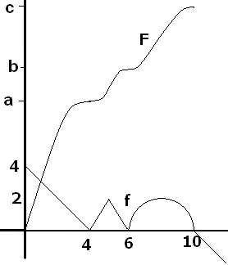

5. F is an antiderivative of f(x) on [0, 10] and f(x) is differentiable on [0, 12] except at 4, 5, 6, and 10. The equation of f on [6, 10] is that of the upper half of a perfect circle centered at (8, 0).

a) f has infinitely many antiderivatives, so draw one that is different than F.

b) Evaluate .

c) Evaluate the value of a on the y-axis, given F(4) = a.

d) Evaluate given that the triangular region is similar to the one over [0, 4].

e) Find F’(2).

f) Evaluate 

g) If partitioning [0, 4] into 4 subintervals of equal length, find an approximation to the area under f on [0, 4] using right endpoints in the Riemann sum which is also a lower sum.

7. Show all of your work and evaluate



8. The post office will accept a package if the length plus the girth equals 120 inches. If you ship a box with a square base, find the dimensions of the box that will maximize the volume.

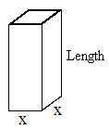

1. You are designing a rectangular bill board to contain a total of 1000 square inches of printing and border. If there is a 4 inch margin at the top and bottom and a 2 inch margin on each side. What overall dimensions will maximize the printed area?

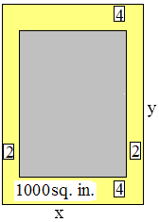

1. Find the c in [0, 2] guaranteed by the MVT for the differentiable function,

Y =





1. Find the critical values. Find where f is increasing.
2. Find the inflection points Find where f is concave up.
3. Classify the critical values as local max, local min, or neither and prove your answer.
4. Graph f [See p 207 of your text book. What is the domain? Show that f is neither even nor odd.
5. Where are the asymptotes?