MATH 1441_I Test 3 April 10, 2013 Name _________________________

1. Evaluate 

2. Given that , , and .

Find:

a) 

b) 

c) 

3. Solve the initial value problem,  There are infinitely many functions that might work, but I want the only one that passes through ( , 2).

4. Find the following indefinite integrals.



 🡪You will need to do some algebra here first.



 🡪Factor and try a trigonometric identity on this one.



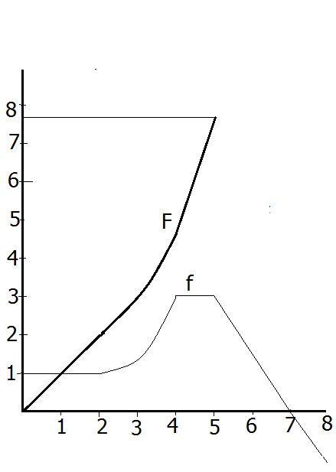

5. F is an antiderivative of f(x) on [0, 5] and f(x) is differentiable on [0, 8] except at 4, and 5. Note that f(5) = 3 and F(5) = 7 and 2/3

a) f has infinitely many antiderivatives, so draw one that is different than F.

b) Evaluate using geometry.

c) Evaluate using the fundamental theorem of calculus.

d) Find F’(4).

e) Evaluate 

f) If partitioning [3, 7] into 4 subintervals of equal length, find an approximation to the area under f on [3, 7] using right endpoints in the Riemann sum.

g) Find the c in [0, 4] guaranteed by the mean value theorem for the function f.

6. Show all of your work and evaluate



7. You are to build an open top box with a square base that holds 500 cubic millimeters. Find x so that the area of the bottom and 4 sides is a minimum.

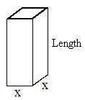

1. You are designing a 5000 square ft. rectangular addition to K-Mart, using the existing wall as one side. Find x that minimizes the new perimeter.

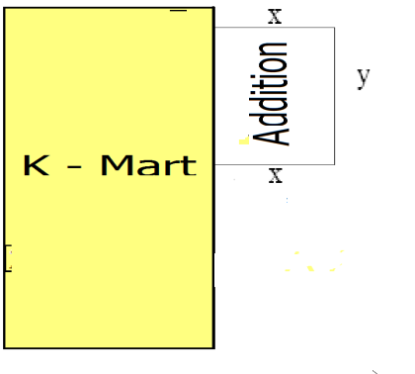

1. Find the c in [0, 2] guaranteed by the MVT for the differentiable function, 
2. We will give you the derivative after it is factored.



1. Find the critical values. Find where f is increasing.
2. Find the inflection points Find where f is concave up.
3. Classify the critical values as local max, local min, or neither and prove your answer.