Dr. McLean Test 1 Calculus I February 19, 2014 Name _____________________

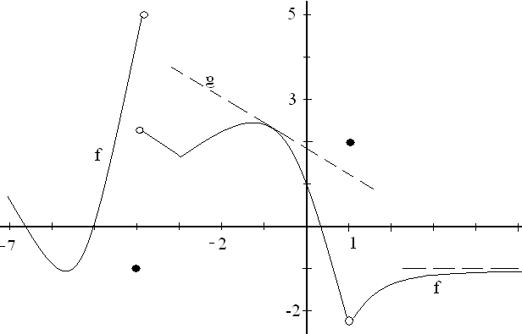

1. The function graphed above, called f, is defined on  . There is an asymptote at

y = -1 and g is a line tangent to the graph of f at the point (-0.9, 2.3).

|  |  |
| --- | --- |
| a)What is the first reason that f is not continuous at x = 1? | b) Guess at f ‘(2), the derivative of f when x = 2. |
| c) What is the range of the function f? | d) Write the equation of the function g. |
| e) Approximate. | f) List all values of x for which f is not continuous at x. |
| g) Evaluate . | h) Evaluate . |

2. Find the average rate of change of on [-1, 3].

3. Show your work and evaluate .

4. Evaluate .

5. Show your work and evaluate 

6. Evaluate .

7. Using only the **definition** of derivative, find f ‘(x) if f(x) = 2x2.

8. Using well known theorems, differentiate each of the following.

1. f(x) = 
2. g(x) = 
3. h(x) = 
4. j(x) = 
5. k(x) = 

9. If a particle travels according to s(t) = , find

a) all t’s when the particle is stopped, ( first derivative is zero ) and

b) t when the acceleration is 3 ft/sec2. ( s’’(t) = 3 )

2 - 2 if -2 < x < 0

10. Define m(x) = 1 if x = 0

2 cos(x) if 0 < x < 2

1. Graph m.
2. State the first reason m is not continuous at x = 0.

c) Evaluate 

11. Write the equation of the line tangent to the graph of y = when x=1.

12. Evaluate 