Survey of Calculus sample test 2 Dr. McLean Name _________________________

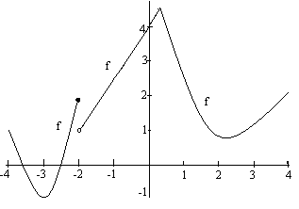

1. The above is the entire graph of a function k. If you can’t see the graph, it is not there. The graph is drawn to scale. The domain of k is [-4, 4] and is differentiable at every point except two and the two endpoints.

a) Where is the absolute maximum? b) Where are the relative minimums?

c) Approximate k'(-1). d) Where are the critical points?

e) Where is k'(x) < 0? f) Where is k concave up?  
g) What is the range of k?

2. Differentiate y = .

3. The weekly cost function for Lincoln Records in pressing x compact discs is

C(x) = -0.0002 x2 + 4x + 2000 on [0, 40000]

1. Find the critical point of the function.
2. Find where the cost function is decreasing.
3. Find the marginal cost function.
4. Find C ' (1000) and explain it’s significance.
5. Find the average cost function, .
6. Find the marginal average cost function.

4. Returning to problem 3 above, suppose we sell the discs for $4.70 each.

a) What is the revenue function?

b) What is the profit function?

5. Find where the absolute maximum and the absolute minimum occur of the function

y =  on [-1, 5].

6. If g(x) = , find the equation of the line tangent to the graph of g at the point

(5, 4).

7. If f(x) = , find the derivative of f.

8. Suppose . Use implicit differentiation to find  at the point

(1, 1).

9. Suppose f(x) = x3 /3 – 2x2 +3 x + 12 on all of the real numbers.

a) Find the critical points.

b) Use the 1st or 2nd derivative test to classify your critical points as relative maximum, relative minimum or neither.

c) Where is f increasing?

d) Find the inflection point and state where f is concave up?

10. If f(x) = , find f’(x).

11. If g(x) = , find g’(x).

12. The number of internet users in China is approximated by N(t) = .(t=1 is 2005)

a) How many Chinese users were there in 2010?

b) Sketch the graph of N(t).

13. Use logarithms to solve for x. a)  b) .