Concavity Problem #2 First Part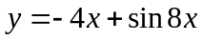 For the inflection points, we look at the graph and notice a switch in concavity close to – ¼, 0 and ¼ . To find out exactly where we will differentiate twice and set y’’ = 0 and then solve for x. 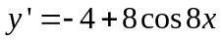 and 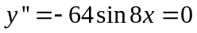when sin(8x)=0. Now sin t =0 when t = -π, t=0, or t = π . Also at other multiples of π but we only need 3 places.
Thus 8x = - π, 0, or π . This happens when x = - π /8, 0, or π /8.
We should also check to see that concavity switches there. These were the x coordinates of answer b) on my homework.
Second Part Find the local max. Graphically it looks like x = 1/10. To find it exactly, set the first derivative to zero and solve for x. = 0 so 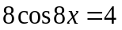of 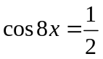. Now we know cos t = ½ when t =- π /3 or π /3 and other places that we do not need. Replacing t with 8x we get x = - π /24 or π/24. Now graph these points and check y’ in the 3 regions.
------- - π /24 ------ π /24 ------ 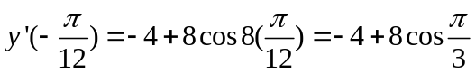<0
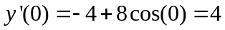>0 and similarly, y’(π /12) <0.
Thus decreasing followed by increasing followed by decreasing
proves x = (-π /24) is the location of the local minimum and
x = (π /24) is the location of the local maximum.

