MATH 1441 Dr. McLean Final Exam 12/7/2009 Name ____________
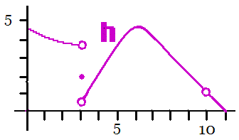
1. The entire graph of h is seen above.
a) For which x, does h not have a limit at x?
b) Where does h have a local maximum?
c) Estimate h’(2).
d) Approximate 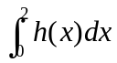.
e) Estimate 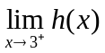.
f) Name a reason why h is not continuous at x = 10.
2. Evaluate | a) 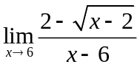
b) 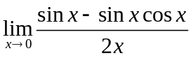 | c) 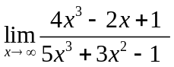
3. Using only the definition of derivative, differentiate f(x) = .

4. Write the equation of the line tangent to the graph of f(x) = 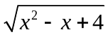when x = 1.
5. Find g '(x) if 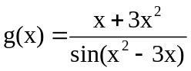.

6. Find h '(x) if 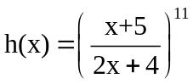.

7. Find 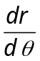if 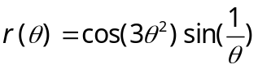.

8. A ball is thrown straight up and the height is always s(t) = -16t² + 80t + 6 on [0,6]. | a) How high did the ball go? | b) Find the acceleration when t = 1.

9. Suppose . Use implicit differentiation to find 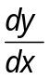.

10. If ,
(a) Find the critical points.
(b) Identify the critical points as local max, local min, or neither.
(c)Prove you’re answer to (c ) is correct using the first or second derivative test.
(d) Where is y concave up?

11. If , find the c guaranteed by the MVT on [0, 3].

12. Let R be a rectangular box sitting on the x-axis underneath the parabola
y = - 5x² + 7 as shown. Find x so that the area of the rectangle is a maximum. Then use the first or second derivative test to prove that it is a local maximum.
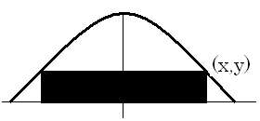
13. Find the area of the region shown in Q I bounded by  y = - 5x² + 7 , y = 2 and x=0. | 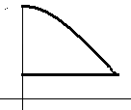

14. Find the average height of y from problem 13.

15. Find an antiderivative of y’ = 5 sec 2x tan 2x that passes through the point (0, 2).

16. Show your work and evaluate 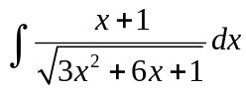.

17. Show your work and evaluate 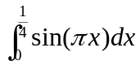.

18. Find the volume when the region is revolved about the y-axis. The region is bounded by the y-axis, y=cos(x²) and y = sin(x²). |  | 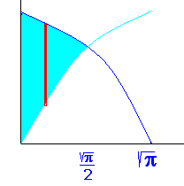
19. Revolve the region about the x-axis and calculate the volume using the washer method. The region is bounded by y = 4 and y = 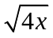 and the y-axis. | 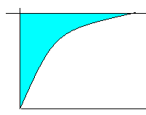

20. Suppose that it takes 20 pounds to hold a spring 3 feet beyond its natural length. Now that the spring is already stretched to 3 feet, how much work will it take to stretch that spring an additional 2 feet?

21. In an electrical circuit, E = I R, where E= 7 volts is constant. The current, I, is in amps and the resistance, R, is in ohms. Differentiate the equation, 7 = I R, implicitly remembering the product rule. One minute after the circuit is closed, I = 5 amps and the amps are increasing at the rate of 3 amps per minute. Decide if the resistance, R, is increasing or decreasing and tell me how fast it is changing.

