Mathematics 1441 I, Spring 2012 Test 2 Dr. Bruce McLean Name___________________

1. The graph of the function, f, is shown below where the dotted line, y = 3 is an asymptote. The domain of f is [-6, +oo).

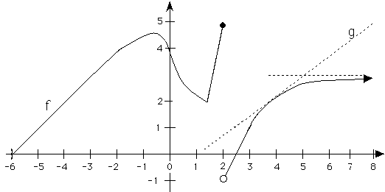
1.
a) Where is the x-coordinate of the absolute maximum? | b) Write down the x coordinate of all critical points.
c) Where is the local minimum? | d) Approximate [f(x)g(x)]’ when x = 4.

2. Find f '(x) where .

3. Find g '(x) if 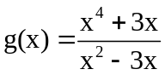.

4. Find h '(x) if 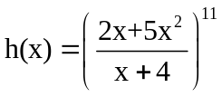.

5. If , evaluate .

6. Let 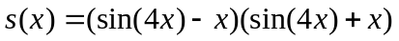
- Find s’(x).

- Find s’().

7. Suppose that a body moves on a coordinate line such that it has position
s(t) = 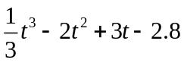.
a) Find the velocity when t = 4.

b) Find the acceleration when t = 4.

c) Find all values of t when the body stops.

8. Consider 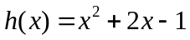. Write the equation of the line tangent to the graph of h when x = 2.

9. Suppose 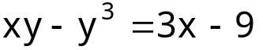. Use implicit differentiation to find 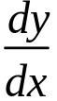 at the point (1, 2).

10. Find where the absolute max. and absolute min. of g(x) = 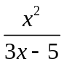 are on [2,5].

11. V = I R describes the number of volts when I in amps and R in ohms are known.
a) If none of the values are constant, write a relationship that describes how the volts change,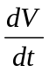, in terms of the way current and resistance change at different values of I and R.

- If I is increasing at amps per sec while R is decreasing at 1 ohm per second when I = 2 and R = 3, find .

12. Suppose a police helicopter is flying East at 120 mph at a constant altitude of 3 miles. Her radar gun hits a thief in an automobile traveling West and measures -76 mph. Find the actual speed of the thief when the radar gun is 5 miles from the thief.
