Mathematics 1441 O, Spring 2012 Test 2 Dr. Bruce McLean Name___________________

1. The graph of the function, f, is shown below where the dotted line, y = 3 is an asymptote. The domain of f is [-6, +oo).

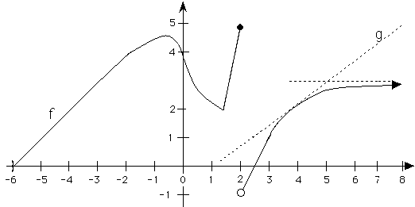

1.
a) Write down the x coordinate of  all local maximums? | b) Write down the x coordinate of all critical points.
c) Where is the local minimum? | d) Approximate [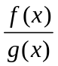]’ when x = 4.

2. Find f '(x) where .

3. Find g '(x) if 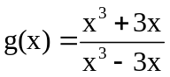.

4. Find h '(x) if 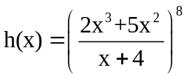.

5. If , evaluate .

5. Let 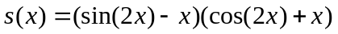

- Find s’(x).

- Find s’().

7. Suppose that a body moves on a coordinate line such that it has position
s(t) = 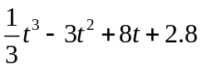.
a) Find the velocity when t = 4.

b) Find the acceleration when t = 4.

c) Find all values of t when the body stops.

8. Consider 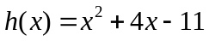. Write the equation of the line tangent to the graph of h when x = 3.

9. Suppose . Use implicit differentiation to find 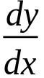 at the point (1, 2).
10. Find where the absolute max. and absolute min. of g(x) = 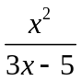 are on [2,5].

11. Suppose a pulley on a dock is always 50 feet above a ring on a boat and a rope goes over the pulley and is attached to the ring. If the owner is pulling the rope at 1.5 feet per second over the pulley when x = 120 feet, find the speed of the boat in the water approaching the dock.
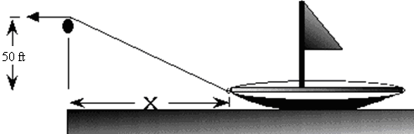

12. The mathematical equation for Boyle's law in a given system is: 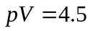, where
p denotes the pressure of the system.
V denotes the volume of the gas.
- Differentiate Boyle’s law implicitly where p and V are functions of t.
- If p = 1.5 pounds per sq. inch and increasing at 0.3 pounds per sec, how fast is V changing?
- Is V increasing or decreasing?

