Test 2 Calculus I Dr. McLean March 7, 2014 Name _____________

1. Find 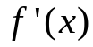 if 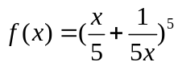.

2. Find 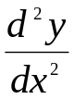, the second derivative of y with respect to x if y = 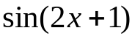.

3. Find if 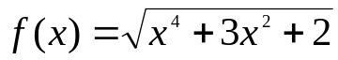

4. Find y’ implicitly if 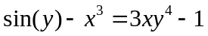 at the point (1, 0).

5. If 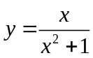 on [0, 5] only, find y’ and then the location of the absolute maximum and the absolute minimum.

Do 6. or 7.

6. The volume of a pine tree is related to the radius of its trunk and its height by V = 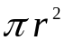H. Suppose the radius is increasing at the rate of 2 cm per year and the height is growing at 3 cm per year. Find how fast the volume is changing when the radius is 40 cm and the height is 800 cm. You must differentiate implicitly and use the product rule on this one.

7. Suppose a pulley on a dock is always 50 feet above a ring on a boat and a rope goes over the pulley and is attached to the ring. If the owner is pulling the rope at 1.5 feet per second over the pulley when x = 120 feet, find the speed of the boat in the water approaching the dock.
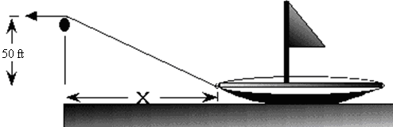

8. Find if 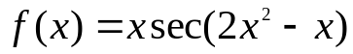.

9. If 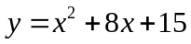 on [0, 2], find the c in (0, 2) guaranteed by the Mean Value Theorem.

10. If y = 1/3 x³ - 2 x² + 4x,
a) find the critical points,
b) find where y is increasing,
c) find all local maximums, and minimums, and
d) prove your answers to c) are correct using the first or second derivative test.
e) Where is y concave down?

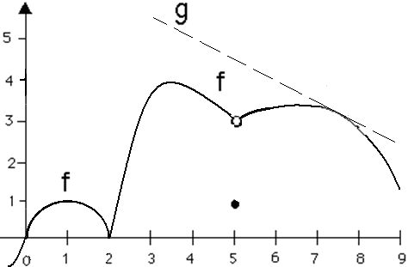

11. The domain of f is [- ½ , 9]
- Where are all of the critical points?
- Where is the absolute maximum?
- Why doesn’t the Mean Value Theorem work on [1, 3]?
- Name an a and b where Rolle’s Theorem applies.
- Where is f decreasing?
- Locate the x value of 3 local maximums.
- The line g is tangent to f at (7.5, 3.3). Write the equation of g.

