Mathematics 1441 O March 7, 2014 Dr. Bruce McLean Name ___________________

1. The graph of the function f is shown below. The domain of f is only [-1, 4.8].
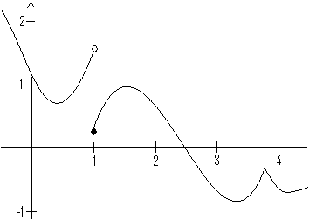
a) Where are all of the critical points?
b) Where is the absolute minimum of f?
d) Where is f concave down?
e) Where is f decreasing ?
f) Locate the x coordinate of 3 local maximums.
g) f satisfies the hypothesis of the Mean Value Theorem on [1, 3.5] so find the c guaranteed by the theorem and show how you found it geometrically on the graph.
2. If 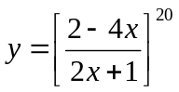, find dy/dx.

3. If 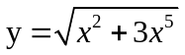, find y’.

4. If 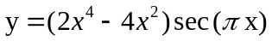, find dy/dx.

5. Find only the slope of the line tangent to the graph of 1 + 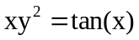 + y at the point . Do it implicitly and show your work.

6. Find where g(x) = 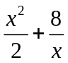 with domain [½, 4] obtains its absolute maximum and the absolute minimum and prove it by showing g’(x) and all of your work.

Do 7. or 8.

7. 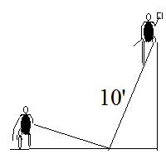
Suppose a painter stands on a ladder that is 10 feet long. Joe secretly ties a rope to the base of the ladder and starts to pull the ladder out from under the painter as shown. When the base of the ladder is 6 feet from the wall, Joe’s speed has increased to 2 feet per second. How fast is the painter falling at that instant?

8. Suppose E = I R.
a) Treat E as a product of 2 unknown functions, where none of the variables are constant, and calculate dE/dt.
b) Calculate dE/dt at the instant when the resistance R is increasing at 2 ohms per sec, the current I is decreasing at 3 amps per second, E = 12 volts, and I = 4 amps.

9. Find the c in (0,2) guaranteed by the Mean Value Theorem for the function y = 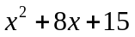on[0,2].

10. Let 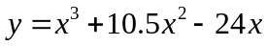 on the real number line.
a) Where are the critical values?
b) Where is y increasing?
c) Where are the local maximum and minimum?
d) Prove that they are what you say using the first or second derivative test.
e) Where is y concave up?

11. Find the second derivative of y with respect to x. y = - cos(4x – 6).

