April 9, 2007 Calculus I Chapter 4/5 Dr. McLean Name _________

2. Let R be a rectangular box sitting on the x-axis underneath the parabola y = - 5x² + 7 as shown. Find x so that the area of the rectangle is a maximum. Then use the first or second derivative test to prove that it is a maximum.
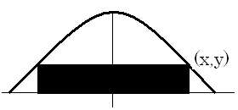

4. A particle is moving with the given acceleration, a(t) = t – 2.
Find the position of the particle if s(0) = 1 and v(0) = 3.

6. Find the antiderivatives of the following functions.
a) g(x) = 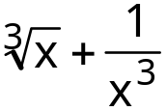
b) h(x) = 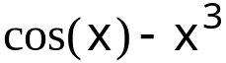

c) k(x) =sec(x) tan(x) + sec2 (x)

8.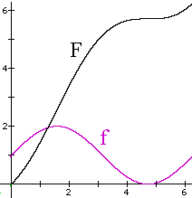
a) Given that F is an antiderivative of f, estimate 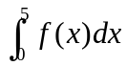.
b) Shade the area that you calculated in a) above.
c) Sketch a different antidervative of f.

9. Evaluate 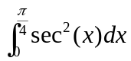.

10. Evaluate 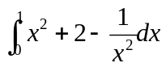
11. Evaluate 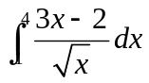

12. Approximate the area under y = 25 – x² on [0, 5] using the right endpoints of 5 equally spaced subintervals.
Is your approximation too large or too small?
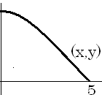

13. Consider y = 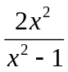. Answer the following questions.
a) What is the domain?
b) Find the x and y intercepts.
c) Find the horizontal asymptote.
d) Find the two vertical asymptotes.
e) Find the critical points and regions of increasing and decreasing.
f) Find the location of the local max and mins and prove they are what you say using the first or second derivative test.
g) Find where the curve is concave up and where it is concave down.
h) Sketch the graph.

14. 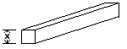The French Postal System requires that the maximum size package is length plus girth equals 6 meters. What size package with a square base will have the largest permissable volume?

15. Find the dimensions of an outside advertising board that has 2000 square feet of total area with borders as shown so the actual advertising area is a maximum.

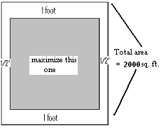
1. Evaluate 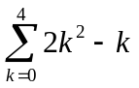

2. Given that 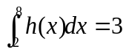, 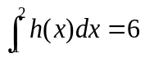, and 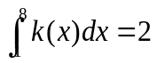.
Find:
a) 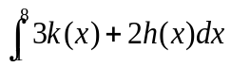
b) 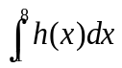
c) 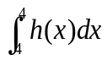

3. Solve the initial value problem, 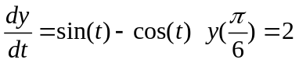 There are infinitely many functions that might work, but I want the only one that passes through ( , 2).

7. You are to build an open top box with a square base using 100 square meters of aluminum. Find x so that the volume of the box is a maximum.
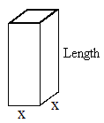

- You are designing an addition to K-Mart, using the existing wall as one side. Given that the new perimeter will be 500 feet, find x that maximizes the new area.

