Mathematics 1441, Final, Fall 2003 Dr. T. Bruce McLean Name______________

1. The graph of the function, f, is shown below. In the following, the dotted line, y = 3 is an asymptote. The function f is defined for every real number larger than or equal to - 6 . The graph of g(x) is tangent to the graph of f(x) at the point (3.8, 2).
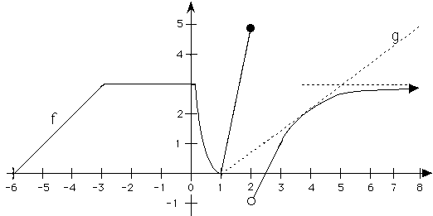
a) What is the average ht. of f on [-6, 0]? b) 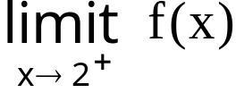 =
c)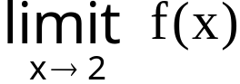 d) For what x values is f not differentiable?
e) Write the equation of g(x). f) 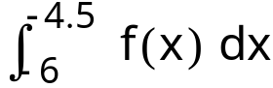 =

g) Evaluate f '(2.5). h) Where is f concave down?

i) Evaluate 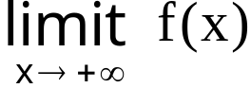.
j) Where is the c in (3, 8) guaranteed by the mean value theorem?

k) If f is the velocity fn. on [-6, 0], how far did the particle travel?
2. Rationalize the numerator and evaluate 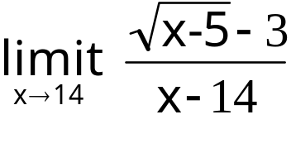 .
3. State the definition of continuity precisely. I'll start it for you.
If f is defined in an open interval I and c is in I , then f is continuous at x = c means three things:

4. Find 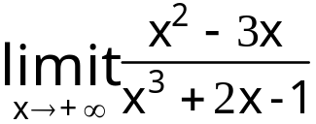 =
5. Calculate 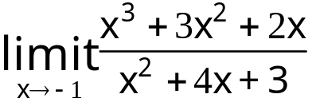.
6. Suppose a pulley on a dock is always 12 feet above a ring on a boat and a rope goes over the pulley and is attached to the ring. If the wind is blowing the boat away from the dock at 4 feet per second when x = 16 feet, find the speed of the rope going over the pulley.
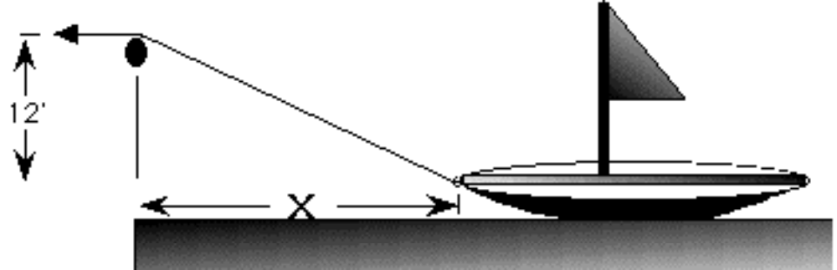

7. Find f '(x) where 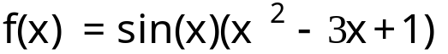.
8. Find g '(x) if 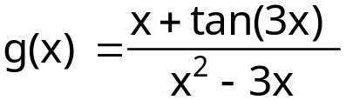.
9. Find h '(x) if 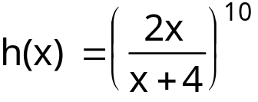.
10. Suppose 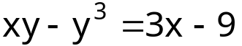.
Use implicit differentiation to find 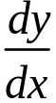 at the point (1, 2).

11. 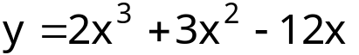
a) Find the local max and mins and the inflection point.
b) Verify you’re answer by the first or second derivative test.
d) Where is y concave up?

12. A Bulloch county farmer has 2000 feet of fence to fence off 3 sides of a rectangular piece of land along the straight Ogeechee river. If the river is the fourth side of the rectangle, what is the largest rectangular area that can be fenced?

13. Evaluate the following indefinite integrals. Remember to add C to all answers.
a) 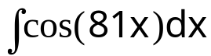
b) 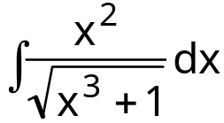
c)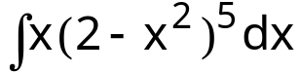
d) 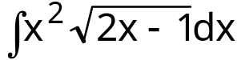
e) 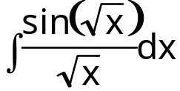
14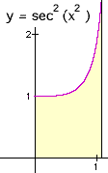Revolve this region about the y-axis. The line is x=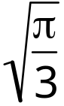. Find the volume.

15. Suppose it takes 25 pounds to hold a spring at 5 feet. How much work will it take to stretch that spring an additional 2 feet?

16. Find the average height of the function, 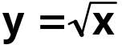 , on [0,4].

17. Find the area of the region bounded by , 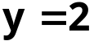, and the y-axis.
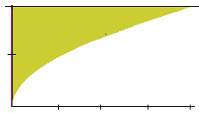

18. Revolve the following region about the x-axis and find the volume. I think the washer method is easier. This region is bounded by 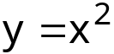 , 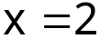, and 