Mathematics 1441, Final, Fall 2003 Dr. T. Bruce McLean Name______________

1. The graph of the function, f, is shown below. In the following, the dotted line, y = 3 is an asymptote. The function f is defined for every real number larger than or equal to - 6 . The graph of g(x) is tangent to the graph of f(x) at the point (3.8, 2).
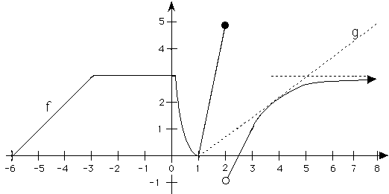
a) What is the average ht. of f on [-6, 0]? Integral from -6 to 0 divided by 6-0. = ( ½ (3)(3) + (3)(3) )/6 = 13.5/6 = 27/12 = 9/4 = 2.25
b) 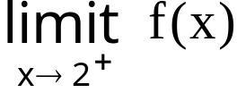 = -0.92 Note that from the other side the answer is 4.9

c)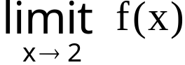 d.n.e. because the left limit, 4.9 doesn’t equal the right, -0.92
d) For what x values is f not differentiable? {-3, 0.2, 1, 2}
e) Write the equation of g(x). (y-2)/(x-3.8) = 4.8/(8-1) f) 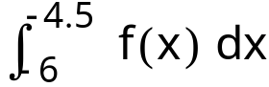 = 9/8 = ½BH = ½(3/2)(3/2) = area under 45 degree line . Note the integral from 2.1 to 2.9 is zero.

g) Evaluate f '(2.5). 2/(2-1) = 2
h) Where is f concave down? (3, +oo)

i) Evaluate 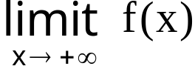.= 3
j) Where is the c in (3, 8) guaranteed by the mean value theorem?
[f(8) – f(3)]/(8 - 3) =(2.9 – 1) /5 = 0.38 Now guess where f’(c) = 0.38. I guess c = 4.9.

k) If f is the velocity fn. on [-6, 0], how far did the particle travel?
It is the area under f that we calculated earlier in 1 a), 13.5 miles.
2. Rationalize the numerator and evaluate 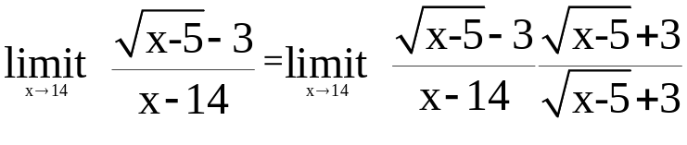 .Multiply only the numerators.
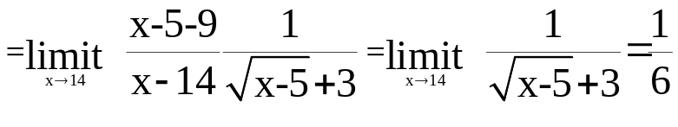
3. State the definition of continuity precisely. I'll start it for you.
If f is defined in an open interval I and c is in I , then f is continuous at x = c means three things:
- C is in the domain of f,
- 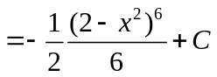exists,and
- 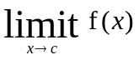= f(c)

4. Find 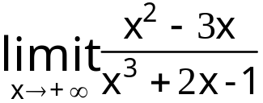 = 0
5. Calculate 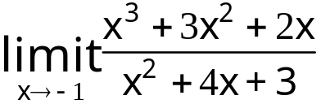.=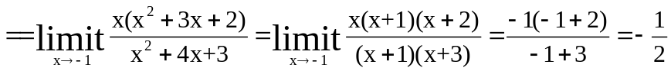after cancelling the (x+1)’s.
6. Suppose a pulley on a dock is always 12 feet above a ring on a boat and a rope goes over the pulley and is attached to the ring. If the wind is blowing the boat away from the dock at 4 feet per second when x = 16 feet, find the speed of the rope going over the pulley.
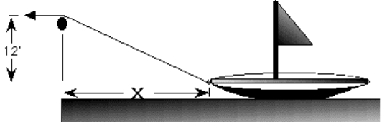

Let s be the rope. S squared =144 + x squared. Diff implicitly getting
2 S S’ = 2 x x’ or 2 (20) S’ = 2 (16) (4) or S’ = 64/20 ft/sec
7. Find f '(x) where 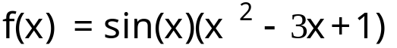.
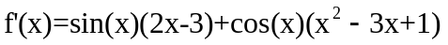
8. Find g '(x) if 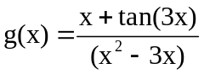
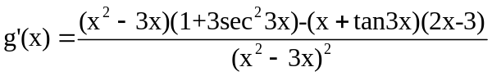.
9. Find h '(x) if 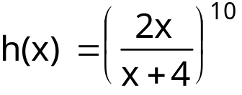.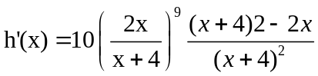
10. Suppose 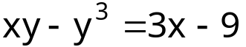. Use implicit differentiation to find 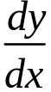 at the point (1, 2). 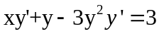 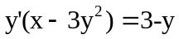 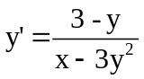At (1,2), dy/dx = (3-2)/(1- 12)= -1/11

11. 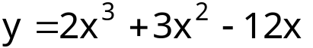y’=6x^2+6x-12=6(x^2 + x – 2) =
6(x+2)(x-1)=0 Critical pts at x = 1 or x = -2
a) Find the local max and mins and the inflection point. Max @ x=-2 Min @ x =1
b) Verify you’re answer by the first or second derivative test.
----- -2 ------ 1 -------
+ --- +
Incre decre incr
d) Where is y concave up?
y’’ = 12x +6 = 0 or x = - ½ ----- - ½ ------- Concave up (– ½ , +oo)
neg pos Concave down (-oo, - ½ )

12. A Bulloch county farmer has 2000 feet of fence to fence off 3 sides of a rectangular piece of land along the straight Ogeechee river. If the river is the fourth side of the rectangle, what is the largest rectangular area that can be fenced?
2x + y = 2000 A = x y = x(2000 – 2x) = 2000x -2x^2 A’ = 2000 – 4x = 0
X = 500

13. Evaluate the following indefinite integrals. Remember to add C to all answers.
a) 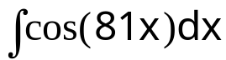 = 1 / 81 sin(81x) + C
b) 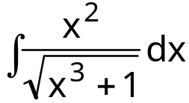= 1/3(x^3+1)^(1/2) divided br ½ + C
c)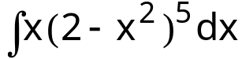 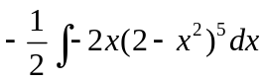
d) 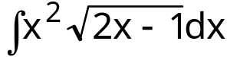Let u = 2x – 1 du = 2 dx
x = ½ u + ½ Integrate u^0.5(u^2/4 + ½ u + ¼) ½ du =
e) 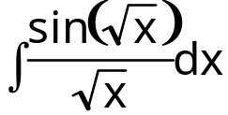= 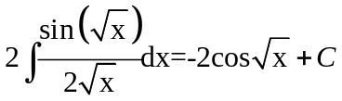
14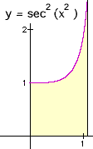Revolve this region about the y-axis. The line is x=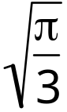. Find the volume. V = 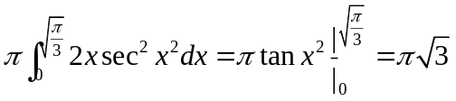

15. Suppose it takes 25 pounds to hold a spring at 5 feet. How much work will it take to stretch that spring an additional 2 feet? 25 = k 5 or k = 5
W = integrate 5x dx from 5 to 7 = 5x^2/2 from 5 to 7 = 5/2[49-25]=60 ft #

16. Find the average height of the function, 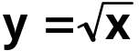 , on [0,4].
AH = integrate root x from 0 to 4 divided by (4 – 0 )= ¼ x ^3/2 divided by 3/2 from 0 to 4 = 2/12 (8)= 16/12 = 4/3
17. Find the area of the region bounded by , 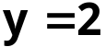, and the y-axis.
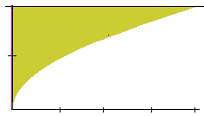
= integrate (2 – root x) dx from 0 to 4 = 2x – x^3/2 over 3/2 from 0 to 4 =
(8 – 16/3)=8/3
18. Revolve the following region about the x-axis and find the volume. I think the washer method is easier. This region is bounded by 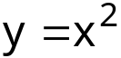 , 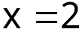, and 