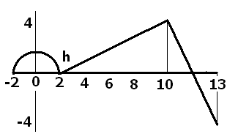
1.
a) Where are the critical points?
b) Where are the local extrema?
c) Where is the absolute max?
d) Where is the absolute min?
f) What is the average rate of change of h on [0, 13]?
g) If k(x) = h⁴(x), evaluate k’(6). Remember k’(x) = 4 h³(x)h’(x).
h) If j(x) = hºh(x) = h(h(x)), evaluate j’(8). Remember j’(x) = h’(h(x))h’(x).

2. Derivatives with the product and quotient rules.
a) If 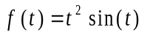, find 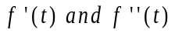.
b) If 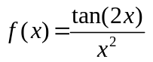, find 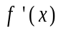.
c) Write the equation of the line tangent to the graph of 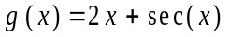 when = 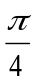.

3. Chain Rule - Differentiate each of the following.

a) 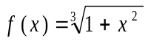

b) 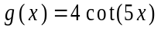

c) 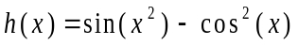
d) 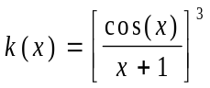

4. Use implicit differentiation to find y' for the relation 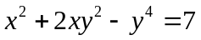. Write the equation of the tangent line and the normal line at the point (2, 1).

5. A ladder 10 feet long rests against a vertical wall. If the base of the ladder is pulled out at the rate of 1.5 feet per second away from the wall, how fast is the angle between the ladder and the wall changing when the base of the ladder is 5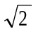 from the wall?

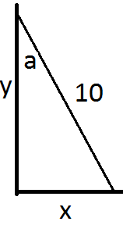
Sin(a) = x/10 so (*) Cos(a) a’ = x’/10
Since x = y, tan(a) = 1 so a = 45 degrees or pi/4 radians

Back to (*), Cos(pi/4) a’ = 1.5/10 = 0.15 feet and a’ = 0.15 root(2) = 0.15 ( 1.414)

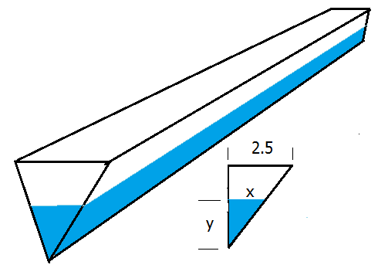
6. A trough 10 feet long has ends in the shape of an isosceles triangle that are 5 feet across the top and have a height of 4 feet. If the trough is being filled with water at the rate of 8 cubic feet per minute, how fast is the water rising in the trough when the water is 2 feet deep? Set up similar triangles. 2.5 / 4 = x / y

V = 10 BaseArea = 10( ½ b h) = 5 (2x) y = 10 x y = 10 (2.5 y/4)y = 25/4 y^2.
dV/dt = 25/2 y dy/dt
8 = 12.5(2) dy/dt so dy/dt = 8/25 = 0.32 feet / minute

8. Find the absolute max and min of g(x) = 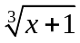 on [-2,2].

g’(x) = 1/3 (x+1)^(-2/3) times 1 = 0 never but the denominator is 0 when x+1=0.
g(-2) = -1 g(-1) = 0 and g(2) = 1 soabsolute max at x = 2 and absolute min at x = -2

