Dr. McLean Test 1 Calculus I February 19, 2014 Name _____________________
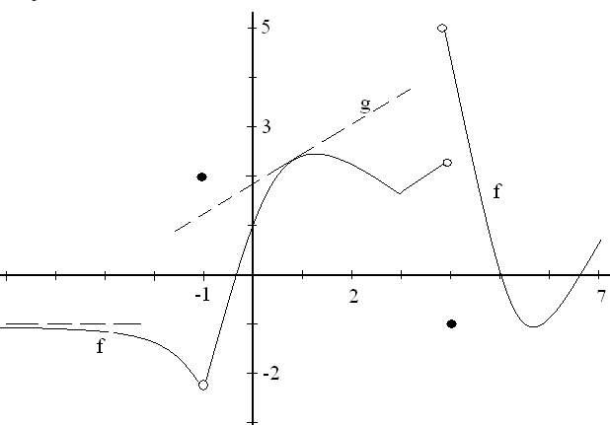
1. The function graphed above, called f, is defined on 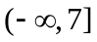 . There is an asymptote at
y = -1 and g is a line tangent to the graph of f at the point (0.9, 2.3).
a)What is the first reason that f is not continuous at x = 4? | b) Guess at f ‘(2), the derivative of f when x = 2.
c) What is the range of the function f? | d) Write the equation of the function g.
e) Approximate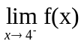. | f) List all values of x for which f is not continuous at x.
g) h) Evaluate 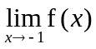. | h) Evaluate 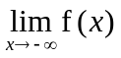.

2. Find the average rate of change of 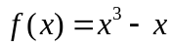on [-1, 2].

3. Show your work and evaluate 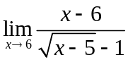.

4. Evaluate 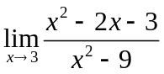.

5. Evaluate 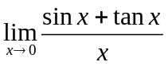

6. a) Evaluate 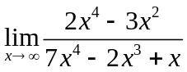
b) Evaluate 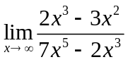.

7. a) State the definition of derivative. If f is a function, then f ‘(x) = -------------------

b) Using only the definition of derivative, find f ‘(x) if f(x) = 4 + 2x².

8. Using well known theorems, differentiate each of the following.
- f(x) = 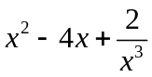

- g(x) = 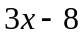

- h(x) = 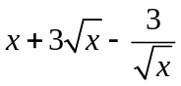

- k(x) = 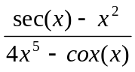

- m(x) = x cos

9.. If a particle travels according to s(t) = 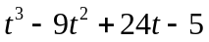, find

a) all t’s when the particle is stopped, ( first derivative is zero ) and

b) t when the acceleration is 4 ft/sec². ( s’’(t) = 4 )

2 + 2 if -2 < x < 0
10. Define m(x) = 1 if x = 0
2 cos(x) if 0 < x < 2
a) Graph m.

b) State the first reason m is not continuous at x = 0.

c) Evaluate 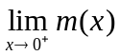

11. Write the equation of the line tangent to the graph of y = 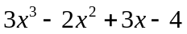when x=1.

12. Evaluate 

