Dr. McLean Test 1 Calculus I Sept. 13, 2010 Name _____________________
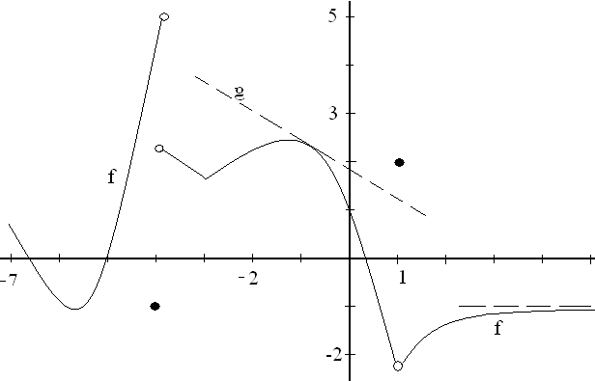
1. The function graphed above, called f, is defined on 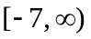 . There is an asymptote at
y = -1 and g is a line tangent to the graph of f at the point (-0.9, 2.3).
a)What is the first reason that f is not continuous at x = 1? | b) Guess at f ‘(2), the derivative of f when x = 2.
c) What is the range of the function f? | d) Write the equation of the function g.
e) Approximate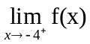. | f) List all values of x for which f is not continuous at x.
g) Evaluate 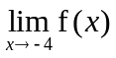. | h) Evaluate 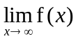.

2. Find the average rate of change of 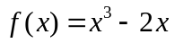on [-1, 3].

3. Show your work and evaluate 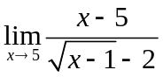.

4. Evaluate 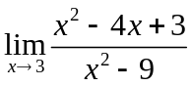.

5. Show your work and evaluate 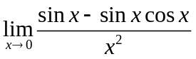
6. Evaluate 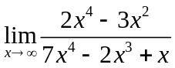.
7. Evaluate 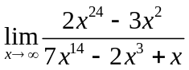.

8. State the definition of derivative. If f is a function, then f ‘(x) = -------------------

9. Using only the definition of derivative, find f ‘(x) if f(x) = x + 2x².

10. Using well known theorems, differentiate each of the following.
- f(x) = 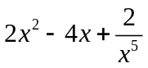

- g(x) = 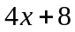

- h(x) = 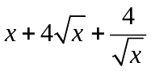
11. If a particle travels according to s(t) = 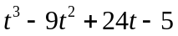, find
a) all t’s when the particle is stopped, ( first derivative is zero ) and
b) t when the acceleration is 3 ft/sec². ( s’’(t) = 3 )

2 - 2 if -2 < x < 0
12. Define m(x) = 1 if x = 0
2 cos(x) if 0 < x < 2
a) Graph m.
b) State the first reason m is not continuous at x = 0.
c) Evaluate 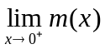

13. Write the equation of the line tangent to the graph of y = 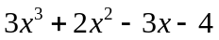when x=1.

14. Evaluate 