Test 2 Calculus I Dr. McLean March 11, 2011 Name _____________

1. Find 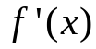 if 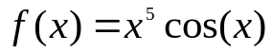.

2. Find 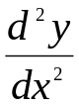, the second derivative of y with respect to x if y = 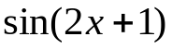.

3. Find if 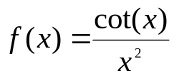.

4. Find 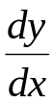 at the point (1, 2) implicitly if 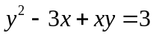.

5. Find if 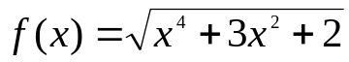.

6. Find if 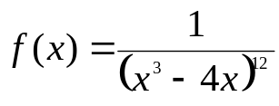.
7. Let 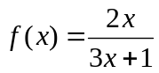. Write the equation of the line tangent to the graph of  when
x = 1.

8.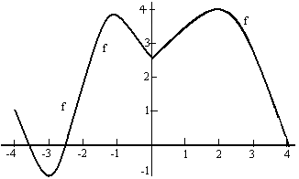
a) Approximate f ' (3) .
b) Where on the x-axis is the absolute minimum?
c) Where on the x-axis are the local minimums?
d) Where on the x-axis are all of the critical points?

9. Find if 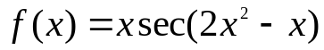.

10. The position of a particle is given by 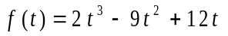where t is nonnegative and is measured in seconds and 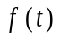 is in feet.
a) Find the velocity at time t.
b) Find the acceleration at time t.
c) Find the value of t when the acceleration is zero and then find the velocity at that time.

11. An open top, rectangular shaped watering tank is 38 feet long, 25 feet wide and 4 feet high. Water is being pumped into the tank at the rate of 8 cubic feet per second. How fast is the water rising in the tank before it is full?
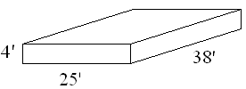

12. A baseball diamond is 90 ft. square. At the crack of the bat, a runner on third base runs home. When the runner is 20% of the way home, what rate is the distance between her and second base changing if she is running at 22 ft./ sec?
13. Find the location of the absolute maximum and the absolute minimum of 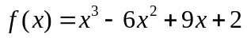on [-1, 4].
third
90 feet square

14. Suppose f ’(x) = (x+1)(x-1)(x-3) on all of the real numbers.
a) Find the critical points.
b) Use the 1st derivative test to classify your critical points as relative maximum, relative minimum or neither.
c) Where is f increasing?

