Test 1 MATH 1441 2/11/2011 Dr. McLean Your Name ______________________
- Answer the following  - Evaluate 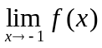 .  - Evaluate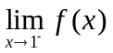 .  - Why is not continuous at x = -1?  - Why is not continuous at x = 1?  - Evaluate (1).  - Approximate the slope, ‘(0).  g) Write the equation of on [-3, -1). |  | 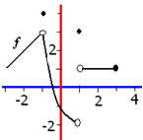
 | a) Domain of g is ________ .  b) Find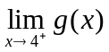  c) Range of g is ____  d) g’(10) = ______ |  | 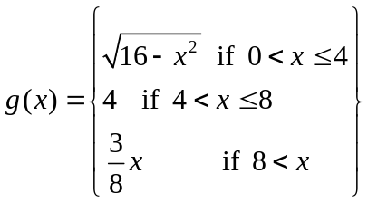
 |  |  | 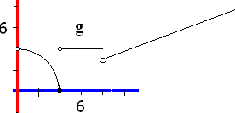
- 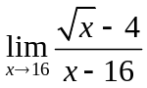.

- Find 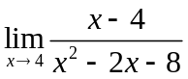.

- a) Evaluate 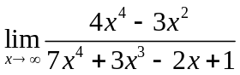.
- Evaluate 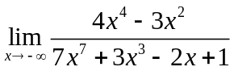.

- Evaluate 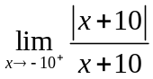
- Find the average rate of change of if (x) = 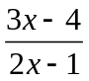on [1,3].

- Find the equations of the horizontal and 2 vertical asymptotes of (x) = 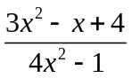.

- Find the first derivative of if (x) = 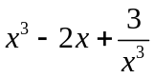.

- Write the equation of the line tangent to the graph of (x) when x = 2 if (x) = 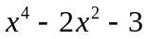.

- Find the first derivative of if (x) = 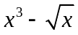.

- State the definition of derivative. If is a function of x, then 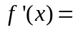________________
If that limit exits.

- Find the acceleration when t = 0 if the position function is s(t) = t³ + 2t – 3sin(t)

- If f(x) = 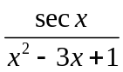, find f’(x)

