September 19, 2007 Dr. Bruce McLean Name ______________________________
1. The entire graph of h is seen below.
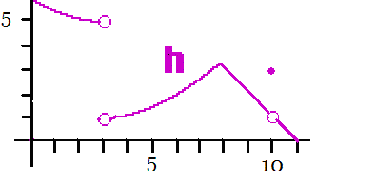
a) What is the range of h? b) What is the domain of h?
c) Evaluate h'(8.5), the slope of h when x = 8.5.
d) What is the first reason that h is not continuous at x = 10 ?
e) Estimate 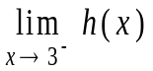.
f) List all x’s where h is not differentable.
g) Estimate h(5).
h) Where does h not have a limit?
- An efficiency study showed that the number of walkie-talkies assembled by the average worker is given by N(t) = - t³ + 6t² + 15t, 0 t 4 where t is the number of hours after starting to work.
- How many walkie-talkies are assembled by an average worker during the first two hours of work?
- What is the rate of change after they have been working for two hours?

3. Show your work and evaluate
a) 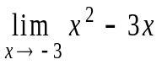,
b) 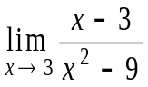
c) 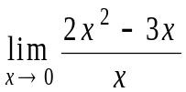
d) 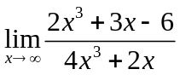
4. What is the definition of the derivative of f at the point x?
f '(x) =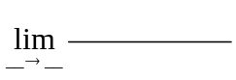
5. Suppose f(x) = 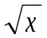+2.
a) What is the domain of f?
b) Write the equation of the line tangent to the graph of f when x = 16.
6. Find the derivative of each of the following functions.
a) f(x) = 3.2x - 12,
b) g(x) = 4x³- + 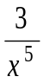,
c) h(x) = (2x²+3x-6)(4x²+2x), and
d) j(x) = 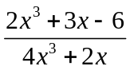
7. If f(x) = 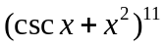, find f ‘(x).
8. If g(x) = 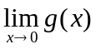, find.
9. Find 

