The triahexaflexagon has 3 different colored faces.
Start with 9 equilateral triangles and crease every edge. Letter the back placing the letter a behind the one, b behind the 2, etc. and finishing with i behind the 9. Also place the bottom of the letters close to the outside edge similar to the digits.
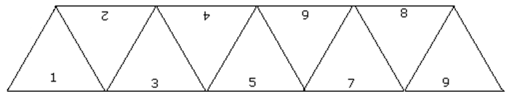Turn upside down and roll d under c, giving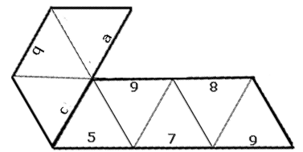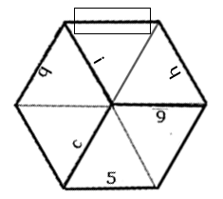
Next roll 7 under 6 and place i on top of a producing. Finish by taping i to 1 as shown. Pinch down h and 6 with the right hand while pushing in on the vertex between b and c.
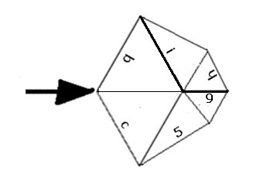 opens into 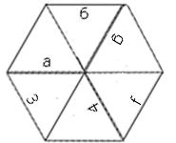
Rotating 60 degrees clockwise and pinching down on 9– g with the right hand and push in from the left gives 1, 2, d, e, 7, 8. Rotating 60º CW and pinching give b, c, 5, 6, h, I which is the starting face.

The hexahexaflexagon will have 6 different colored faces. Start with 18 triangles and a tab as shown on the last page. For each number on the front, add 18 to it and place that number on the back. Crease each edge both directions. Holding the tab, fold 3 under 2, pull 23 on top of 22, roll 7 under 6, 27 onto 26, 11 under 10, 31 onto 30, 15 under 14, and 35 onto 34. Then roll 6 under 5, 12 under 11 placing 17 on top of one. Push 0 back onto 19 and tape the tab to 0.
