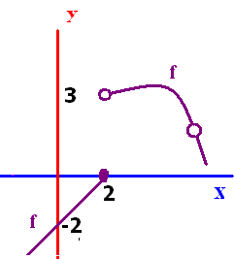
Understanding of limits geometrically
- A) 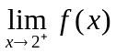 B) 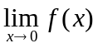 C) 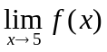 D) 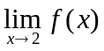
- Write the equation of f on [0,2]
- Find the average rate of change of f on [0,2]. On [2.1,4.9].
- Domain of f =
- Range of f =

- Why is f continuous at x = 0? Why is f not continuous at x = 5? X=2?

- A) 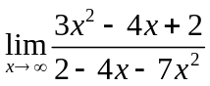 B) 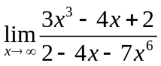 C) corrected 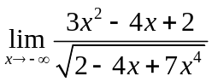

- A) 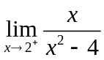 B) 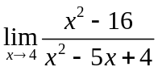 C) 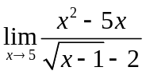
Rule 4 Rule 5
- A) 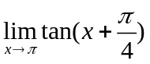 B) 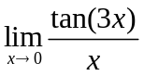 C) 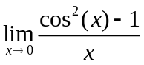
- 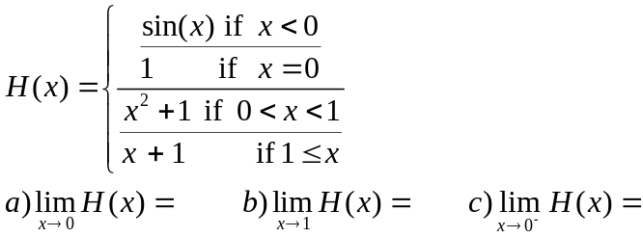

Answers
- 3 -2 2 dne
- (y-0)/(x-2)= 1 or any other version
- [f(2)-f(0)]/2=1 (2.8-3.1)/2.8 = -3/28
- Rule 1 – Plug it in 2/0 dne Rule 2 factor and cancel 8/3 Rule 3 * by conjugate/conjugate 5*4=20
- [-1.5,4.3]-{4}
- [-3.5,0]U[0.4,2)U(2,3.4]
- 1 3 sin(3x)/[3xcos 3x]=3/1 =3 [(cosx-1)(cosx+1)]/x -> 0*2=0
- -3/7 0 divide the num. and denom. by root(x^4) = x^2 > 0 away from 0 so 3/root(7)
- 0 is in the domain and f(0) = -2 , lim as x->0 of f(x) = -2 the 2 answers are the same
5 is not in the domain lim f(x) as x -> 2 d.n.e.
- d.n.e. 2 0

