Dr. McLean Test 1 Summer 2012 Survey of Calculus Name ________________________

1. Find the limit, if it exists. (If an answer does not exist, enter DNE.) 
2. A major corporation is building a 4325 acre complex of homes, offices, stores, schools, and churches in the rural community of Glen Cove. As a result of this development, the planners have estimated that Glen Clove's population (in thousands) *t* yr from now will be given by the following function.

P(t) = (35 t^2 + 125t + 100)/(t^2 + 2 t + 20)

1. What is the estimated population of Glen Clove a year from today?
2. What will the population be in the long run? (Find the limit P(t) as t approach +oo)
3. Find the rule for the composite functions *f* compose*g*.

f(x) = sqrt(x + 8) text( ; ) g(x) = 1/(x - 8)

*f* compose*g* (x) = *f* (*g* (x)) = 1

1. Find the derivative of the function. *f*(*x*) = 0.5*x*−1.1 + 3.5*x*1.1

5. In the following

A) 

B) explain why f is not continuous at x = 3.

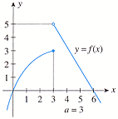

6.

$$ f(x) = \left\{
    \begin{array}{rcl}
    x^2+1 \ \text{if} \ x \ne 0\\
    0 \ \text{if}\ x=0\\
    \end{array}
    \right. $$

1. Why is f not continuous at x = 0?
2. Write the equation of the tangent line to f when x = -2.

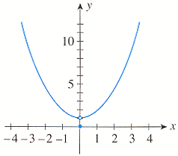

1. Find the derivative of the function. g(x) = 
2. The relationship between the amount of money *x* that Cannon Precision Instruments spends on advertising and the company's total sales *S*(*x*) is given by the following function where *x* is measured in thousands of dollars.

*S*(*x*) = −0.002*x*3 + 0.3*x*2 + 2*x* + 500      (0 ≤ *x* ≤ 200)

1. If the company spends $100,000 on advertising, what is their estimated sales?
2. Find the rate of change of the sales with respect to the amount of money spent on advertising.  
   *S'*(*x*) =

1

C) Are Cannon's total sales increasing at a faster rate when the amount of money spent on advertising is $100,000 or $150,000?