July 13, 2007 Survey of Calculus Dr. McLean Name _________________________
1. a) Evaluate the limit if it exists. 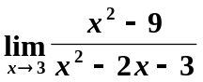.
b) What is the first reason that 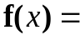 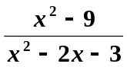 is not continuous at x = 3?
2. Suppose 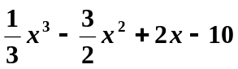on all of the real numbers.
a) Find the critical points.
b) Use the 1st or 2nd derivative test to classify your critical points as relative maximum, relative minimum or neither.
c) Find the inflection point.
d) Where is f decreasing?

3. The English postal service regulations specify that a parcel sent by parcel post may have a combined length and girth of 12 feet. If a rectangular box has a square cross section, find the size of the square that would produce the maximum volume. Girth is the perimeter of the square.

4. Differentiate 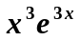.

5. Differentiate 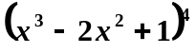 and then write the equation of the tangent line passing through 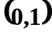.

6. Differentiate 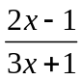.

7. Suppose that the unit price p in dollars and the quantity demanded x of your loud speaker system is given by the equation p = -0.02 x + 400 on the domain
[0, 20000].
a) Find the revenue function, R(x).
b) Find the marginal revenue function, R’(x).
c) Compute R’(2000) and interpret your result.
d) If the total cost function is C(x) = 100 x + 200000, find the profit function.
e) If the average cost is 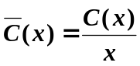, find the marginal average cost function.
8. If an investor wants her $10000 to double in 11 years, compounded continuously, what interest rate will she need to find? ( 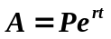 and you must show all of your work)

9. Find 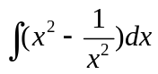.

10. Find 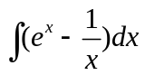.

11. Find 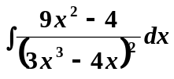.

12. Find 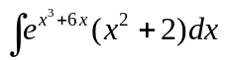.

13. Evaluate 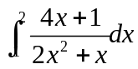.

14. Find the area over the x-axis and under f(x) = 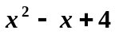 between x = -1 and x = 3.

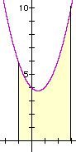
15. Find the area bounded by the graphs of f(x) = and g(x) = 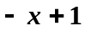 between x = 0 and x = 2.
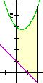

16. The management of National Electric has determined that the monthly marginal cost function associated with producing their automatic drip coffee makers is given by
C’(x) = 0.00003x² – 0.03x +20
Find the cost function, C(x) if C(0) = $500. In other words, the monthly fixed cost is $500.

17. 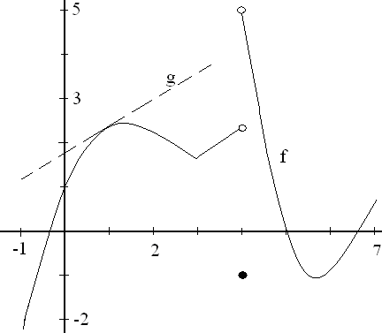
The domain of the above function called f is [-1, 7]. If you do not see the graph, it is not there. The function g is a line tangent to f at the point (1, 2.2).
a) Find the range of f. b) Evaluate 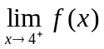.
c) Where are the critical points of f? d) Where is f concave up?
e) Where is f increasing? f) Evaluate 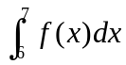.
g) Where are the relative mins of f? h) Where is the absolute min of f?
i) Evaluate g ’(1). j) Evaluate f ’(2).

