MATH 1232 Dr. McLean Test 1 June 3, 2011 Name ___________________
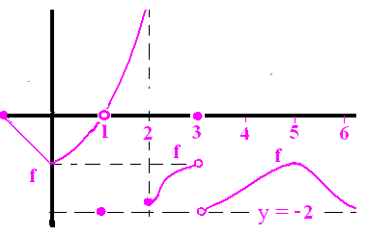
- The domain of the shown function, f, is [-1, +oo) where y = -2 and x = 2 are asymptotes.
- What is the range of f? [-2,+oo) | - Approximate f(2.5). -1.2
- Approximate f ‘(5.5). -1 | - Approximate 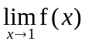. 0
- Evaluate 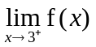. -2 | - List all of the x values in domain of f where f is not continuous at x. {1, 2, 3}

- For each answer in 1 f) above, give the first reason why it is not continuous there.
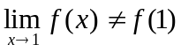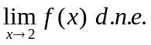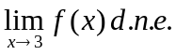
- A company purchases a new machine for $3 million and depreciates it to zero over 15 years.
A) Write the equation of the straight line that shows you the current value given that it passes through (0, 3) and ( 15, 0). (y-3)/(x-0) = -0.2 y = -0.2(x) +3
B) What is the value of the machine after 8 years? y(8) = -1.6 + 3 = 1.4
- Evaluate 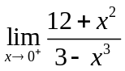. 12/3 = 4
- Evaluate 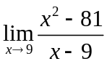. 9 + 9 = 18
- Evaluate 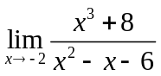 =12/(-2-3) = -12/5
- Evaluate 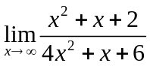 1/4
- Evaluate 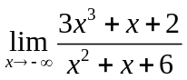. d.n.e. or +oo
- If 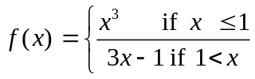, state the first reason is not continuous at x = 1.
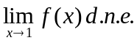
- State the Intermediate Value Theorem..
If is continuous on [a, b] and d is between f(a) and f(b), then there exists a c,
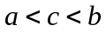so that f(c) = d

- Find the derivative of 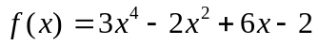. 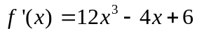
- Find the derivative of 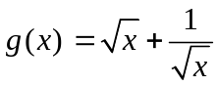 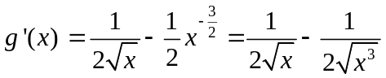
- Write the equation of the line tangent to the graph of 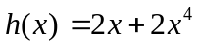 when x = 1.
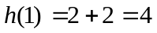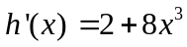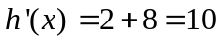
(y-4)/(x-1) = 10

