MATH 1230, Survey of Calculus Final Exam
R(x) = x p(x) A = Pe^{rt} 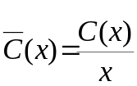
P(x) = R(x) – C(x) A = P(1 + r/n)^{nt} r_{eff} = ( 1 + r/n)^{n} – 1

ln(e^{x}) = x ln(1) = 0 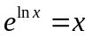
Average rate of change (velocity) on [a, b] ARC =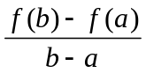
Average height of a function on [a, b] AH = 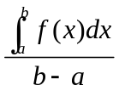
[f(x)g(x)]’ = f(x)g’(x) + g(x)f’(x)

[f(x) / g(x)]’ = [g(x)f’(x) – f(x)g’(x)]/g²(x)
[x^{n}]’ = n x^{n-1} 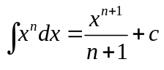
[e^{x}]’ = e^{x} 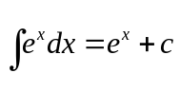
[ln(x)]’ = 1/x 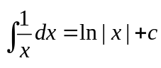
[g^{n}(x)]’ = n g^{n-1}(x)g’(x) 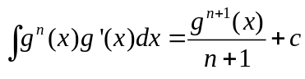
[e^{g(x)}]’ = e^{g(x)} g’(x) 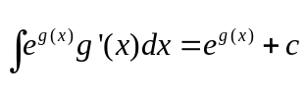
[ln(g(x))]’ = g’(x)/g(x) 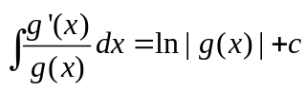
[x]’ = 1 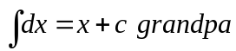
If y is a fn of u and u is a fn of x then 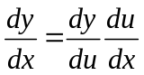
Pythagorean Theorem 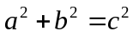
Volume of a rectangular box with a square base V = 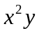
Surface area of the above if it has no top. A = 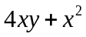
Volume of a cube V = 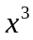 Surface area of a cube A = 6
Volume of a basketball V = 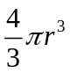 Surface area of a basketball A = 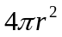
Volume of a coke can V = 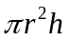 Surface area of a coke can A = 