This report details the testing procedures for the Samples API application produced for cloud platform development. This application consists of a API that handles the CRUD for information into azure tables as well as a webjob which allows 20 second samples to be created from uploaded songs and then stored as blobs. Testing for this application had two main areas which were off cloud testing and on cloud testing. The report also describes the third party software used to test in both cases.

## Off Cloud Testing

This testing took place before the application was fully deployed to Azure and was instead being supported by the azure storage emulator. This testing was an important round of testing as it was important to ensure the application would work before spending unnecessary time deploying it to azure where it would be more challenging to test and find bugs that arise.

White box testing was used throughout development to find bugs and troubleshoot any bugs. This was a clear choice as white box testing is where the individual testing has knowledge of the system, compared to black box is where the tester does not. The tester having knowledge of the system was important as it allowed for the key area where any potential bugs could occur to be apparent immediately allowing fixes to be put into place quickly. This was also used after development finished as it was necessary to once again identify the area that was causing bugs when they were found and due to the limited personal available which was not sufficient to provide black box testing. Postman was used to do this testing with

## On Cloud Testing

On cloud testing was taken place after the application was fully deployed to azure. The environment difference between on cloud and off cloud could be significant to cause issues within the application so it was important to testing the application after it had been deployed to the cloud via azure. Testing the application early in cloud was important as first deployments can be difficult which the application experienced, this testing was beneficial to the project as it helped highlight key errors that occurred quickly when deployed and meant they did not appear later in the project.

Postman was used to test each feature of the API and to ensure it is RESTful. The ability to execute GET, POST, DELETE, and PUT commands quickly was beneficial as it allowed quick testing to be done on the many features as well as provide tactical feedback that showed changes and HTTP responses provided by the API .

There is a number of ways to potentially have test scenarios for this application on the cloud that have not been undertaken. These include concurrency, which can relate to the potential for users to be accessing the same resources at the same time and how the application will deal with this and if it leads to a deadlock in resources. For this application concurrency could test the ability for multiple users to be adding samples and blobs together or getting them which would be multiple table reads. Security testing is also important as it is one of the driving effects in most modern applications today and especially cloud applications. The application being an API also lends the importance of security testing as other developers may use the API for their own applications and if it is not secure then it may lead to a failure point in many applications and not this one. Bottleneck testing is also a potential form of testing that can occur for cloud applications as databases can bottleneck since it is not as easy to scale out the database but is possible with data sync, this testing would help show the potential for bottlenecking as well as the severity of it.

## Postman Testing

This section chronicles the screenshots of the testing of the application On Cloud with postman to ensure the functionality is correct.

Get all samples

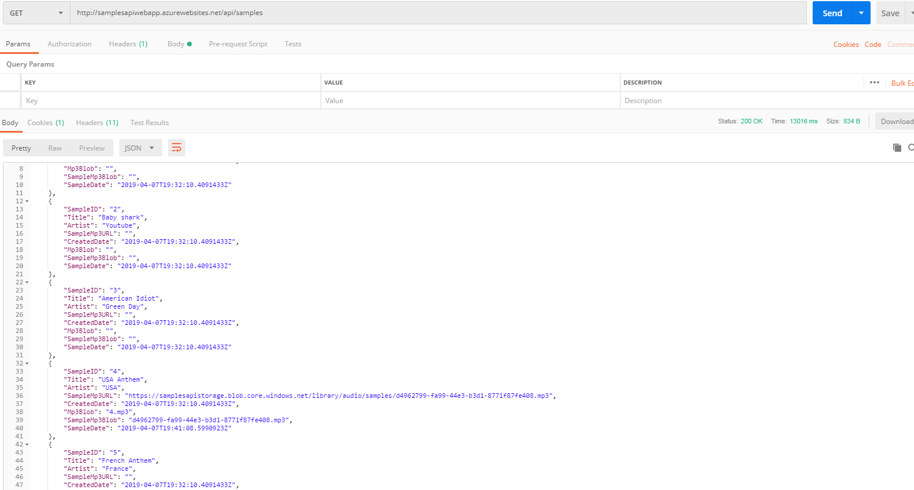

Get specific sample by ID

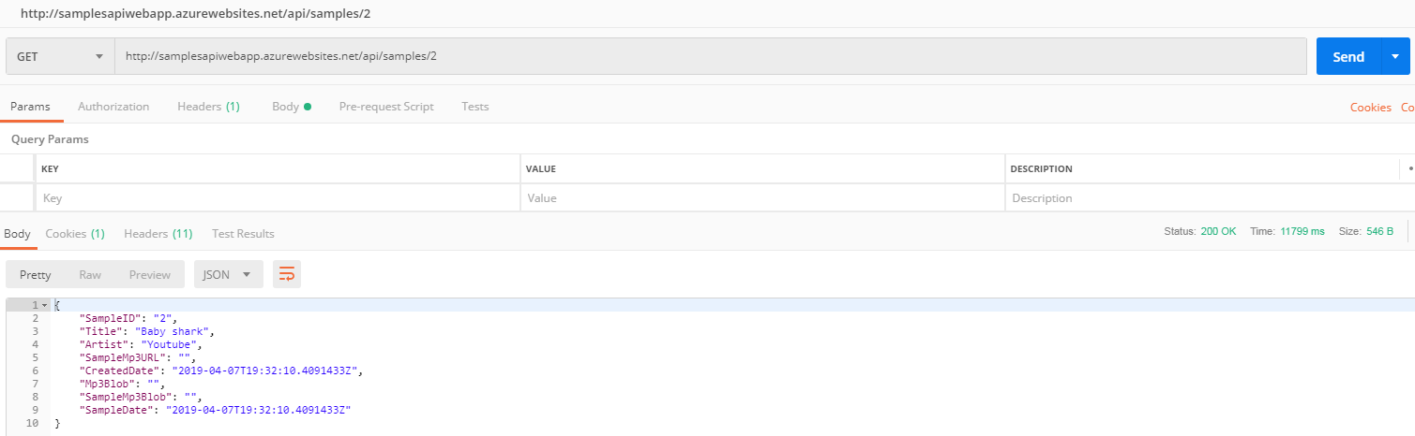

Put music sample into a sample

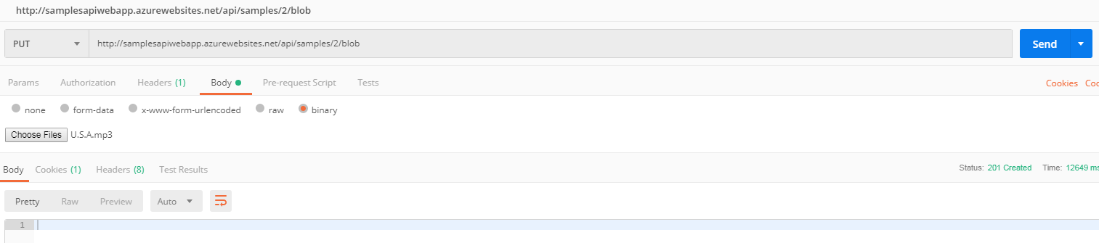

Putting new data into a sample

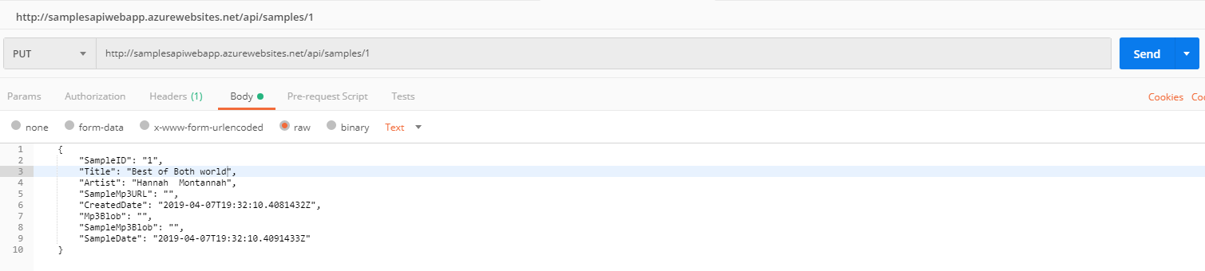

Inserting a new sample

