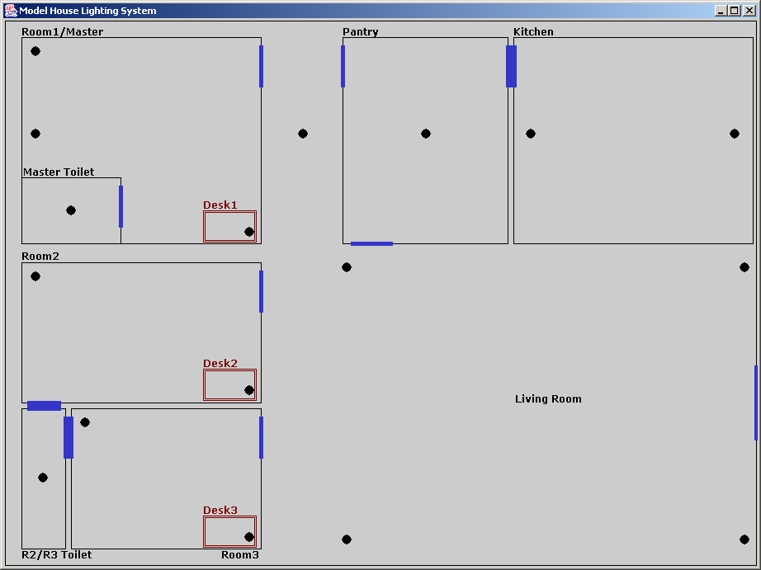

light
on
master || room1
nw
w
desk
toilet
room2
nw
desk
toilet
room3
nw
toilet
desk
corridor
pantry
kitchen
w
e
living
nw
ne
sw
se

off
master || room1
nw
w
desk
toilet
room2
nw
desk
toilet
room3
nw
toilet
desk
corridor
pantry
kitchen
w
e
living
nw
ne
sw
se

