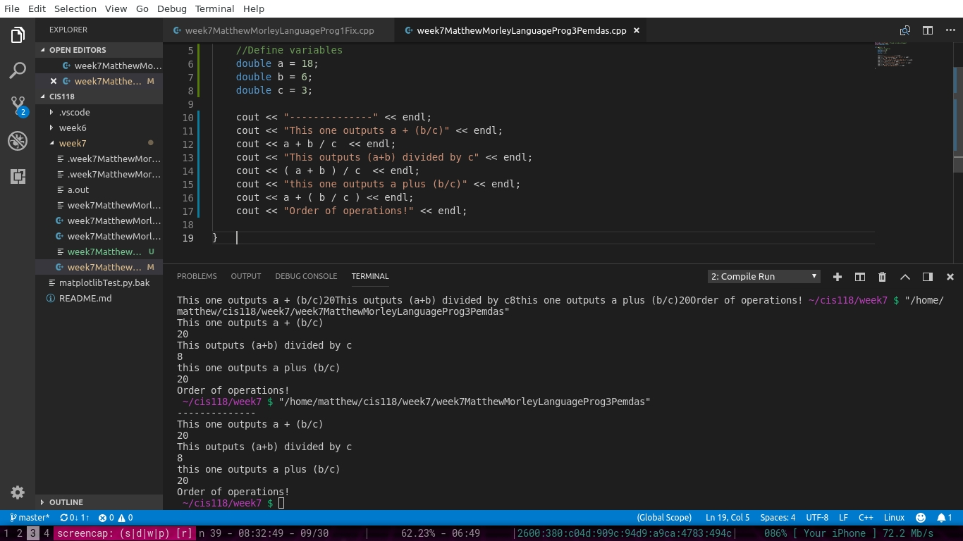Order of operations is very important - it totally changes the output.