Comparing Techniques for Single Handed Text Input on Mobile Devices

Matthew MacEachern
Dept. of Electrical Engineering and Computer Science
York University
Toronto, Ontario, Canada M3J 1P3
mcmaceac@my.yorku.ca

ABSTRACT
(To be added later)

Keywords
Mobile text entry, prediction based text input, gesture based text input.

INTRODUCTION
Mobile devices and specifically mobile phones have become an indispensable tool to the average citizen in modern times. Looking around in any public space, one would be hard-pressed not to see at least one person using some type of mobile device such as a smartphone or tablet.
The nature of communication in the modern world has changed drastically since the days of early mobile phones. The shift from voice based communication to more communication taking place by methods of text messaging has marked an important culture shift that has had large implications in the design of mobile user interfaces to deal with this shift. The importance of methods to input these text messages fast, and with high precision has become a necessity in mobile computing. However, with soft keyboards becoming more prevalent and widespread throughout modern smartphones, precision has taken a hit as the feedback of pressing a key on a hard keyboard is missing. This leads us to various predictive text entry systems that come with most soft keyboards today. Predictive text is not something new to soft keyboards, though, and has been studied and improved extensively over the past decade.
Some of the earliest text prediction systems in mobile computing can be seen in the original T9 style mobile devices, where a 3x4 keyboard was used with multiple characters assigned to each key [1]. This T9 predictive text technology allowed the user to enter texts fairly accurately without having to press the key that contained the desired letter multiple times in order for the letter to appear on the screen before moving onto the next letter in the sequence. This technological breakthrough at the time increased the speed at which users could input text into the device, and offered a new way to which users can interact with their devices.
Predictive text entry systems have been used not only in mobile computing but have also been used previously in the realm of disability assistance services for individuals with motor and speech impairments [1].
Often, when users are interacting with their mobile devices, they are in the middle of completing other tasks such as eating breakfast or other tasks that occupy at least one of the users’ hands. This can negatively affect the speed and accuracy at which users are able to enter text messages or other fields that require text input. This is important to note since users are typically not used to only using one hand to enter text, since traditional keyboards on computers encourage the use of two hands to input into the device.

METHOD
This particular user study will involve the collection of data as participants enter various texts into the device using varying techniques involving one hand. This will be elaborated on further in this section.

Participants
This section will be elaborated further as the project proceeds and develops. However, the demographic of users that will take place in this user study will be University students. This is because this demographic has a high amount of experience with computing devices and in particular mobile computing devices. This will ensure that most of the participants will have a relatively equal skill level when dealing with the task set ahead of them. There will be outliers, of course, with some participants having far greater experience with these devices than others, but this is acceptable in this user study. Ideally, roughly fifteen participants will be asked to participate in this user study in order to gain a good amount of data, with each participant entering a set number of text phrases using different methods of text entry onto a device. The text entry will be repeated in order to see if progress is being made and the participants are gaining more skill in entering the text using different techniques.

Apparatus
The device that will be accessible to all participants in this user study will be the Samsung Galaxy S6. This device will be used along with the standard keyboard that is installed on the device in order to get input from the participant in the study. The standard swipe based input method (also known as the Swype keyboard on Android) that can be enabled or disabled on the device will be used in one part of the user evaluation in order to obtain input from the user (see Figure 1). Another method will be to have the user enter text with the swipe to type gesture recognition part of the keyboard disabled, forcing the user to tap the keys individually to input text into the device.
The user will need to become accustomed with the device, since they may or may not have used the device in the study, so there will be an integration period of 2 minutes for participants to understand how the keyboard works and what they will be asked to do.
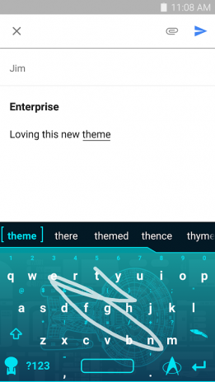
Figure 1. Screenshot of a user typing ‘theme’ with the gesture based keyboard Swype.
Further details as to the exact configuration of the apparatus will be included once the user study has actually taken place and the software is developed to fit the specific need of the user study.

Procedure
This will be expanded upon when the user study is actually performed, but some preliminary details will be discussed as to how the users will be tested in order to ensure that the testing is independent and consistent across all participants involved in the study. Prior to the testing, the users will be asked to fill out a short questionnaire which will include demographic questions such as their age, gender, etc. The questionnaire will also ask questions as to how often the user uses their mobile device, how much time the user spends on any type of computing device, and what their dominant hand is (in order to determine which hand they will use in order to complete the study). This questionnaire will be a part of the application, and the answers will be stored along with the data obtained from their trials of the text entry. Each participant will be asked to sit down at a desk with the device on top of the desk. This will be where participants will perform the task. Figure 2 shows what a typical user may look like when performing a trial of the study, with their non-dominant hand resting on their thigh as to not interfere with the hand performing the text entry.
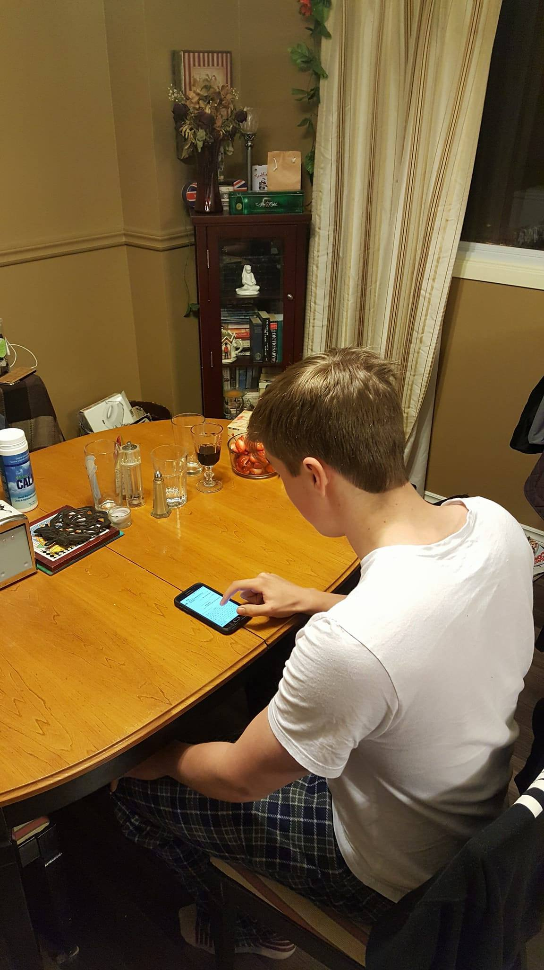
Figure 2. Typical user performing one handed text entry on the Samsung Galaxy S6 device.

Design
For the user study, the 2 × 5 within-subject design will be used with two levels of our independent variable. That is, all participants of the study will all be exposed to the varying level of the independent variable. The advantage of this is that it does not require as large of a participant base compared to the between-subject design, and due to time constraints, this is important.
The independent variables in the case of this user study are:
- Input method (single handed tap, Swype)
- Phrases user is asked to enter (this will be determined later, but will most likely be constrained to at most two to save on participant time)
- Trials (1, 2, 3, 4, 5)
That is, the input method has two levels: the traditional tap method of typing on a mobile device, but with one hand in this case, and the use of Swype gestures to input text. The phrases the user is asked to enter is another added independent variable for the following reasons: when a user is entering a single phrase, it may not have all the aspects that a user will encounter on a daily bases of text entry. Therefore, either a lengthened phrase needs to be chosen that incorporates many different aspects (such as punctuation, grammar, hard to spell words, etc.), or multiple phrases can be chosen independent of each other to test. The number of trials chosen is five to keep the user study both informative, but without taking too much time from each participant and to again save on time since the user study must be completed within a constrained amount of time. Another level to the input independent variable may be added. That level being two-handed input, as a sort of baseline test to see where users stand on text entry, but this will be determined at a later time depending on the need.
The dependent variables in the case of this user study will be the time it takes them to complete the various phrases that are put on the screen for them to complete, as well as the accuracy of the inputted text to the phrase presented to the participant. The time it takes a participant to enter various phrases will be recorded and converted to a WPM (words per minute) score for each trial they take place in.
Of course, with this being a proposal and not the actual user study itself, the number of participants is to be determined. However, the number of participants in the user study will most likely be roughly ten. Therefore, with 10 participants × 2 text phrases × 2 input methods × 5 trials each = 200 trials in total. This is assuming a baseline test is not used (the two-handed text entry method explained above). If the baseline test is used, there will be 300 trials in total.

RESULTS AND DISCUSSION
(To be added later)

CONCLUSION
(To be added later)

ACKNOWLEDGMENT
(To be added later)

REFERENCES
[1] N. Garay-Vitoria and J. Abascal, "Text prediction systems: a survey", Universal Access in the Information Society, vol. 4, no. 3, pp. 188-203, 2005.
[2] R. Soukoreff and I.S. MacKenzie, "Text Entry for Mobile Computing: Models and Methods, Theory and Practice", Human-Computer Interaction, vol. 17, no. 2, pp. 147-198, 2002.

