Comparing Single Handed Text Entry Using Tap and Gestural-based Input Techniques

Matthew MacEachern
Dept. of Electrical Engineering and Computer Science
York University
Toronto, Ontario, Canada M3J 1P3
mcmaceac@my.yorku.ca

ABSTRACT
Participants in this study were tested on single handed text entry speed using two different text input methods: the gesture based input method Swype and the traditional tapping method. The user study was done with nine participants which compared the speed and error rate of the two text entry methods. It was discovered that Swype was 9.73% faster on average than traditional tap based input. Error rates of Swype based input were slightly higher than tap based. Qualitative analysis revealed a majority preference for tap based input, with five of the nine participants indicating a preference for tap based input.

Keywords
Mobile text entry, prediction based text input, gesture based text input, single-handed text input.

INTRODUCTION
Mobile devices and specifically mobile phones have become an indispensable tool to the average citizen in modern times. Looking around in any public space, one would be hard-pressed not to see at least one person using some type of mobile device such as a smartphone or tablet in their day to day lives.
The nature of communication in the modern world has changed drastically since the days of early mobile phones. The shift from voice based communication to more communication taking place by methods of text messaging has marked an important culture shift that has had large implications in the design of mobile user interfaces to deal with this shift. The importance of methods to input these text messages fast, and with high precision has become a necessity in mobile computing. However, with soft keyboards becoming more prevalent and widespread throughout modern smartphones, precision has taken a hit as the feedback of pressing a key on a hard keyboard is missing. This leads us to various predictive text entry systems that come with most soft keyboards today. Predictive text is not something new to soft keyboards, though, and has been studied and improved extensively over the past decade.
Some of the earliest text prediction systems in mobile computing can be seen in the original T9 style mobile devices, where a 3x4 keyboard was used with multiple characters assigned to each key [1]. This T9 predictive text technology allowed the user to enter texts accurately without having to press the key that contained the desired letter multiple times in order for the letter to appear on the screen before moving onto the next letter in the sequence. This technological breakthrough at the time increased the speed at which users could input text into the device, and offered a new way to which users can interact with their devices.
Today, predictive text entry systems are an important part of many systems such as the Swype gesture based text entry system used for Android, and will be used throughout this user study.
Predictive text entry systems have been used not only in mobile computing but have also been used previously in the realm of disability assistance services for individuals with motor and speech impairments [1]. Although it is not the focus of this study, the restriction of only using one hand to perform text input is an important distinction for those who may have limited mobility in their hands or complete loss of mobility in one of their hands.
Often, when users are interacting with their mobile devices, they are in the middle of completing other tasks such as eating breakfast or other tasks that occupy at least one of the users’ hands. This can negatively affect the speed and accuracy at which users are able to enter text messages or other fields that require text input. This is important to note since users are typically not used to only using one hand to enter text, since traditional keyboards on computers encourage the use of two hands to input into the device. Even when a user can use two hands to input text into the device, in the case of mini-QWERTY keyboards (as is the norm for modern smartphones), the user is usually limited to at most two fingers due to the size restriction of the screen [4]. This opens the field to many interesting input techniques that only require a single finger, allowing the user to multitask efficiently while entering text into their device.

METHOD
This user study involved the collection of data as participants entered text phrases into the device using varying techniques involving one hand. This will be elaborated on further in this section.

Participants
Prior to completing their assessment, the participants of the study were asked to complete a short demographics survey that was a part of the testing application. This demographics survey asked several questions including: the participants age, the participants gender, the participants dominant hand, how many hours per day the participant spends on a computing device (mobile or desktop), and finally if the participant has ever used the Swype input method previously. In total, nine users participated in this study. Out of the nine, two were female, and seven were male. The demographic of users sought out for this study were predominantly University age, since intuitively these were users that were most likely to spend a greater amount of time on mobile devices. However, there were outliers, with three of the participants being over the age of 40. This is because this demographic generally has a high amount of experience with computing devices and in particular mobile computing devices. Participants in this study on average use computing devices for seven hours per day, and all use a mobile computing device throughout the day. Since this is a study of single handed text input, the dominant hand of the user is relevant. Two of the nine users reported that their left hand was their dominant hand, leaving seven participants reporting that their right hand was their dominant hand. Finally, out of the nine participants, only four reported that they had ever used the Swype keyboard previously.

Apparatus
The device that was accessible to all participants in this user study was the Samsung Galaxy S6. This device was used along with the standard QWERTY keyboard that is installed on the device to get input from the participant in the study. The standard Swype keyboard for Android that can be enabled or disabled on the device was used in one part of the user evaluation to obtain input from the user (see Figure 1). Another method was to have the user enter text with the Swype gesture recognition part of the keyboard disabled, forcing the user to tap the keys individually to input text into the device. This is described by Starner as the “hunt-and-peck” method of input, which can average around 23 WPM [4].
Since the user may or may not be accustomed with the Swype method of text based input on mobile devices, a preliminary demographic survey was presented to the user before they begin the input portion of the study. Among other demographic questions discussed previously, the user was asked if they have ever used Swype previously. If they had used Swype before, they can move on to the next portion of the user study. If they had not, they would choose the No option from the spinner and a minute and a half long Youtube tutorial on Swype was played for users to get a general sense on how to use the input method, so they were not going into the study with absolutely no knowledge. The Youtube video tutorial was called “Swype Tips: How to Swype” by the user MySwype.
When designing this user study, there was a design decision that had to be made on whether to allow users to have a preliminary practice period, so they could become accustomed with the Swype based keyboard, or just the device in general (since it may or may not have been a new environment than they were used to). Ultimately it was decided not to do this for two reasons: the participants in the study were short on time for the most part due to exam season, and without a practice period we could more accurately judge learning trends among the two methods of input.
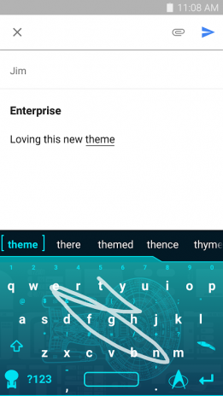
Figure 1. Screenshot of a user entering the word ‘theme’ with the gesture based keyboard Swype.
Further details as to the exact configuration of the apparatus will be included once the user study has taken place and the software is developed to fit the specific need of the user study.

Procedure
Prior to the testing, the users were prompted with a form that was within the application that asked for some general information about themselves (as discussed in the Participants section previously). This included demographic information questions to get a sense of who the test was on. The questionnaire also asked questions as to how often the user uses a computing device, how much time the user spends on any type of computing device, and what their dominant hand is (in order to determine which hand they will use in order to complete the study). Finally, the questionnaire will ask the participant if they have experience using the Swype input system. The participant’s answers to these questions were stored on the device along with the results of their trials to be discussed shortly.
Each participant was asked to sit at a table with the device resting on top of the table as shown in Figure 2. This was where participants performed the task of text entry into the application. The reason the device was be laid on the desk was to ensure that the size of the participant’s hand was not an inhibiting factor when entering text into the device with a single hand, allowing for consistent testing across participants. Ideally, the participants would be tested in a controlled setting with the exact same desk for each participant. However, due to constraints in participant schedules, testing was performed at a desk that was close with seating relatively similar across participants. Figure 2 shows what a typical user may look like when performing a trial of the study, with their non-dominant hand resting on their thigh as to not interfere with the hand performing the text entry.

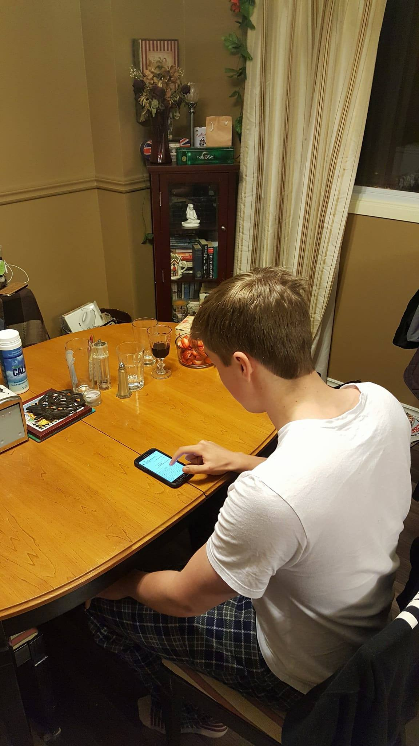
Figure 2. Typical user performing one handed text entry on the Samsung Galaxy S6 device.
Since the Swype gesture input method was new to many of the participants of this study, a tutorial video was shown if the participant had indicated that they had never used Swype as to aid the participant in their understanding of the use of the gestural input method. A video was used to ensure that all the participants that had never used the input method previously would have the same amount of information at their disposal when attempting to enter the phrase presented to them with Swype.
The participants were then asked to perform a text copy task, as described by Mackenzie and Soukoreff [2]. This is where the participant is given text to enter using the technique under investigation, in this case one-handed tap and one-handed gesture using Swype [2]. This is important in ensuring that our independent variables are maintained, which will be elaborated on in the Design section following. In this study, due to time constraints on both the study itself and the participants involved being mostly University students during exam season, the participants were only asked to enter a single phrase.
The users were then asked to enter the phrase presented five times with the tap method, and five times again with the Swype method. An alert on the screen was presented prior to each method section to ensure that the participants knew what input method they were supposed to be using at that point in the study. The phrase that they were supposed to be copying was presented at the top of the device screen followed by a text entry section, shown in Figure 3. An indication as to what trial number the participant was currently on as well as the entry mode that they were currently in was also presented on the screen as a reminder. The text entry method that the users would be evaluated on first depended on what text entry method the previous participant used first. This was done so the study would not succumb to order effects.

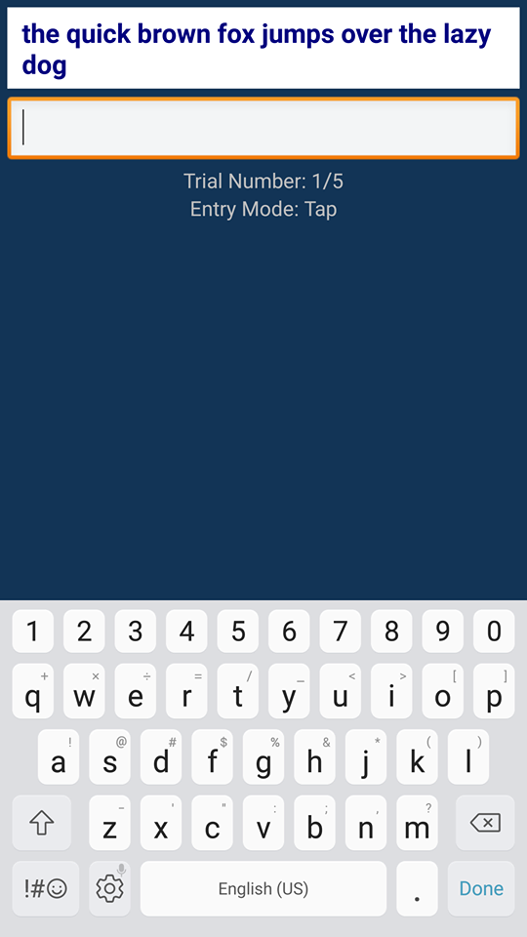
Figure 3. Testing screen where users are asked to enter the phrase presented.

The phrase that was chosen was: “the quick brown fox jumps over the lazy dog”. This phrase was chosen simply because it covers all the letters on the keyboard. This was to ensure that no positions on the device’s keyboard were left out when entering text into the device.
After the study portion was done (the participant had completed ten total trials, five with each text entry method), the user was asked a simple question of which text entry method they had preferred. This was to have qualitative data on each of the text entry methods, and will be discussed further in the Results and Discussion section of this paper.

Design
For the user study, the 2 × 5 within-subject design was used with two levels of our independent variable. That is, all participants of the study were all be exposed to the varying level of the independent variable. The advantage of this is that it did not require as large of a participant pool compared to the between-subject design, and due to time constraints, this was important.
The independent variables in the case of this user study are:
- Input method (single handed tap, Swype)
- Trials (1, 2, 3, 4, 5)
That is, the input method has two levels: the traditional tap method of typing on a mobile device, but with one hand in this case, and the use of Swype gestures to input text. The phrases the user is asked to enter is another added independent variable for the following reasons: when a user is entering a single phrase, it may not have all the aspects that a user will encounter on a daily bases of text entry. Therefore, either a lengthened phrase needs to be chosen that incorporates many different aspects (such as punctuation, grammar, hard to spell words, etc.), or multiple phrases can be chosen independent of each other to test. The number of trials chosen is five to keep the user study both informative, but without taking too much time from each participant and to again save on time since the user study must be completed within a constrained amount of time. Another level to the input independent variable may be added. That level being two-handed input, as a sort of baseline test to see where users stand on text entry, but this will be determined later depending on the need.
The dependent variables in the case of this user study will be the time it takes them to complete the phrase that was put on the screen for them to complete, as well as the accuracy of the inputted text to the phrase presented to the participant. The time it takes a participant to enter various phrases was recorded and converted to a WPM (words per minute) score for each trial they took place in. The accuracy was determined by how closely accurate the phrase that the user entered is to the phrase that was presented for them to enter. This was important when comparing both text entry methods, and will be discussed further in the Results and Discussion section of this paper. Another metric that was being considered during the design of this experiment was the number of times the backspace key was entered. However, since with Swype the backspace key deletes entire words versus single characters in the case of regular tap input, it was determined that this would not be a relevant statistic to track.
The participants were encouraged to enter the phrase exactly how it is presented on the screen; however, mistakes were inevitably made which provided useful statistics for both input methods. The error metric KSPC (key strokes per character) described by Mackenzie and Soukoreff [3] on its own was not particularly useful in the case of this user study due to the nature of the Swype gesture based text entry system. Swype uses a continuous gesture based input method to obtain text from users, which means that there are not individual key strokes when the participant is entering text using Swype. Another important error metric was used in this experiment however: MSD (minimum string distance error rate) as described by Mackenzie and Soukoreff [3]. MSD does use KSPC, but is more useful in the context of gestural based input when compared to traditional tap based input.
In this study, nine participants were chosen, and each participant were asked to enter a single phrase five times with both input methods. Thus, 2 input methods × 9 participants × 5 trials each = 90 total trials. Ideally more trials would be beneficial to showing meaningful results, however there were various inhibiting factors that stopped that from happening in this study.

RESULTS AND DISCUSSION
The post-study analyses gave interesting results in the two dependent variables used in the study, text entry speed in words per minute and error rate in minimum string distance. The qualitative analysis gave results that were also significant in the study.
In this study the speed measured in words per minute was the main dependent variable and was the most important in measuring participant performance when entering text into the mobile device. This was measured independent of the error rate that may have been produced during that trial. The error rate may need to be factored into this metric for future studies, however in this case we kept it straight forward.
Figure 4 shows the overall average text entry speed for both text entry methods. The mean entry speed for Swype was 30.5838 WPM with a standard deviation of 2.99768 WPM while the mean entry speed for tap was 27.8709 with a standard deviation of 2.07734 WPM. This meant that Swype was 9.73% faster on average than tap input for single handed text entry.

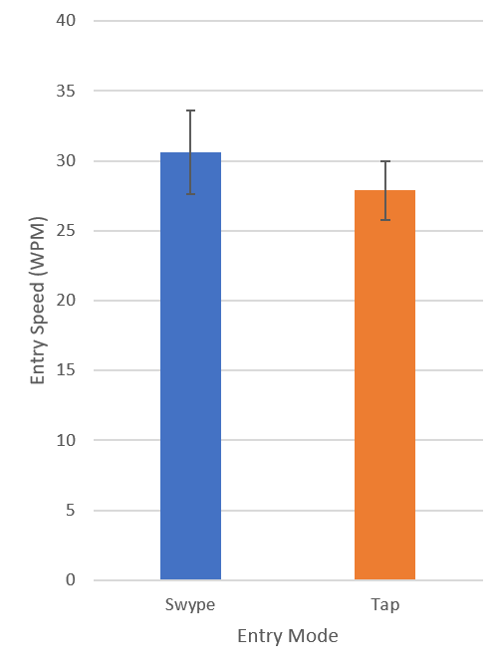
Figure 4. Average text entry speed overall of Swype and tap based input in words per minute

As shown in Figure 5, the results based on the average speed per trial for each entry mode was extrapolated to show up to the 20th trial. The squared relations for both input methods are above 0.85, which indicates that the lines are a good fit with the data that was gained from the study. The squared relations show a logarithmic relation, showing the power law of learning. Also shown in Figure 5, the gap between the two extrapolated lines seems to widen, which is confirmed by the higher power in the exponent for the extrapolated Swype line versus the extrapolated tap line. This shows that over time, users will be faster at entering text with one hand using Swype, than using one handed tap to enter text. This is significant considering that for five out of the nine participants who took part in the study, this was their first time ever using Swype, compared to the tap method that they most likely use every day.
An interesting point was seen when looking at the error rate of each entry method. When thinking intuitively about how Swype is processed with its predictive nature, one would think that it would result in a lower error rate than tapping since tapping can be less accurate (especially if the participant has larger fingers). However, the average error rate across all Swype trials was 3.49% while the average error rate for tap input was 2.15%, as shown in Figure 6. This error rate may seem negligible, but it still shows a higher error rate when using Swype.

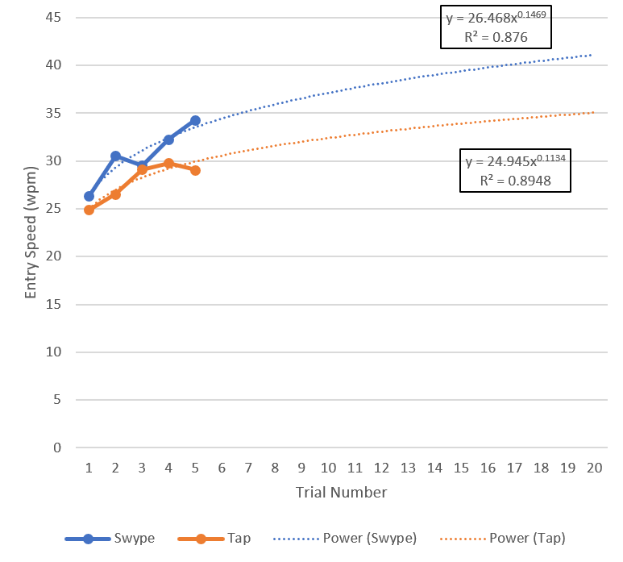
Figure 5. Average text entry speed per trial of Swype and tap in words per minute

The error rate increase may be due to many factors, that could have been a result of a less than adequate design of the study. For example, when entering the word “brown”, the gesture is very close to the gesture for both “broken” and “bean”. This could have been mitigated by testing out different phrases to ensure that the error rate increase was not simply because of a phrase chosen that had many words contained in it that had gestural translations close to other common words. However, due to time constraints, this could not happen. Another factor that could be a contributor to the higher error rate in the Swype method of text entry could be the way in which feedback is processed by the user when compared to how the user processes feedback when tapping to enter text into the device. When tapping to enter text on the default keyboard of the Samsung Galaxy S6, the letter that gets pressed is enlarged for users to know with great certainty that the key they wanted to press was indeed pressed. This is shown in Figure 7.
With Swype, participants do not get the guarantee that the gesture that they entered is being processed properly in real time. Rather, they need to wait for it to be displayed on the screen when they release their finger from the gesture being inputted. From personal experience, this can mean that the results of the gesture do not get checked in favor for faster gesture speed resulting in a higher error rate.
This lack of feedback could be a contributing factor to the inclination to preferring the Swype method of input, but this is pure speculation and not a result of this study.
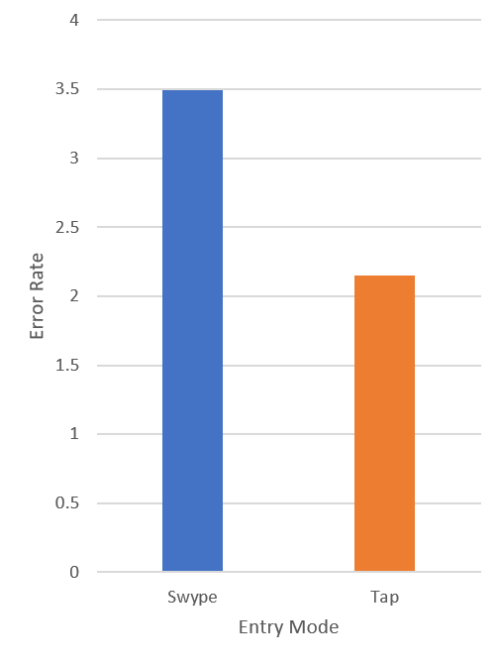
Figure 6. Average error rate overall of Swype and tap based input

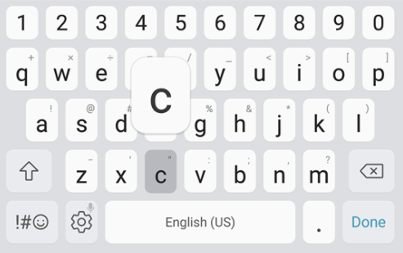
Figure 7. The enlargement of the letter c when tapped on the Samsung Galaxy S6
As a last measure, a qualitative analysis was performed by asking the participant which text input method they prefer after gaining some experience with Swype (if they had not experienced it previously). Five of the nine participants reported that they prefer tap based input for single handed text entry. It comes as no surprise that these five participants were the ones who had never used Swype before. The other four participants indicated that they preferred using Swype. This is shown in Figure 8. This may be an indication that if users were exposed to more sessions and had more practice with Swype, they would show a preference towards it, but this is speculation and not confirmed in the results of the study.

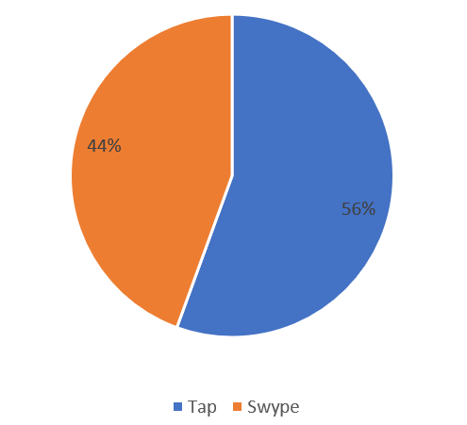
Figure 8. Comparing preference for tap and Swype text entry methods

CONCLUSION
Prior to beginning the study, it was believed that Swype would be significantly faster than traditional tap based input since it is often touted by participants that use the gesture based input method as far superior to traditional tap. However, it was discovered that this difference is not as significant as many users of the input method may believe. The extrapolated line shown in Figure 5 may indicate that through extended practice with the gesture based input method that the speed differences would increase over more sessions. Surprisingly, the error rate of Swype was shown to be higher in this study by over 1%, which doesn’t seem particularly significant, but makes sense when thinking intuitively about how feedback is processed in Swype based input when comparing to traditional tap.
Of the participants in the study, 44% of the participants expressed a preference for the Swype text entry method over tap. These were the participants who indicated that they had used Swype previously, which leaves to speculation the question of whether users would prefer Swype if they used it for a more extended period.
Further study that would have more resources would be needed to gain a clearer result when it comes to entering multiple phrases during the study over a longer period of sessions.

REFERENCES
- Garay-Vitoria N. and Abascal J., Text prediction systems: a survey, Universal Access in the Information Society, vol. 4, no. 3, pp. 188-203, 2005.
- MacKenzie I.S. and Soukoreff R. Text Entry for Mobile Computing: Models and Methods, Theory and Practice, Human-Computer Interaction, vol. 17, no. 2, pp. 147-198, 2002.
- MacKenzie I.S. and Soukoreff R., Metrics for text entry research: An evaluation of MSD and KSPC, and a new unified error metric, 2002.
- Starner T., Keyboards Redux: Fast Mobile Text Entry, IEEE Pervasive Computing, vol. 03, no. 03, pp. 97-101, 2004.

