Objectives:
- To use R to perform NMDS on data from Hampton and Duggan 2003
- To critically evaluate the choices Hampton and Duggan made in their paper
- To expand our R-programming and graphical capabilities ever-so-slightly
- To learn a bit about functions in R, at least the self-written kind

I. Materials for today

A. Datasets
- The primary dataset for today is Hampton-Lab.csv

B. R-code: You should have only one R-script for today’s lab:
- ‘Hampton-NMDS.r’: This script does the majority of what we’ll be doing today. It reads the dataset, performs the transformation specified by Hampton and Duggan, performs the NMDS, and gets you started with some basic graphing, including producing a Scree plot that will help us evaluate the robustness of Hampton and Duggan’s analysis.

II. Getting started: Loading and transforming

The ‘Hampton-NMDS.r’ script should be run in pieces rather than as a whole, similar to some of the scripts we have used in the past.

The first part of the script should be very familiar to you by now. Prior to performing the NMDS, there are 4 preliminaries:

- Setting the working directory. Should be familiar to you by now. Also, you don’t necessarily need this command since there are several other ways to point R to the right location on your machine
- Loading the vegan library. While there are multiple packages and functions in R that will perform NMDS, the metaMDS function in vegan is the one that provides the most complete functionality, including utilities for graphing.
- Loading the dataset. This step should also be familiar to you.
- Applying the 4th-root transformation. We haven’t used the 4th root transformation before (see Hampton and Duggan 2003 for an explanation of what the transform does) but the general idea is similar to previous transformations you’ve seen, to reduce the differences in magnitude that exist in the raw data. Also remember that you can easily comment out the transformation by placing a ‘#’ in front of the line of code. However, since there is no specific function like 4throot() in R, you may want to figure out how the transformation was applied.

Run the script up through the transformation. At this point, you should have a data matrix ‘DATA’ that is a transformed version of the original data.

III. Running the NMDS

metaMDS is the function that performs the NMDS. Look up the documentation (?metaMDS) and make sure that you understand what each section of the function is doing.

- Why do we not just tell metaMDS to perform the function on the whole ‘DATA’ dataset?

The data set includes non-abundance, categorical data.

- What distance measures are available?

Any distance method argument available in the vegdist() function

- What do the ‘k’ and ‘trymax’ options do?

K is in regards to the number of dimensions in which our NMDS will run, and trymax sets the number of attempts that metaMDS() will test to find the least stress.

- There are several other options specified. What are those doing (or not doing if they are set to FALSE)?

autotransform = TRUE/FALSE: transforms the data, but this has already been done, and data were transformed with the code dat.trans <- dat^(1/4).

pc = TRUE/FALSE: when true rotates to principal components. Otherwise, metaMDS will plot by ranking?

plot = TRUE/FALSE: plots interim results. When set to true, 3 graphs were produced appearing to show movement lines for points, and perhaps that 4 attempts were enough to arrive at the final solution.

Submit the line that performs the NMDS. You’ll notice that unlike the other methods we’ve used, this one is taking some time to run (though hopefully not too much). Keep in mind that the analysis requires this amount of time with only 20 random starts (assuming you didn’t change that setting yet) on PCs that are modern and relatively fast. It takes about 2 seconds on my office PC which is pretty robust. This computational effort may not seem significant now, but it illustrates why this method hasn’t been popular until (fairly) recently. Imagine running this analysis on the old IBM386 or Apple 2c that at least one of your parents has stashed away in the basement somewhere.

Things that show up in the Console window. You’ll hopefully notice that a scroll of numbers appears in the Console. What is this information telling you?

Calculated stress for each run, identifying each time the lowest stress value is found.

Notice the last few lines of this scroll. Do you obtain convergence in a solution? What does obtaining convergence mean? We discussed that point briefly in class, but make sure you understand what is happening here.

No convergence is shown. In running through twenty potential solutions, no best solution was found that is the absolute minimum stress.

Now, let’s explore some output. As is usually the case, our output is stored in a variable, in this case ‘X’. Use the names function (‘names(X)’) to see what is stored in X. There are a lot of objects. You can access any of these using the ‘$’ notation, for example X$stress. Here are the two pieces of information stored in X that are most relevant to us.

- stress: Remember that for NMDS, the primary evaluator of quality of the ordination is stress. You can access the stress in a number of ways. If you simply type ‘X’, you’ll get some summary data that includes the stress as well as the distance metric and number of dimensions you chose.

How does the stress from the solution you generated compare to the stress in Hampton and Duggan 2003?

The stress value matches that in Hampton and Duggan 2003 (0.22).

- points: The points in NMDS are equivalent to the scores of PCA. They are the major output of NMDS and we use them make figures. Remember, while they are functionally equivalent to the points of PCA, the way that we arrived at these is quite different. These are stored as ‘X$points’ in R. However, what happens if you type ‘X$species’? What are these and where do they come from?

MDS dimension values for each species, final values after ranking along these axes.

There is a considerable amount of other information stored in X. Most of it has to do with things like the starting points for the random starts, the amount each point in the ordination was adjusted by the algorithm in each time step, and the actual rank orders of the dissmiliarities. At some point in time, those properties might become useful for you, but for the vast majority of us the vast majority of the time, we’re pretty much just interested in points and Stress.

IV. Graphing the results

A. There are some built-in graphing functions with metaMDS. We’ll be using those along with a combination of traditional graphics today.

There are 2 sections of plotting code here. The first is very basic and will simply splash up all of the points. Submit the line of code that performs the basic plot as indicated by the comments. Now examine the plot.

- How does your plot compare to that found in Hampton and Duggan besides the obvious lack of symbol and color coding?

I am not sure. I cannot figure out how the plot is determining ‘sites’. I do not see it in the MDS object like I see ‘species’. I see it comes default in the metaMDS() documentation but still do not see where the points for sites exist within the object.

Upon further examination, red crosses must be what is stored as species (only 22 or so). Hollow points are the X$points, I am guessing corresponds to ‘sites’.

- If your plot is different, in what ways is it different?

There appear to be more outliers. If data were the same, would expect to see similar plot points, but values would appear to be different. If the graph scale were at issue, one might still see the general shape/trend of points, but am unable to match areas of our created graph to those in the paper.

I won’t make you slog through the data to try and figure out what’s going on here. However, if you look at the names of the variables in your original dataset vs. the variables (species) in Hampton and Duggan, you’ll find that it’s difficult to match some of the variables up with some of the taxa names. It seems that the authors did some pooling or splitting of a couple of taxa that isn’t explicitly explained in the manuscript. These small changes in variables made some noticeable changes in the output. However, hopefully we’ll find that it doesn’t actually change the outcome that much…..

B. There is a plot() statement built into metaMDS and it has some nice functionality. Try playing around with some of the options (details on plotting options are in the metaMDS documentation/help).

- How would you create a bi-plot, i.e., species and site scores together?

plot(X, display=c('sites', 'species'), choices=c(1,2), type='t')
Is that not what display=c(‘sites’, ‘species’) is doing? Otherwise, I found code at the link below that allows introduction of environmental variables into a biplot with (I am guessing) ‘sites’ plot points.

https://ourcodingclub.github.io/tutorials/ordination/
env.data = DATA[,c(23:25)]
area = DATA[,25]

ef <- envfit(X, env.data, permu = 999)
ef
plot(X, type = "t", display = "sites")
plot(ef, p.max = 0.05)

- If you had decided on a 3-dimensional solution, how would you look at the other dimension?

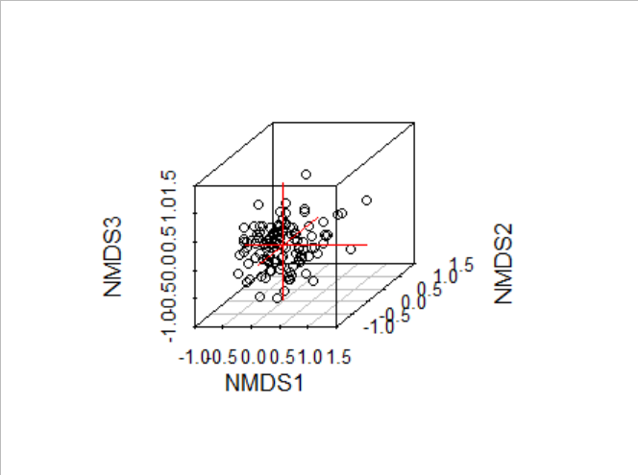
Library(vegan3d)
ordiplot3d(X3, display = c("sites",'species'), choices = 1:3)

D. Now, go to the third part of the script that makes a third figure. This script is more complex but is used to superimpose treatments or groups on our plot using colors or symbols. This week also introduces something new: a legend.

Submit these lines of the script.

0. What am I doing differently here to produce a plot with different colored symbols? It is still the same basic plot() function, but I’m applying it a bit differently. It may be informative to submit it line-by-line and see what happens to the plot window in each step.

Building the plot, then laying on different groupings of points one at a time

- Now that we can see the breakout between day samples and night samples, would you make a conclusion similar to what Hampton and Duggan found?

There does seem to be some separation in groups between night and day. However, results in the scripts’ plot appear to be reversed with the day/night plot seen in Hampton and Duggan. Groups are more clearly defined along NMDS2. In our plot, daytime values are generally more positive along NMDS 1 and NMDS 2. In Hampton and Duggan, NMDS1 seems to be the greater separating axes, albeit slightly, with no real clear separation along NMDS 2.

- Are there any differences between your output and theirs that would give you concern?
Where night and day cluster along NMDS1 seems to be reversed in our plot compared to Hampton and Duggan.

E. Advanced graphing options

There are a couple of really nice graphing options that can really help improve understanding and figure quality. I’ll list them below and generally what they do, but you should explore these a bit. Remember that you can see the details on each of these functions using ?, for example ?ordiplot.

ordiplot(): This function is an alternative plotting function that gives you some additional options.

ordihull(): You should use ?ordihull to examine the several options available to add either convex hulls (drawing lines around the outer points in a group) using ordihull(), to adding confidence ellipses using ordiellipse() plus some other options in which you might be interested.

Using these functions is pretty simple once you have an ordination. If you wanted to draw confidence ellipses Day vs. Night (as in Hampton and Duggan), you would only have to submit ordiellipse(X, DATA$time). Make sure you understand why that works. All of these functions work in a similar way.

V. Exploring the number of dimensions + evaluating Hampton and Duggan

Remember, we can choose the number of dimensions in which to perform an NMDS. In this section, we have 2 goals:
- Perform the steps you’ve just performed to run an NMDS, but with more or fewer dimensions and examine the differences in the output.

- Collect information along the way to make a Scree plot. Remember, the Scree plot can be used to evaluate how many dimensions would be best to use.

So first examine the final bit of graphing code (currently commented out). There are 3 lines:
- The first creates a vector, 1 to 6. This will be the X-axis for your Scree plot. It also implies that you’ll need to determine the stress of your solutions from 1 to 6 dimensions (unless you cheat).
- This line is for you to record the stress as you determine it. Obviously there is no data now, so what you’ll need to do is to run the analysis using different dimensionalities and thing fill in the vector with the resulting stresses at each dimension (for example c(29, 24, 20,….)
- Once you’ve filled in the 2 vectors, the final line should produce a nice Scree plot for you.
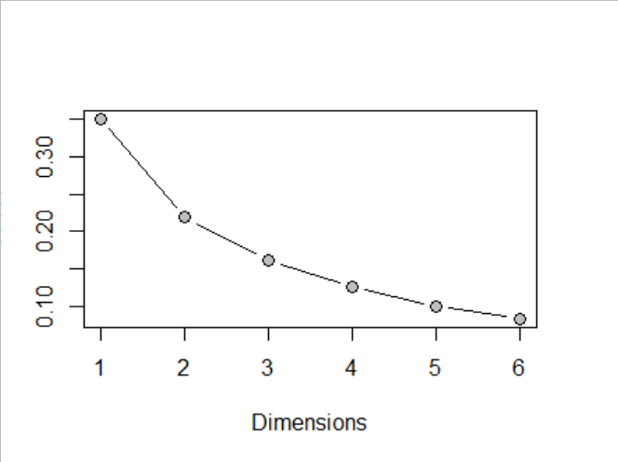

Now, go through and examine how the NMDS solutions change as you add or delete dimensions. Remember, you’ll have to modify the graphing code in order to visualize this.

- Did the answer (difference between day vs. night samples) change as you added or subtracted dimensions?

Not noticeably. Some plots seemed to show a clearer division than others, k = 4 for example, and even k = 6.

- What does the Scree plot suggest that Hampton and Duggan should have chosen in terms of dimensionality? Why? This question is probably the biggest in the lab in terms of understanding NMDS results, so take some time with this one.

Without overfitting their answer, 3 dimensions could have safely been chosen. The stress value drops below 0.2 at k = 3
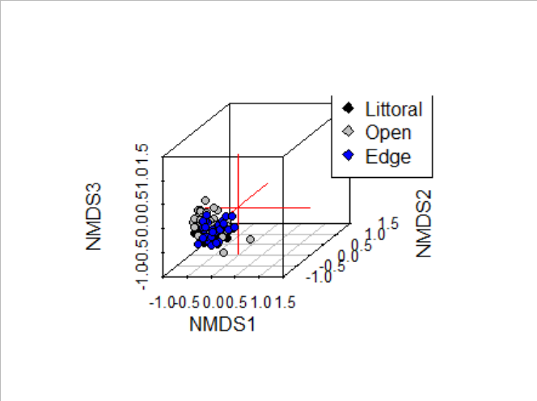
Assignment (due in a couple of weeks):
As with a couple of previous labs, I just want you to answer the questions in bold and then turn those in. Hopefully doing so will ensure that you have understood what is happening with this analysis.

