**MODIS time-series data analysis**

**Introduction**

MODIS (Moderate Resolution Imaging Spectroradiometer) data has been increasingly used to monitor vegetation phenology at regional and global scales, since being launched in 2000. One of the most appealing aspects of MODIS data is its unique combination of spectral, spatial, radiometric, and temporal resolutions; which are considered to be substantially improved over other similar observation systems. It has become common practice to utilize MODIS time-series data to monitor vegetation characteristics and condition using phenology information.

The objective of this lab is to develop a MODIS EVI (Enhanced Vegetation Index) database that allows easy visualization of time-series data for any user-provided location

(e.g., Longitude = -80.429361, Latitude = 37.229596). Your R code will read the user-provided longitude and latitude information and extract MODIS EVI values from MODIS EVI images (2001-2017) for the specific location. Then you’ll generate a plot in R visualizing the EVI time-series (see the following figure as an example).

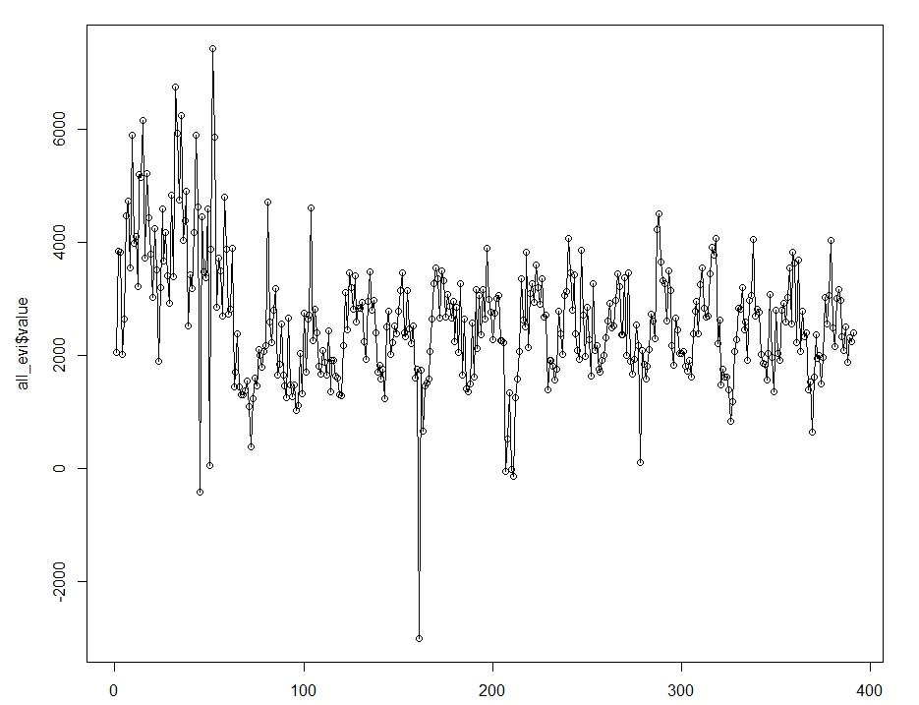

**Download MODIS NDVI/EVI data**

1. Go to the following website: http://daac.ornl.gov/modisglobal

2. Click and drag the balloon to an area that you are interested in (Blacksburg 37.2300 N, 80.4178 W).

3. Click Continue.

4. Select the Vegetation Index product (NDVI/EVI Terra).

5. Select 10 km above and below and 10 km left and right.

6. Select 17 year of data (2001-2017).

7. Leave the GeoTIFF option as the default.

8. Give a valid email address.

9. Check your selection and click create subset (at the bottom of the page).

10. Wait for the email from MODIS_Subsets@ornl.gov

11. Click on the link in the email and check out the order details.

12. Click the GIS data in **Product GeoTIFF** format link. Save the data in your lab directory.

13. Unzip the GTIFF.tar.gz file. In Windows system, you’ll need 7-zip software package to unzip the file. In Linux environment, you may use the following command to unzip the file: tar xzvf GTiff.tar.gz. **Within R, you can use untar() function.**

As you can see from the data folder, there are hundreds of TIFF files, including reflectance, reliability, view zenith angle, EVI, and NDVI. Each category has a total of 391 TIFF files (2001-2017).

**Your tasks:**

1. **Generate a spatial point object within RStudio. Using the following coordinates:** (longitude = -80.429361, latitude = 37.229596)
2. **Plot the spatialpoint object using Mapview library. Attach the figure here:Map

   Description automatically generated**
3. **For this point location, please extract MODIS EVI values from MODIS EVI images (2001-2017). Generate a plot in R visualizing the EVI time-series. Attach the figure here:**

1. **Time-series data trend analysis**

Please generate annual integrated EVI first and then use simple trend analysis (linear regression against time or year) to characterize change trend for each MODIS pixel. Change trend analysis should be implemented for the entire study area, pixel-by-pixel. Please provide any calculated numbers, figures, or tables that you deem appropriate. Chart, surface chart
