Josh McMillen

11-17-2020

IT FDN 110 A

Assignment 05

Foundations Of Programming: Python

Performing Assignment 05

**Introduction**

This document lays out how to perform assignment 5 in the Foundations of Program: Python course at the University of Washington. In order to complete this assignment I used PyCharm to create a script that gives the user the options of viewing existing tasks/priorities, adding a new item to the list, removing an item from the list, saving back to the file and lastly closing the program.

**Creating Third Python Script**

Since PyCharm was already setup on my machine I simply created a new project in a Assignment05 folder on my C drive. This assignment was different where I started with a “starter” script that needed editing. The main task was to: “*Now that you have reviewed the websites and videos ,modify a new script that manages a "ToDo list..* *The "ToDo" file will contain two columns of data, "Task" and “Priority." Load the columns into a Python Dictionary object. Each dictionary object represents one row of data, and these rows must be added to a Python List object to create a table of data”.* To accomplish this I reviewed the script and started at the top.

**Script header and data sections**

The top of the script already had a comment section, but I needed to add in to the change log that I was updating it. The “Data” section was mostly intact. I chose to rename the variable objFile to strFile to reduce confusion around what that variable represents, by default this appeared to create errors as well. The remaining data section was untouched.

**Processing section**

The processing section was mostly blank. The main code added here was to open the target file, then go through each row of the object file and split the items within the row to be captured in a string. This string is then used to load a dictionary row and “Task” and “Priority” are added at this time to the dictionary definition. The strip function is used to remove the returns at the ends of the row (used when saving the data later though). Each dictionary row is appended to a single list table. The file is then closed.

**User input section and exit**

The main body of the user input section is a large while loop that us the constant True. This loop starts with displaying user options to user (every time the loop continues). The user is then asked to make an input and an if/elif begins. If the user chooses to display the items, a small for loop goes through and prints each row of the list table, which is made easier by using the dictionary definition names. The loop then resets back to the top with continue. If the user chooses to add data then a new dictionary row is collected from the user input and then appended to the list table. The loop then resets back to the top with continue. If the user wants to remove a row, a small for loop begins to go through each row in the list. First the row is printed, then user input is asked if the row should be removed. If the user inputs “Y” exactly “Row Removed” is printed and the small for loop is broken and resets the user to the menu. If the user selects any other input then the small loop continues to cycle through all of the rows. If the user selects to save the date then the object file is opened and a small for loop writes each row into the file. The file is closed the user is notified the data is saved and loop then resets back to the top with continue. Finally if the user selects to leave the program then the program is paused and asks the user to select enter to close out of the program.

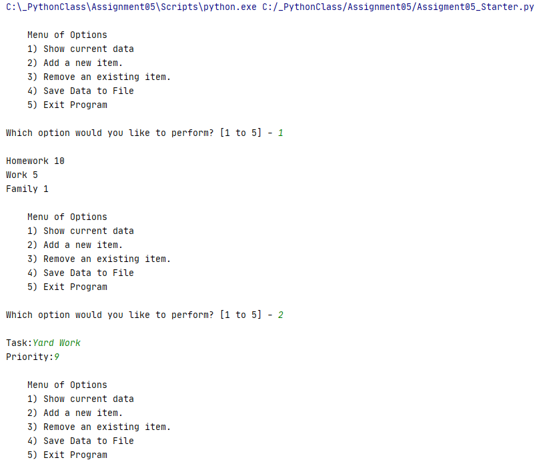

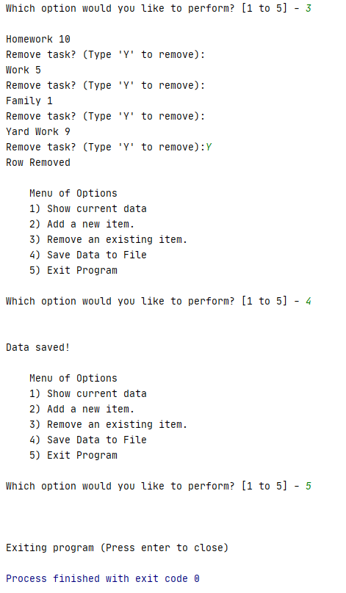

**Figure 1: Working Python script running in PyCharm**

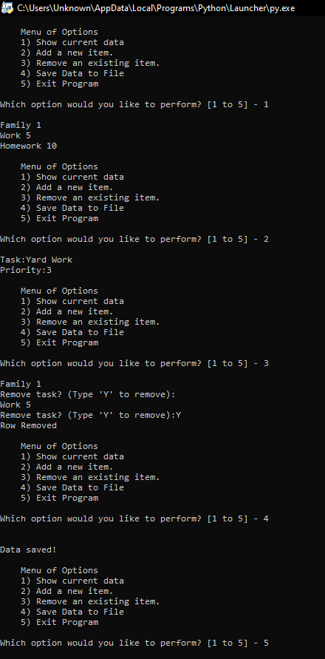

**Figure 2: Working Python script in Command Line**

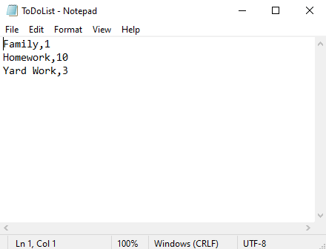

**Figure 3: Text file output**

**Summary**

To fulfil the requirements of assignment 5 I modified the starter script. The main changes made where to first process the data by finding the text file and importing its information. Then the 5 main selections for the user were included, which were: displaying the data using a for loop, adding a new row using input and append, removing a row using a if function and remove function of the list, then allowing the user to save by using a small for loop and finally closing the program using break.