**DIGITAL MOTOR CHECKER EMC-28A**

**•Electric Motor, Generator and Transformer Trouble Shooter•Know in a few minutes what the problem is: Electrical or Mechanical ?•Complete Condition of STATOR, ROTOR,Coil, Connections,Internal Fault or Ground Fault ?**

**NEW**

**Features:**

* Very handy
* Light Weight
* Insulation Resistance (IR) Measurement
* Identify open and short circuits / loose connections in a winding coil
* Identify interterm shorts
* Detect rotor bar problems without dismantling the rotor
* Inductance of the winding with respect todifferent positions for rotor for detecting blow holes or cracks in the rotor bars.
* Simple operationaccurate & quickassessment of motor condition.
* Low battery Indication

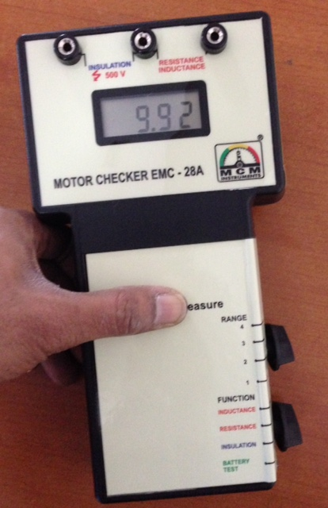

**PREDICTIVE MAINTENANCE:**Regular testing can identify developing faults before a failure occurs.All measurement data can be trended for predictive maintenance condition monitoring. By making proactive repairs and eliminating unscheduled down- time, plant productivity is greatly improved.**EMC-28A** is a Digital portable diagnostic tool for Electrical Engineer and is used for quick on - site checks of electric motor and other three - phase machines.  
A reduction in machine performance, such as inefficient operation or tripping of overloads, may indicate mechanical or electrical faults. If the fault is electrical the EMC-28A will immediately detect it, without dismantling the equipment.The instrument has three separate operating modes to measure different types of faults like fully insulation, open circuits / loose connections, short circuits, Ground faults and rotor defects. Motor insulation is tested with a high voltage at **500V** DC supplied by the instrument.

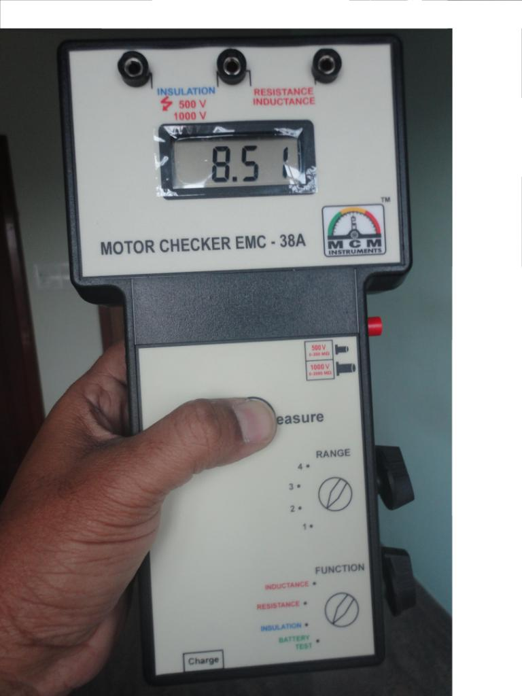



**Motor Checker EMC-28A** finds the faults you can’t see with any other handheld instrument

* Turn -to-turn , coil-to-coil and phase-to-phase faults
* Open phase
* Burned or contaminated winding
* Poor Connections
* Broken / Cracked rotor bars
* Grounded windings
* Cable faults.

**Technical Specifications**

|  |  |  |  |  |
| --- | --- | --- | --- | --- |
| B) **RESISTANCE**   1. **INSULATION RESISTANCE**: 0 – 200 MΩ at 500 V DC ± ( 2% + 1digit), 0.1 MΩ resolution | **RANGE** | **(OHMS) F.S.R** | **RESOLUTION** | **TOLERANCE** |
| 1 | 200 | 0.10Ω | ± 2% |
| 2 | 20 | 0.01 Ω | ± 2% |
| 3 | 2 | 0.001 Ω | ± 2% |
| 4 | 0.2 (200mΩ) | 0.10 milli Ω | ± 2% |

|  |  |  |  |  |
| --- | --- | --- | --- | --- |
| C) **INDUCTANCE** | **RANGE** | **(mH) F.S.R** | **RESOLUTION** | **TOLERANCE** |
| 1 | 2000 | 1 mH | ± 3% |
| 2 | 200 | 0.1 mH | ± 3% |
| 3 | 20 | 0.01 mH | ± 3% |
| 4 | 2 | 0.001 mH | ± 3% |

* Display: 3½ LCD
* Temp. Operating Range:0- 55ºC
* Size: 237x131x45
* Weight:500gms
* Power: 1.5V x 6 AA size cells
* Enclosure: Molded in high impact ABS

|  |
| --- |
| **Standard Supply: 1. Motor Checker EMC-28A 2.Test Leads (Clips) - 1set 3.Batteries - 6 nos 4. Manual with Warranty/ Guarantee Certificate 5.Test & Calibration Report with Warranty / Guarantee Certificate 6.Carry Case** |

|  |  |
| --- | --- |
| https://pmequipments.com/assets/img/pm_equipments_logo.png | **PREDICTIVE MEASURING EQUIPMENTS**  Plot No 146, Phase 1, Mytrinagar, Madinaguda, Hyderabad – 500049  Mobile: +91-90593 40351, eMail: info@pmequipments.com, www.pmequipments.com |

|  |
| --- |
| Technical Data are subject to change without Prior Notice. |