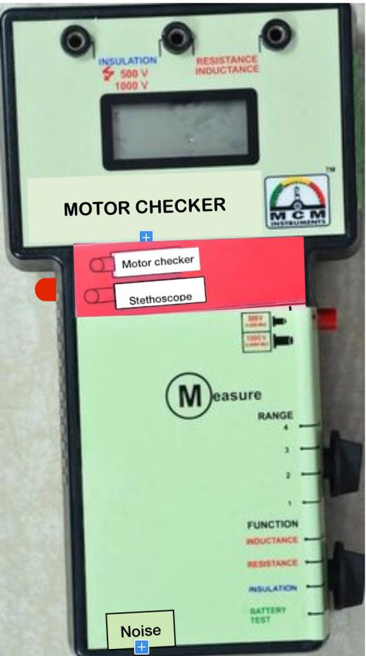

|  |  |  |
| --- | --- | --- |
| **D**NE**IG**W **I DIGITAL MOTOR CHECKER EMC-38N**  ***MCM Introduces new feature in Motor Checker–Detects machinery noise in industrial Environments* Test all kinds of Motors and Coil based Devices** •**Electric Motor, Generator and Transformer Trouble Shooter** •**Know in a few minutes what the problem is: Electrical or Mechanical?** •**Complete Condition of STATOR, ROTOR, Coil, Connections, Internal Fault or Ground Fault? & detect Mechanical Noise of Machines / Bearing, gear and pump noise.** | | |
|  |  | **Features:**  ❖ Insulation Resistance (IR) Measurement  ❖ Detects blow holes or cracks in the Rotor bar without dismantling the rotor  ❖ Inductance Measurement of the winding  ❖ Low resistance measurement of the winding  ❖ Identifies open and short circuits / loose  Connections in a winding coil  ❖ Identifies intertern shorts  ❖ Simple operation accurate & quick assessment of motor condition.  ❖ Noise (Mechanical sounds detection)  **for easy location of machinery noise in industrial Environments**  ❖ Very handy  ❖ Battery Condition of Instrument  ❖ Low battery Indication  ❖ Light Weight |
|  |  |  |

**PREDICTIVE MAINTENANCE:** Regular testing can identify developing faults before a failure occurs. All measurement data can be trended for predictive maintenance condition monitoring. By making proactive repairs and eliminating unscheduled down- time, plant productivity is greatly improved.**EMC-38N** is a Digital portable diagnostic tool for Electrical Engineer and is used for quick on - site checks of electric motor and other three - phase machines. A reduction in machine performance, such as inefficient operation or tripping of overloads, may indicate mechanical

or electrical faults. If the fault is electrical the EMC-38N will immediately detects it, without dismantling the equipment. The instrument has three separate operating modes to measure different types of faults like fully insulation, open circuits / loose connections, short circuits, Ground faults and rotor defects. Motor insulation is tested with a high voltage at **500V/1000V**DC supplied by the instrument.

**NOISE:** (Electronic stethoscope) Listening to machine sounds in order to determine the probable source of abnormal noise is one of the most widely used methods in maintenance departments across all branches of industry. Our electronic stethoscope is a practical and easy-to-use listening device that helps pinpoint the source of mechanical noise in a broad range of applications. Bearing condition, gear and pump noise, and electric relay operation are just a few of the many sounds which can be identified, amplified, and assessed.

**Motor Checker EMC-38N** finds the faults you can’t see with any

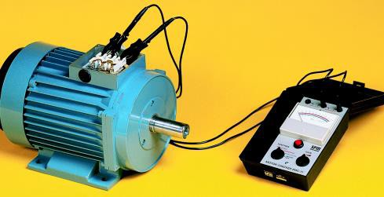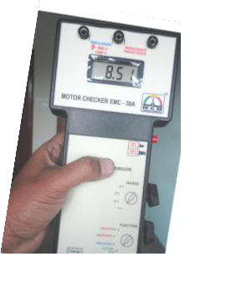

other hand held instrument

• Turn -to-turn , coil-to-coil and phase-to-phase faults

• Open phase

• Burned or contaminated winding

• Poor Connections

• Broken / Cracked rotor bars

• Grounded windings

• Cable faults.

• Mechanical Noise of Machines / Bearing, gear and pump noise

**Technical Specifications**

A) **INSULATION RESISTANCE** 0 – 200 MΩ at 500 V DC ± ( 2% + 1digit), 0.1 MΩ resolution

0 – 2000 MΩ at 1000 V DC ± ( 2% + 1digit) 1 MΩ resolution

|  |  |  |  |  |
| --- | --- | --- | --- | --- |
| B) **RESISTANCE** | **RANGE** | **(OHMS) F.S.R** | **RESOLUTION** | **TOLERANCE** |
| 1 | 200 | 0.10Ω | ± 2% |
| 2 | 20 | 0.01 Ω | ± 2% |
| 3 | 2 | 0.001 Ω | ± 2% |
| 4 | 0.2 (200mΩ) | 0.10 milli Ω | ± 2% |

|  |  |  |  |  |
| --- | --- | --- | --- | --- |
| C) **INDUCTANCE** | **RANGE** | **(mH) F.S.R** | **RESOLUTION** | **TOLERANCE** |
| 1 | 2000 | 1 mH | ± 3% |
| 2 | 200 | 0.1 mH | ± 3% |
| 3 | 20 | 0.01 mH | ± 3% |
| 4 | 2 | 0.001 mH | ± 3% |

D) **NOISE (stethoscope)** • Frequency range: 30 Hz to 20 kHz

• Filters: low, middle, high, unfiltered

• Display: 3½ LCD • Temp. Operating Range: 0- 55ºC • Size: 237x131x45 • Weight: 700gms

•Power: 1.5V x 6 AA size cells • Enclosure: Moulded in high impact ABS

**Standard Supply: • Motor Checker EMC-38N • Test Leads - 1set • Noise Probe with Tip • Head Phone**

**• Batteries - 6nos• Manual • Calibration Report & Warranty / Guarantee Certificate •Carry Case**

|  |  |
| --- | --- |
| https://pmequipments.com/assets/img/pm_equipments_logo.png | **PREDICTIVE MEASURING EQUIPMENTS**  Plot No 146, Phase 1, Mytrinagar, Madinaguda, Hyderabad – 500049  Mobile: +91-90593 40351, eMail: info@pmequipments.com, www.pmequipments.com |