Vibration Transducer VSF - IF

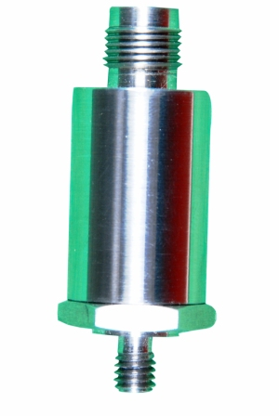

Vibration Transducer VSF – 1F is a piezo-electric accelerometer of
compression type, designed for vibration monitoring of industrial
machinery. It can be used together with a handheld vibration instruments
or Permanent installation.

Technical Specifications
 |  |  | Sealed membrane
  Accelerometer | Piezo electric type
  Charge Sensitivity | 10Pc/m/S²
  Linear frequency Range | 1 – 2000 Hz
  Temperature Range | -10 to 120°C
  Accelerometer mounting thread | 6 mm
  Casing | Stainless Steel, acid proof
  Size | 27x48mm
  Weight | 70 gms
  Connector Type | TNC

 | PREDICTIVE MEASURING EQUIPMENTS  Plot No 146, Phase 1, Mytrinagar, Madinaguda, Hyderabad – 500049  Mobile: +91-90593 40351, eMail: info@pmequipments.com, www.pmequipments.com

