Bearing (Shock Pulse) Condition Analyzer BVT-111

Three Instruments in one
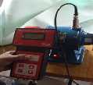

Bearing Condition Monitoring Machine Vibration Monitoring Rotational Speed
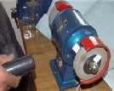


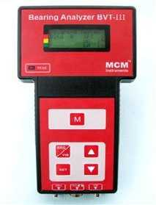

FEATURES

❖ Direct indication of machine condition in terms of good – reduced – bad in condition scale

❖ Detects Mechanical Condition of Bearings

❖ Damage severity readings of bearings

❖ Detects Lubrication condition of ball-and-roller- type Bearings

❖ Non-contact measurements of rotational speed

❖ Vibration Measurements according to ISO recommendations.

MCM Presents a small Micro Processor based diagnostic tool for comprehensive condition analysis of rotating machinery.
Objective measurements of machine condition are needed as a reliable base for preventive maintenance. Now maintenance personal can analyze bearing condition, measure machine vibration and check rotational speed - with a single and easy to use instrument.
The best way is to periodically monitor bearing condition and replace the bearing at the right time by least influencing the production efficiency.
Technical Specifications:

Bearing Tester Function |  | Laser Tachometer Function
* Measuring range (Shock Pulse) | -19 to 99 dBpv | * Measuring range | Up to 19,999 RPM
* Resolution | 1 dBpv | * Measuring Distance | Up to 2 feet
Vibration Tester Function |  | * Resolution | 1 rpm
* Measuring Range | 0.1 to 99.9mm/s RMS | * Temperature range | 0oC to 50oC
* Resolution | 0.1 mm/s | * Display | 16x4 line Dot Matrix LCD
* Accuracy | +/- (2% + 0.1 mm/s) | * Keypad | Sealed membrane

Standard Supply:
1) Bearing Analyzer BVT-111 with Protective Pouch, 2) Bearing Probe, 3) Vibration Transducer VSF-1F (Accelerometer), Magnetic Base, Low Noise Cable with Connectors 1.5Mtrs, Hand-Held Probe rod, 4) Head Phone , 5) Laser Tachometer with Reflecting Tapes, 6) Manual, 7) Batteries-6 nos (1.5V AA), 8) Test & Calibration Report with Warranty/Guarantee Certificate &
9) Carry Bag.
 | PREDICTIVE MEASURING EQUIPMENTS  Plot No 146, Phase 1, Mytrinagar, Madinaguda, Hyderabad – 500049  Mobile: +91-90593 40351, eMail: info@pmequipments.com, www.pmequipments.com

Technical Data are subject to change without Prior Notice.

