Machine Conditioner- 803
(Suitable for Monitoring Machinery Vibration caused by imbalance, Misalignment & Gear Faults)
3 functions in one
Vibration, Tachometer, Electronic Stethoscope (Noise) Function

Features

❖ Vibration Measurement all three
Parameters
(Velocity, Acceleration & Displacement)
❖ Noise Test (Electronic Stethoscope) (Locate the sound source quickly and accurately in a generally noisy environment with headset)
❖ Laser Tachometer measurement
❖ Microcontroller based
❖ Battery Low Indication
❖ Data Hold
❖ Back light LC Display
❖ Small size & Light weight
❖ Auto Power off

Technical Specifications

• Vibration Velocity : 0.1 – 199.9 mm/s True RMS  Accuracy: ± 2% + 0.1 mm/s | • Power: Rechargeable Battery
• Acceleration: 0.1 – 199.9 m/s² Peak  Accuracy: ± 2% + 0.1 m/s² | • Display: 2 x 16 line back light dot matrix LCD
• Displacement: 1.0 – 2828 µm Peak – Peak  Accuracy: ± 5% | • Operating Temp. Range: 0 - 55ºC
Resolution: 0.1 mm/s | • Casing: ABS
Frequency response: 10HZ – 1KHZ | • Sealed Membrane key pad
• Electronic Stethoscope (Noise): Stereo type Head Set | • Input Connectors: BNC & MIC
Contact Tip: 220mm Stainless Steel | • Size: 200x100x40 mm
• Laser Tachometer: 10 – 30000 rpm | • Weight: 600gms (Approximately)
Resolution: 1 rpm
Accuracy: ± (1 rev. + 0.1% of reading)

Standard Supply :
01) Machine Conditioner 803 with Protective Pouch,
02) Vibration Transducer (Accelerometer) VSF-1F, Magnetic Base, Low Noise Cable with Connectors (1.5 mtrs),
03) Head Phone & contact tip, 04) Laser Tachometer Probe with Reflecting Tapes (3 Strips), 05) Charger,
06) Manual, 07) Test & Calibration Report with Warranty/Guarantee Certificate & 08) Carry Bag.

Technical Data are subject to change without Prior Notice.
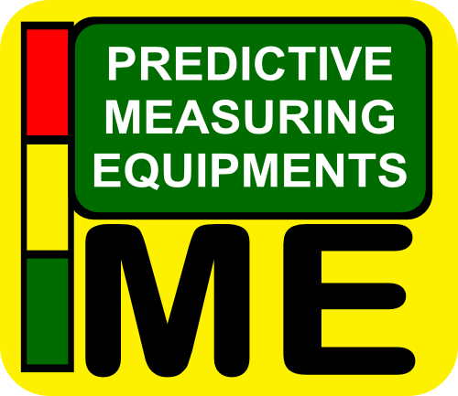 | PREDICTIVE MEASURING EQUIPMENTS  Plot No 146, Phase 1, Mytrinagar, Madinaguda, Hyderabad – 500049  Mobile: +91-90593 40351, eMail: info@pmequipments.com, www.pmequipments.com

